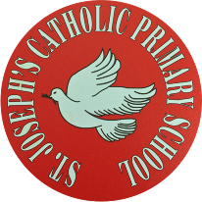
St Joseph’s Catholic Primary School - LEARNING AT HOME PLANNING
YEAR 4
Date- WC 4th May 2020
Weekly Mathematics Tasks  (Aim to do 1 per day) | Weekly Reading Tasks  (Aim to do 1 per day)
- Continue your daily work on Times Tables Rockstars. We have been logging on to see how you are doing. Well done to those children who are improving their scores- keep practising!  - Ensure you are completing your daily 4 calculations in your orange book. Want to challenge yourself? Ask for some adding fractions or decimals this week.  - Go to: https://whiterosemaths.com/homelearning/year-4/ This page has links to a whole week’s worth of lessons on multiplication and division. Please choose the option Summer Term Week 3.  - If you would like some extra work on multiplication and division, why not have a go at completing this booklet?  - Hit the Button  This is a fun game that you can play on your laptop or tablet.  - Multiples and Factors  A multiple choice game looking at factors | Please read to an adult or a sibling as often as possible and discuss what you read.  This PDF provided last week has great examples of question prompts that you can use.  Can you think of your own questions about the texts that you read and set questions for a sibling? Make sure you write down the answers too for when you’re ready to be the teacher and mark their work!  Read with expression and intonation.  Complete the VE Day Reading Comprehension. Can you think of any of your own questions based upon this text?
Weekly Spelling Tasks  (Aim to do 1 per day) | Weekly Writing Tasks  (Aim to do 1 per day)
Practise the following words.  where wear were we’re  their there they’re  Can they improve their score each day?  Can they put these words into sentences?  There, their and they're quiz  Where, were, wear and we're Quiz  NB: If your child has differentiated spellings,  their words are:  there their they’re  Can they put these words into sentences? | VE Day (or Victory in Europe Day) falls on Friday 8 May - to mark the 75th anniversary, the early May bank holiday was moved from its usual position on a Monday. Please look at the powerpoint below and make notes. Remember notes should be short and to the point – you do not need to write in full sentences.  Now complete this short activity…

Foundation subjects and Learning Project - to be done throughout the week
- Science – We are looking at ways of classifying living things. Please complete the attached activity as best as you can.
- Geography – Look at the images and note how the rainforest has many different types of plants growing in it. We call these plants vegetation. There are 4 layers of vegetation in the rainforest. Using the images below, match the name of each layer to its name.

- Art – Create a medal for British soldiers who served in the Second World War.
Let’s get physical!
Try to join in with Joe Wicks daily PE lessons. If you dress up on Friday, why not send a photo to our school Twitter account! We are sure that your friends (and us) would love to see you!
We all loved joining in with circuit training during our PE lessons in the hall, didn’t we?!! Can you create a circuit for you and your family members to complete?

Pray Together
The Gospel for the coming Sunday can be found at http://universalis.com/mass.htm
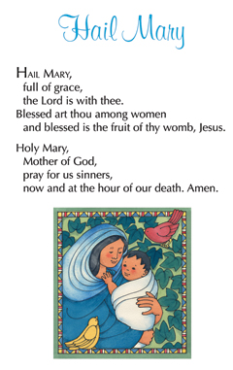
A children’s liturgy for Sunday 3rd May and Sunday 10th May can be found here, with accompanying activities. CAFOD Children's Liturgy
May is the month of Mary.
Please say the Hail Mary prayer daily.

Additional learning resources parents may wish to engage with
Our school Twitter page will keep you up to date with challenges set by the teachers and let you see what other pupils have been up to. Follow us @stjosephsbh

Oxford Owl has some free ebooks, similar to those we use in school. You will need to register initially (for free), but many resources are free.
https://home.oxfordowl.co.uk/books/free-ebooks/
Teacher Tips
- Working for short but focussed chunks of time, punctuated by breaks to play or have snack, may suit your child best.

- If your child has produced work they are really proud of, we would love to see it on our school Twitter page.

- Have fun with learning and feel free to adapt and tailor any of the activities above to your child’s interests.

- Don’t forget to go outside and clap in appreciation for our wonderful NHS at 8pm on Thursday evening. We really do appreciate all of the hard work that they are doing to help us at this challenging time.

