T.
0151 652 6781
www.stjosephscatholicprimarybirkenhead.co.uk
E. schooloffice@stjosephs-birkenhead.wirral.sch.uk | @stjosephsbh
St Joseph’s Catholic Primary School
Woodchurch Road, Birkenhead CH43 5UT
Headteacher.
Mr A. Turner
Attendance and Punctuality Newsletter

As you will be aware, we are having a big push on attendance and punctuality in our school as we are seeing our data heading in the wrong direction. The three key areas we want to address are based on
1) Our whole school headline figure for attendance is dropping below 96%
2) Too many of our children are classed as ‘Persistently Absent’ – that is, they have attendance of below 90%
3) Too many children are arriving late to school on a regular basis

As such, we just wanted to send out this newsletter with some key information, facts and figures, as well as some of the actions we are taking to make improvements.

Last half term we sent a survey out to parents to gather some parent voice about attendance and punctuality. Many thanks for taking the time to help us build up a picture of the barriers and views. Some of these findings are also included in this newsletter.

What is our overall attendance looking like?

It is a legal requirement that we take, track, monitor and report on levels of attendance at school and individual child level. As a minimum, we are expecting to get whole school levels of at least 96%. However, we have a fluctuating picture:

Whole school 2020-2021 | 95.6%
Whole school Autumn 1 2021 | 94.6%
Whole school 1st September 2021 to date | 93%

Whole school 2018-2019 | 95.3%
Whole school 2019-2020 | 93.7%

As you can see, these figures have gone up and down over a three-year period. Covid has absolutely had an impact, however, we need to ensure that overall attendance levels rise and we hit that 96% mark at least.

What do you think?

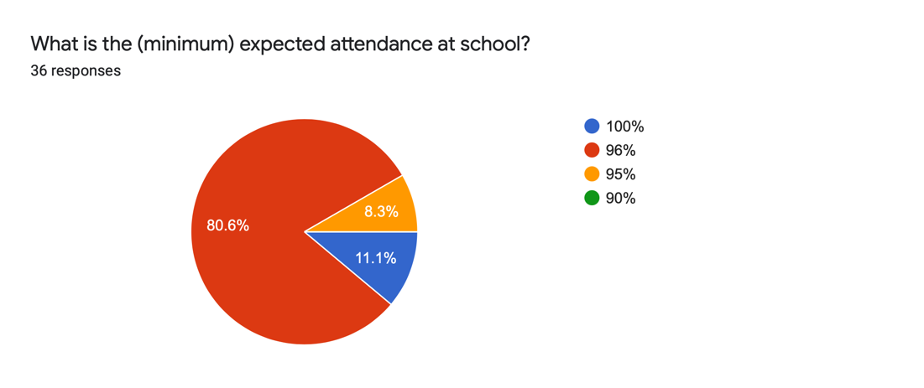
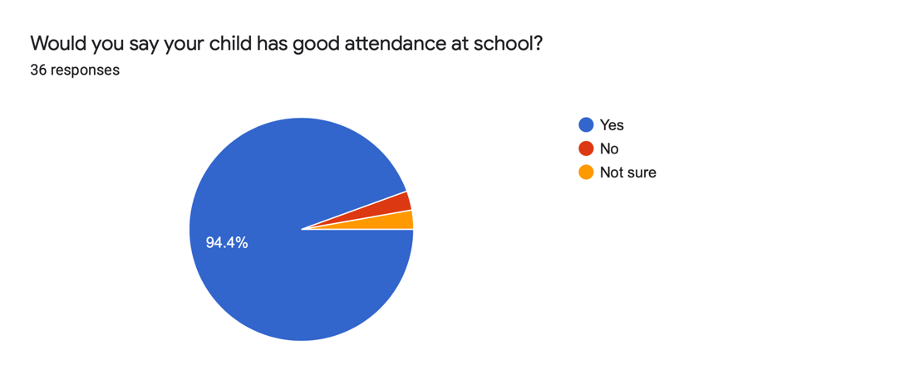
When asked in our survey, 94.4% of parents said that they believed their child has good attendance.
3% said they didn’t and 3% said they weren’t sure.

Asked about expectations, 80% were correct in identifying minimum expectations as 96%.
11% were very aspirational and believed that 100% is expected. 8% were slightly low, thinking that 95% is expected.

Persistent Absence
An area of particular concern is the number of our children who are classed as ‘Persistently Absent’. This is defined as children who have attendance levels below 90%.
90% might sound ‘OK’, after all, if you scored 90% in a test you’d be fairly pleased with that? But 90% attendance is not a good place to be.
Every day in school counts, as each day brings new learning, new opportunities and time spent with friends in the bliss of childhood.
90% attendance means 1 day in every 10 is missed – and that scaled up to a year means 19 whole days of missed. Scale that up even further over a 6-year period, and look at the impact if a child has 90% attendance each year from Y1 to Year 6 and that means that in total, over half a whole year has been lost!
At this very moment, we have 56 children with attendance below 90%. And very sadly, some of those are way below 90%. So the losses explained above are even greater.

Why are children staying off school?

The last two years have been impacted by Covid, but when we analyse data, we take these cases out of the figures and just look at the other reasons. When we asked, you told us:
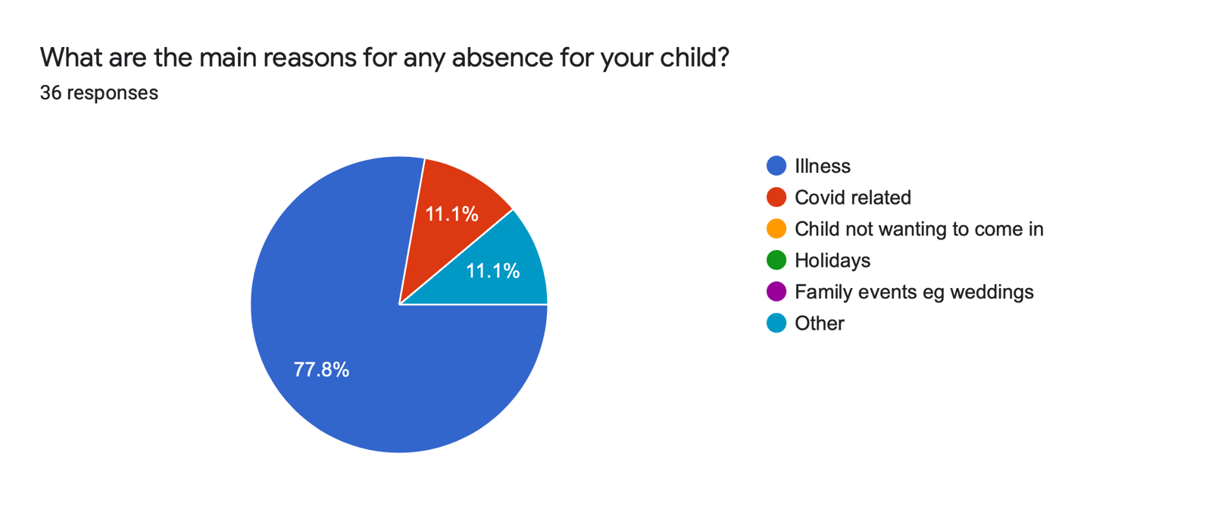
We do understand that children get ill, and for some illnesses in particular (e.g., D and V), we are advised to keep children off school for 48 hours. However, all of these days add up and cause individual and overall attendance to drop.

What about punctuality?

Not only do we need the children in school regularly*, we need them in on time every day. First thing in the morning is when instructions and plans for the day ahead are shared, as well as key stand-alone sessions or targeted interventions such as calculations, spelling and reading. By consistently being late to school, the children are missing these crucial lessons. That’s to say nothing of the embarrassment the children may feel; imagine how it feels when as adults we have to walk in late to a meeting or conference – it feels like the whole room turns and stares at you! Just imagine how that feels as a child.
So, what did you tell us about punctuality?
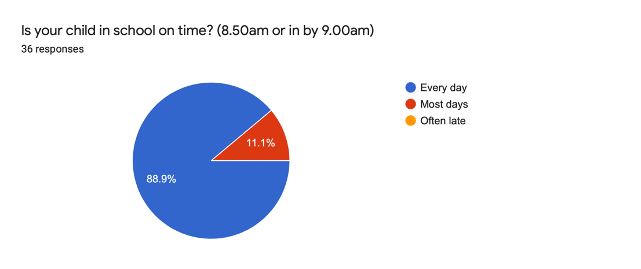
89% of respondents said that their child was in school on time every day. However, our monitoring tells us a different story – and every day we are seeing late arrivals, and in some cases, the same children every day are arriving long after the start of the day.

Looking at the reasons you shared with us, we see barriers such as: just having difficulties in the morning; eating breakfast too slowly; traffic, and also the systems we have in place for doors.

*We just thought it worth clarifying – we say we need the children in school regularly… but why do we say that? It’s not actually about getting an abstract percentage figure up, or being able to celebrate a data table – it’s about the children that sit behind those figures. As professionals we have made a conscious decision to build our careers, and indeed lives, around the pursuit of developing and supporting your children. Bottom line is we care about them – that’s why we do the job we do. And we can’t help, teach, support or celebrate with them if they’re not here.

Solution focussed…

So now we know what the picture is, let’s focus on solutions.

- We need whole school attendance levels to improve.
- We need the number of children with attendance below 90% to reduce.
- We need good levels of punctuality and for children to be in school on time.

We have some further strategies we want to put in place, which we will explain below, and we also want to take account of some of your ideas and suggestions. However, as we have explained, good attendance and punctuality is a legal requirement and we are held to account about these areas. In some cases, that potentially leaves us no option other than the ‘hard way’ of informing the Local Authority, who in turn may seek to serve Penalty Notices, or even Prosecution. But we really don’t want things to come to that.

Step one of our strategy is to continue to promote attendance and punctuality and keep it front and centre in our communication – letters, newsletters, social media, reports – we are going to keep you armed with the information so you can see where we are as a school, and where your child is in comparison.

We have also introduced a weekly class percentage breakdown and whole school figure in our weekly staff briefing and bulletin. This means that each week, the teachers can see the overall attendance percentage for the week before for their class and how that compares to other classes and the whole school. The teachers will share these figures with their classes and encourage children to be in and get their class score up (further explanation below**). The teachers will also start to speak to you on the playground or over the phone if they are noticing that their class figures are down, and your child has been absent for a number of days. A further important point to note is that this is immediate intervention and designed to be supportive – so please help us uncover if there is a reason your child is not able or wanting to come in so that we can address any issues.
** We are mindful that children have some genuine and legitimate reasons for absence, so we will always have this in mind when discussing attendance levels with a class, or designing any reward systems so that children do not feel singled out or responsible for a low whole class score.

In her role as attendance lead, Angie is also starting to analyse attendance data on a weekly basis, and will be highlighting children who have any absences in two consecutive weeks. We will then contact you either by phone or text, just to bring it to your attention. We understand that some illnesses (and including Covid) may well cross over into two weeks, but we are finding that for some children there are ‘one offs’ each week.

Punctuality will continue to be monitored and tracked. Thank you for your feedback about our morning systems. This is a difficult one, as we are an unusually large and spread-out site and we do understand that if you are dropping children at different entrances, then it is a tight window to get from one side of the building to the other. We will write again about the best solutions for the morning systems as there is quite a lot to unpick and think about.
School starts at 8.50am and we must stress that is the time to aim for – arriving at 9.00 really is too late and shouldn’t be seen as acceptable. However if on rare occasions, you do miss the ‘doors’ and enter via the main office, it only becomes a late mark after 9.00am
If your child arrives after the registers close, then a U mark will be given. If we have to enter 10 U marks, then we may have to inform the LA to issue a Penalty notice.

If your child is absent, please help us by informing us as early as possible, each day of absence. This can be done by calling the school 0151 652 6781 and pressing option 1 or using the absence reporting tab on the Parent App. Please provide as much detail as possible – e.g. ‘your child has a stomach bug and a case of D/V’ rather than just ‘ill’.

A reminder that we cannot authorise any holidays during term time. For an absence to be authorised it must be ‘unavoidable’ and ‘rare’ and sadly, even grabbing a bargain holiday is not unavoidable.

What have you suggested?

Within our survey we asked for your views on any extra solutions to our shared issue of attendance levels. Thank you for your suggestions – here are a few:
It’s a difficult one as sometimes it’s not the child but the parent

One thing I wondered about was peer support from other parents. Not to turn up and gets kids ready in the morning, but to act as a co-problem solver: “When I struggled to get mine up in the morning, we tried this, maybe you could too? I know there has been great success in the peer support model for breast feeding and wondered if it could be applied here? It would require very little resource apart from a bit of thought and organising. But regardless, I think it’s great that school is doing this survey. Collaborative working will always produce better outcomes

It would be better to line up with the class outside, to encourage them to be there on time?

Perhaps certificates, even given privately, to celebrate children’s punctuality and attendance. Or if something enticing happened in the first five minutes of the day that children didn’t want to miss

Share with pupils the Importance of a healthy active lifestyle and what good nutrition looks like. Enough sleep and being hydrated. Do parents realise the impact of poor attendance in GCSE results.

Each week give the classes with best attendance/punctuality a treat. Extra 5 mins play or fun snack on a Friday. Could have most improved attendance/punctuality over a half term give the class a movie afternoon the Friday before half term. Ask the children in the classes with repeat offenders how they can improve their attendance…what could they do. Give repeat offenders who are late a responsibility that they have to be on time to carry out or ask them to attend a breakfast club which they may be late for but will still be on time for school.

Focussed support work and intervention with those families who are struggling perhaps?

People hearing about fines for those who holiday in school time

Prizes for attendance and punctuality BUT which allow children to still be included if they have medical reasons for absences such as hospital appointments etc

There are some great suggestions in your responses, as well as a clear and honest response about the challenges faced in getting children to school, and systems that may unfairly penalise children who are not always the decision makers in matters of attendance. There is more work to be done, and some deep thinking needed. But we tackle this issue together, in partnership, as going back to one of my core beliefs – we are all on the same team here, just trying to help the children to succeed.

