**RE Newsletter – Autumn 1**

Dear Parents,

Welcome back to the new academic year. Below you will find information about what your child will be learning in their Religious Education this half term.

We hope you find this newsletter of interest and as always, please keep us in your prayers as we continue to support your child in their religious education.

**FS1 and FS2– God’s World** 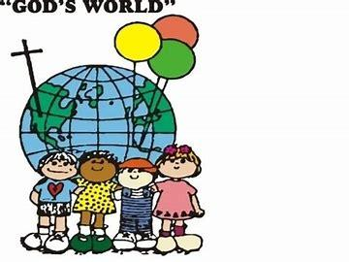

**“Creation is the first and universal revelation of God’s love”**

*Religious Education Curriculum Directory*

This half term, the children in the Nursery and the Reception classes will be learning about God’s world. Throughout this topic , the children will begin to appreciate the beauty of the world and know that God made it.

They will learn that God loves and cares for each one of us and reflect on this. They will hear about and respond to the things God created for us.

They will know that God has asked us to care for the world and think of ways in which we can help to do it.

At home

You could help your children by:

• looking at pictures of animals and plants and talking about how special creation is

• encourage them to notice different parts of God’s wonderful creation and think of ways to care for the world.

**RE Newsletter – Autumn 2**

Dear Parents,

The dark nights have certainly found their way back to us and we return from half term to the month of November – a time to remember those who have gone before us into the loving embrace of God.

We also find ourselves moving towards the season of Advent when we prepare to celebrate the birth of Jesus, the Son of God, at Christmas.

Below you will find what your child is learning about in RE this half term.

**FS1 and FS2– God’s Family**

“**Creation is the first and universal revelation of God’s love … Each human person is made in God’s image …**”

*Religious Education Curriculum Directory*

This half term, the children in Early Years will be learning about God’s Family. Throughout the topic, the children will be given opportunities to become aware that God made all the people in the world to be part of his family and that we are part of it too.

They will learn that God made us to know and love him, as well as to show our love for him by helping one another. They will find out that God has given us gifts so that we can show his love to others. 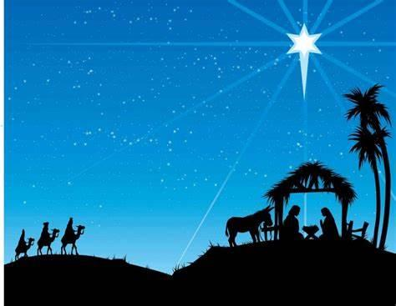

As Christmas approaches, they will learn that God’s greatest gift to us was to send his only son Jesus and learn how to respond to that gift.