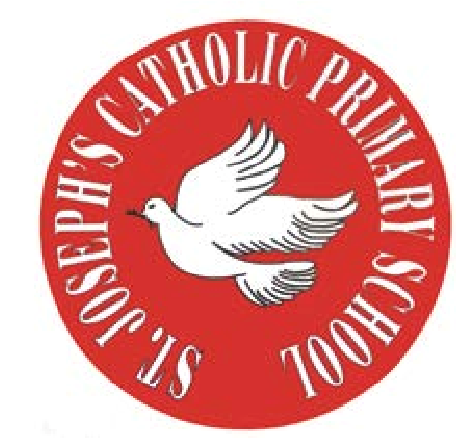
RE Newsletter – Autumn 1

St Joseph’s Catholic Primary School
Woodchurch Road, Birkenhead CH43 5UT
Headteacher.
Mr A. Turner

Dear Parents,
Welcome back to the new academic year. Below you will find information about what your child will be learning in their Religious Education this half term.

We hope you find this newsletter of interest and as always, please keep us in your prayers as we continue to support your child in their religious education.

T.
0151 652 6781
www.stjosephscatholicprimarybirkenhead.co.uk
E. schooloffice@stjosephs-birkenhead.wirral.sch.uk | @stjosephsbh

Year 1 – God’s Great Plan
“As the first action of Father, Son and Holy Spirit, creation is the first step towards the covenant relationship God seeks with every human being”
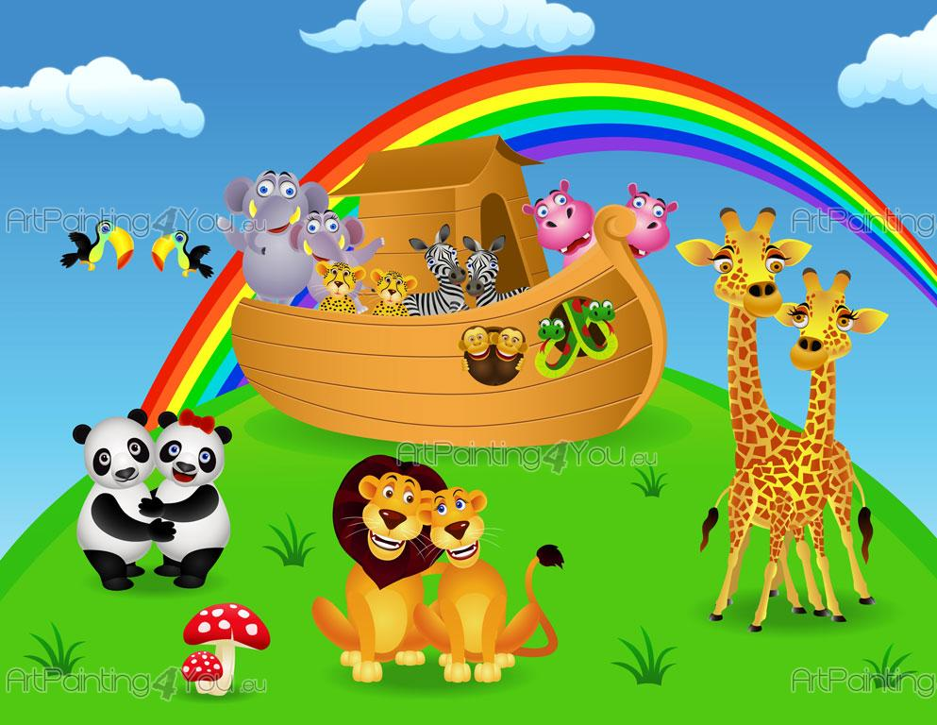
Religious Education Curriculum Directory

The children will learn about the beauty of God’s world and explore and
respond to wonders of creation e.g. the seasons. They will also hear
about the story of Creation from Genesis and talk about its meaning.
They will be reflecting on the knowledge that God made us because he loves
us and develop their understanding that we show God we love him by looking
after the world and each other. They will learn that we can spoil God’s
creation and that we have a responsibility to look after it, as well as hearing
an appropriate part of the story of Noah and the Flood and its message of
salvation and hope.

At home
You could help your child by:
• talking about how we can look after the world, e.g. recycling, not dropping litter, conserving energy and how we can care for plants and animals
• look at the trees during the autumn season and talk about the different colours. You could collect leaves to make a collage or painting.

RE Newsletter – Autumn 2

Dear Parents,
The dark nights have certainly found their way back to us and we return from half term to the month of November – a time to remember those who have gone before us into the loving embrace of God.

We also find ourselves moving towards the season of Advent when we prepare to celebrate the birth of Jesus, the Son of God, at Christmas.

Below you will find what your child is learning about in RE this half term.

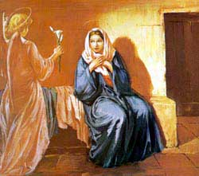
Year 1 – Mary our Mother

This half term, the children will learn that God sent the Angel Gabriel with a message to Mary and learn why this is important. They will learn that God asked Mary to be the mother of his son and will have an opportunity to reflect on her response.

They will hear about Mary’s visit to her cousin, Elizabeth and reflect on the good news. They will begin to reflect on how we can prepare to celebrate the birth of Jesus and learn that Mary is our mother in heaven and that she is looking after us.

At Home
You could help your child by:
reinforcing why Mary is important for Christians

discussing the importance of mothers.

T.
0151 652 6781
www.stjosephscatholicprimarybirkenhead.co.uk
E. schooloffice@stjosephs-birkenhead.wirral.sch.uk | @stjosephsbh

