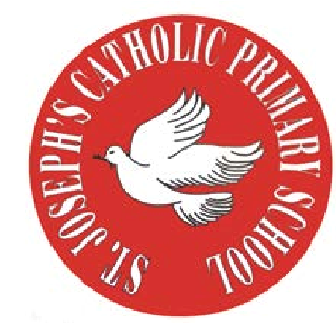
RE Newsletter – Autumn 1

St Joseph’s Catholic Primary School
Woodchurch Road, Birkenhead CH43 5UT
Headteacher.
Mr A. Turner

Dear Parents,
Welcome back to the new academic year. Below you will find information about what your child will be learning in their Religious Education this half term.

We hope you find this newsletter of interest and as always, please keep us in your prayers as we continue to support your child in their religious education.

T.
0151 652 6781
www.stjosephscatholicprimarybirkenhead.co.uk
E. schooloffice@stjosephs-birkenhead.wirral.sch.uk | @stjosephsbh

Year 2 – Chosen People
“In order to gather together scattered humanity God calls Abram … and makes him Abraham, that is, ‘the father of a multitude of nations.’ … God formed Israel as his people by freeing them from slavery in Egypt … he gave them his law so that they would recognise him and serve him as the one living and true God, the provident Father and just judge, and so that they would look for the promised Saviour.”
Catechism of the Catholic Church

The children will learn that we are chosen by God and learn that God chose certain people to lead and guide his people. They will learn that God called Abraham and that God chose Moses to be a great leader. They will also learn about how Samuel responded to God’s call and find out about the story of Daniel in the lions’ den.
They will have an opportunity to reflect on Abraham’s trust in God and learn that we should always trust God.
They will learn that God chooses unexpected people and will be given the opportunity to reflect on their own response to God’s call.
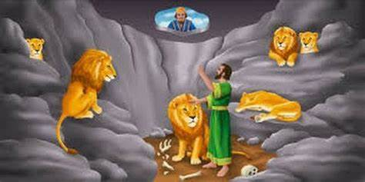

RE Newsletter – Autumn 2

Dear Parents,
The dark nights have certainly found their way back to us and we return from half term to the month of November – a time to remember those who have gone before us into the loving embrace of God.

We also find ourselves moving towards the season of Advent when we prepare to celebrate the birth of Jesus, the Son of God, at Christmas.

Below you will find what your child is learning about in RE this half term.

Year 2 – Mysteries
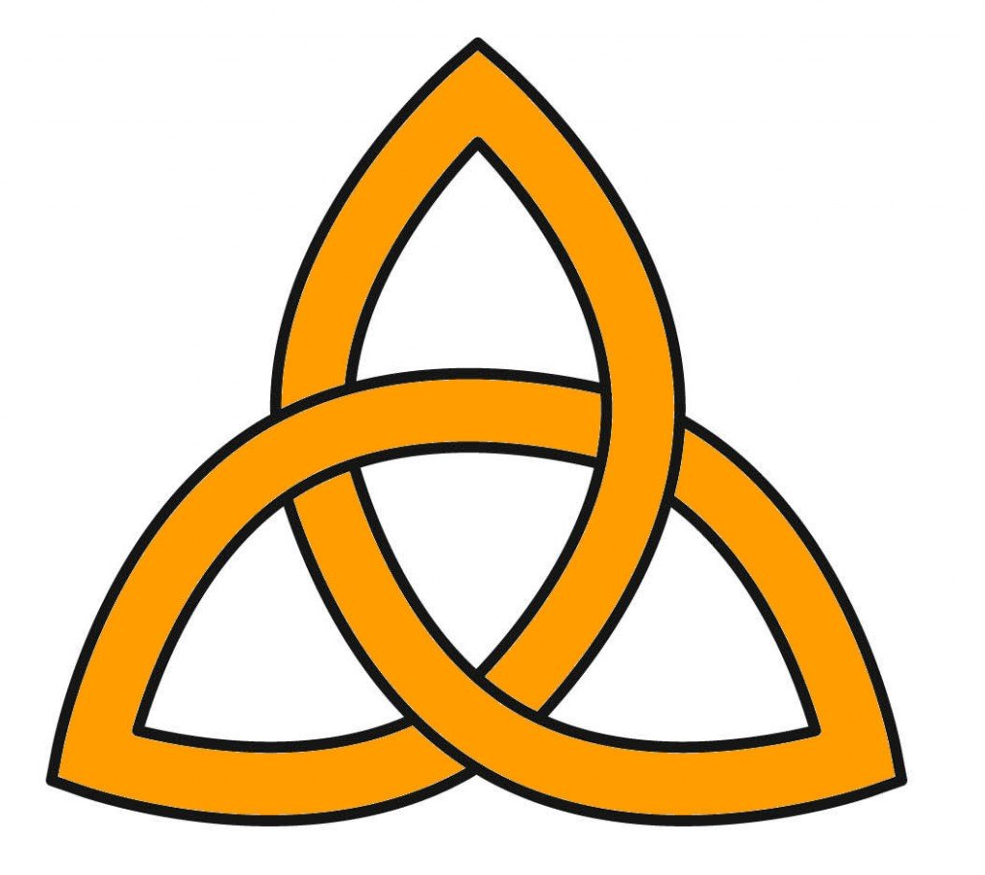

“God is one and God is Three, a Trinity of persons:
Father, Son and Holy Spirit”
Religious Education Curriculum Directory

This half term, the children will learn about and reflect on mysteries. They will be encouraged to say and reflect on what they wonder about. The children will learn that there are three persons in one God and that we can experience God in three different ways as Father, Son and Holy Spirit.
They will learn about and reflect on God’s choice of Mary and Joseph and know that Jesus is God’s gift to the whole world.

At home
You could help your child by:

• reminding them, as they make the sign of the cross, that God is Father, Son and Holy Spirit

• reading the Christmas story and encourage them to ask questions

T.
0151 652 6781
www.stjosephscatholicprimarybirkenhead.co.uk
E. schooloffice@stjosephs-birkenhead.wirral.sch.uk | @stjosephsbh

