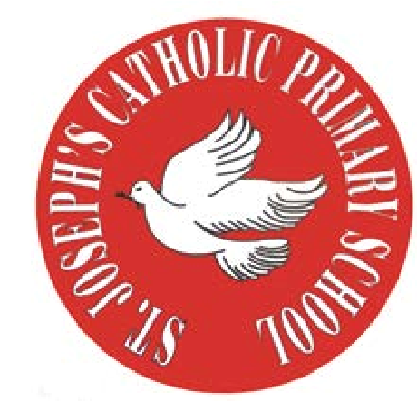
RE Newsletter – Autumn 1

St Joseph’s Catholic Primary School
Woodchurch Road, Birkenhead CH43 5UT
Headteacher.
Mr A. Turner

Dear Parents,
Welcome back to the new academic year. Below you will find information about what your child will be learning in their Religious Education this half term.

We hope you find this newsletter of interest and as always, please keep us in your prayers as we continue to support your child in their religious education.

T.
0151 652 6781
www.stjosephscatholicprimarybirkenhead.co.uk
E. schooloffice@stjosephs-birkenhead.wirral.sch.uk | @stjosephsbh

Year 3 – Christian Family
“The Church is the family of God, the people that God gathers in the whole world.”
Religious Education Curriculum Directory

The children will develop their understanding that the Church is the family of God and know that we join this family when we receive the Sacrament of Baptism. They will learn what happens at Baptism and learn about the signs used and why they are used. They will learn about the promises made by parents and godparents at Baptism and develop their understanding.
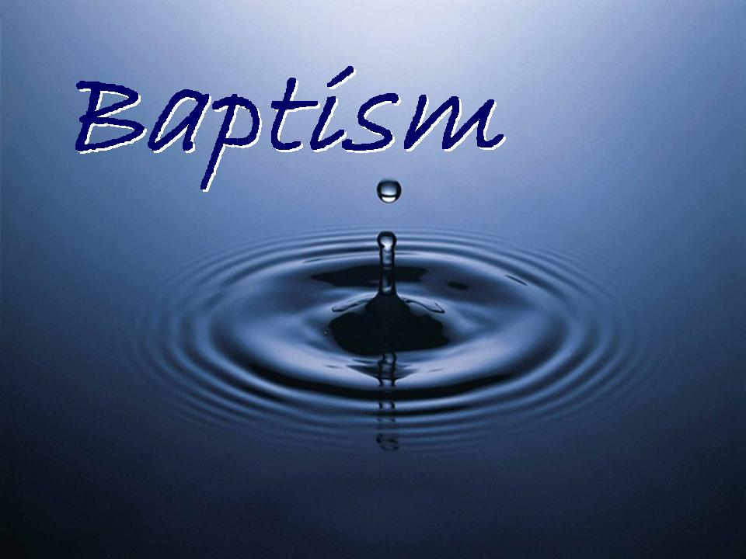

The children will have a chance to:
• reflect on what it means to be part of a family
• reflect on what it means to be part of the Christian family
At home
You could help your child by:
• sharing your experiences about their Baptism. Look at any gifts or photographs that they received on their special day.
• discuss what it means to be part of God’s family

RE Newsletter – Autumn 2

Dear Parents,
The dark nights have certainly found their way back to us and we return from half term to the month of November – a time to remember those who have gone before us into the loving embrace of God.
We also find ourselves moving towards the season of Advent when we prepare to celebrate the birth of Jesus, the Son of God, at Christmas.

St Joseph’s Catholic Primary School
Woodchurch Road, Birkenhead CH43 5UT
Headteacher.
Mr A. Turner

Below you will find what your child is learning about in RE this half term.
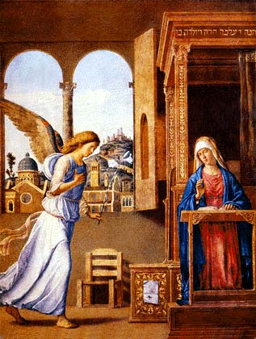

Year 3 – Mary, Mother of God

“Mary the Mother of Jesus and therefore the Mother of God is the first disciple…She is the Church’s model of faith and charity
and because of her singular response to God’s Word is Mother of the Church.”
Religious Education Curriculum Directory

This half term, the children will learn that God called Mary to be the Mother of Jesus and learn how Mary responded to God’s call. They will learn the ‘Hail Mary’ and begin to understand what the words mean.
They will learn that Advent is a time to prepare for the coming of Jesus at Christmas and begin to understand that Christmas is a celebration of the birth of Jesus, the Son of God. They will also learn about the stories of the shepherds and the wise men’s visit to see the baby Jesus.
At home
You could help your child by:
• saying the ‘Hail Mary’ everyday
• talking with them about the importance of Mary in Jesus’ life

T.
0151 652 6781
www.stjosephscatholicprimarybirkenhead.co.uk
E. schooloffice@stjosephs-birkenhead.wirral.sch.uk | @stjosephsbh

