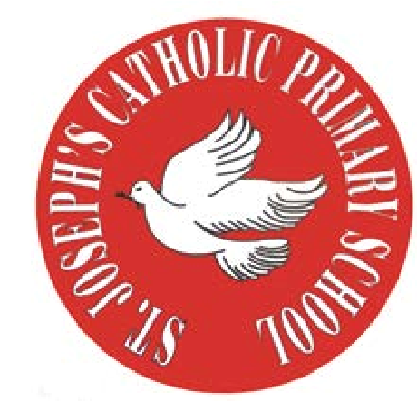
RE Newsletter – Autumn 1

St Joseph’s Catholic Primary School
Woodchurch Road, Birkenhead CH43 5UT
Headteacher.
Mr A. Turner

Dear Parents,
Welcome back to the new academic year. Below you will find information about what your child will be learning in their Religious Education this half term.

We hope you find this newsletter of interest and as always, please keep us in your prayers as we continue to support your child in their religious education.

T.
0151 652 6781
www.stjosephscatholicprimarybirkenhead.co.uk
E. schooloffice@stjosephs-birkenhead.wirral.sch.uk | @stjosephsbh

Year 4 – The Bible
“The Scriptures are the living Word of God, written under the guidance of the
Holy Spirit received and faithfully handed on within the living Tradition and teaching of the Church.”
Religious Education Curriculum Directory

The children will learn that the Bible is a story of God’s love and concern for us. They will learn that the Bible is a living book through which God speaks to us and tells us about himself. They will learn that the Bible is one story told through many different books and they will learn about Moses, David and Jonah as well as learning how to find a Bible reference.

The children will have the chance to:
• explore how the Bible helps us to pray and experience how God speaks to us in the Bible
• participate in a liturgy and experience a guided meditation on a text from the Bible

At home
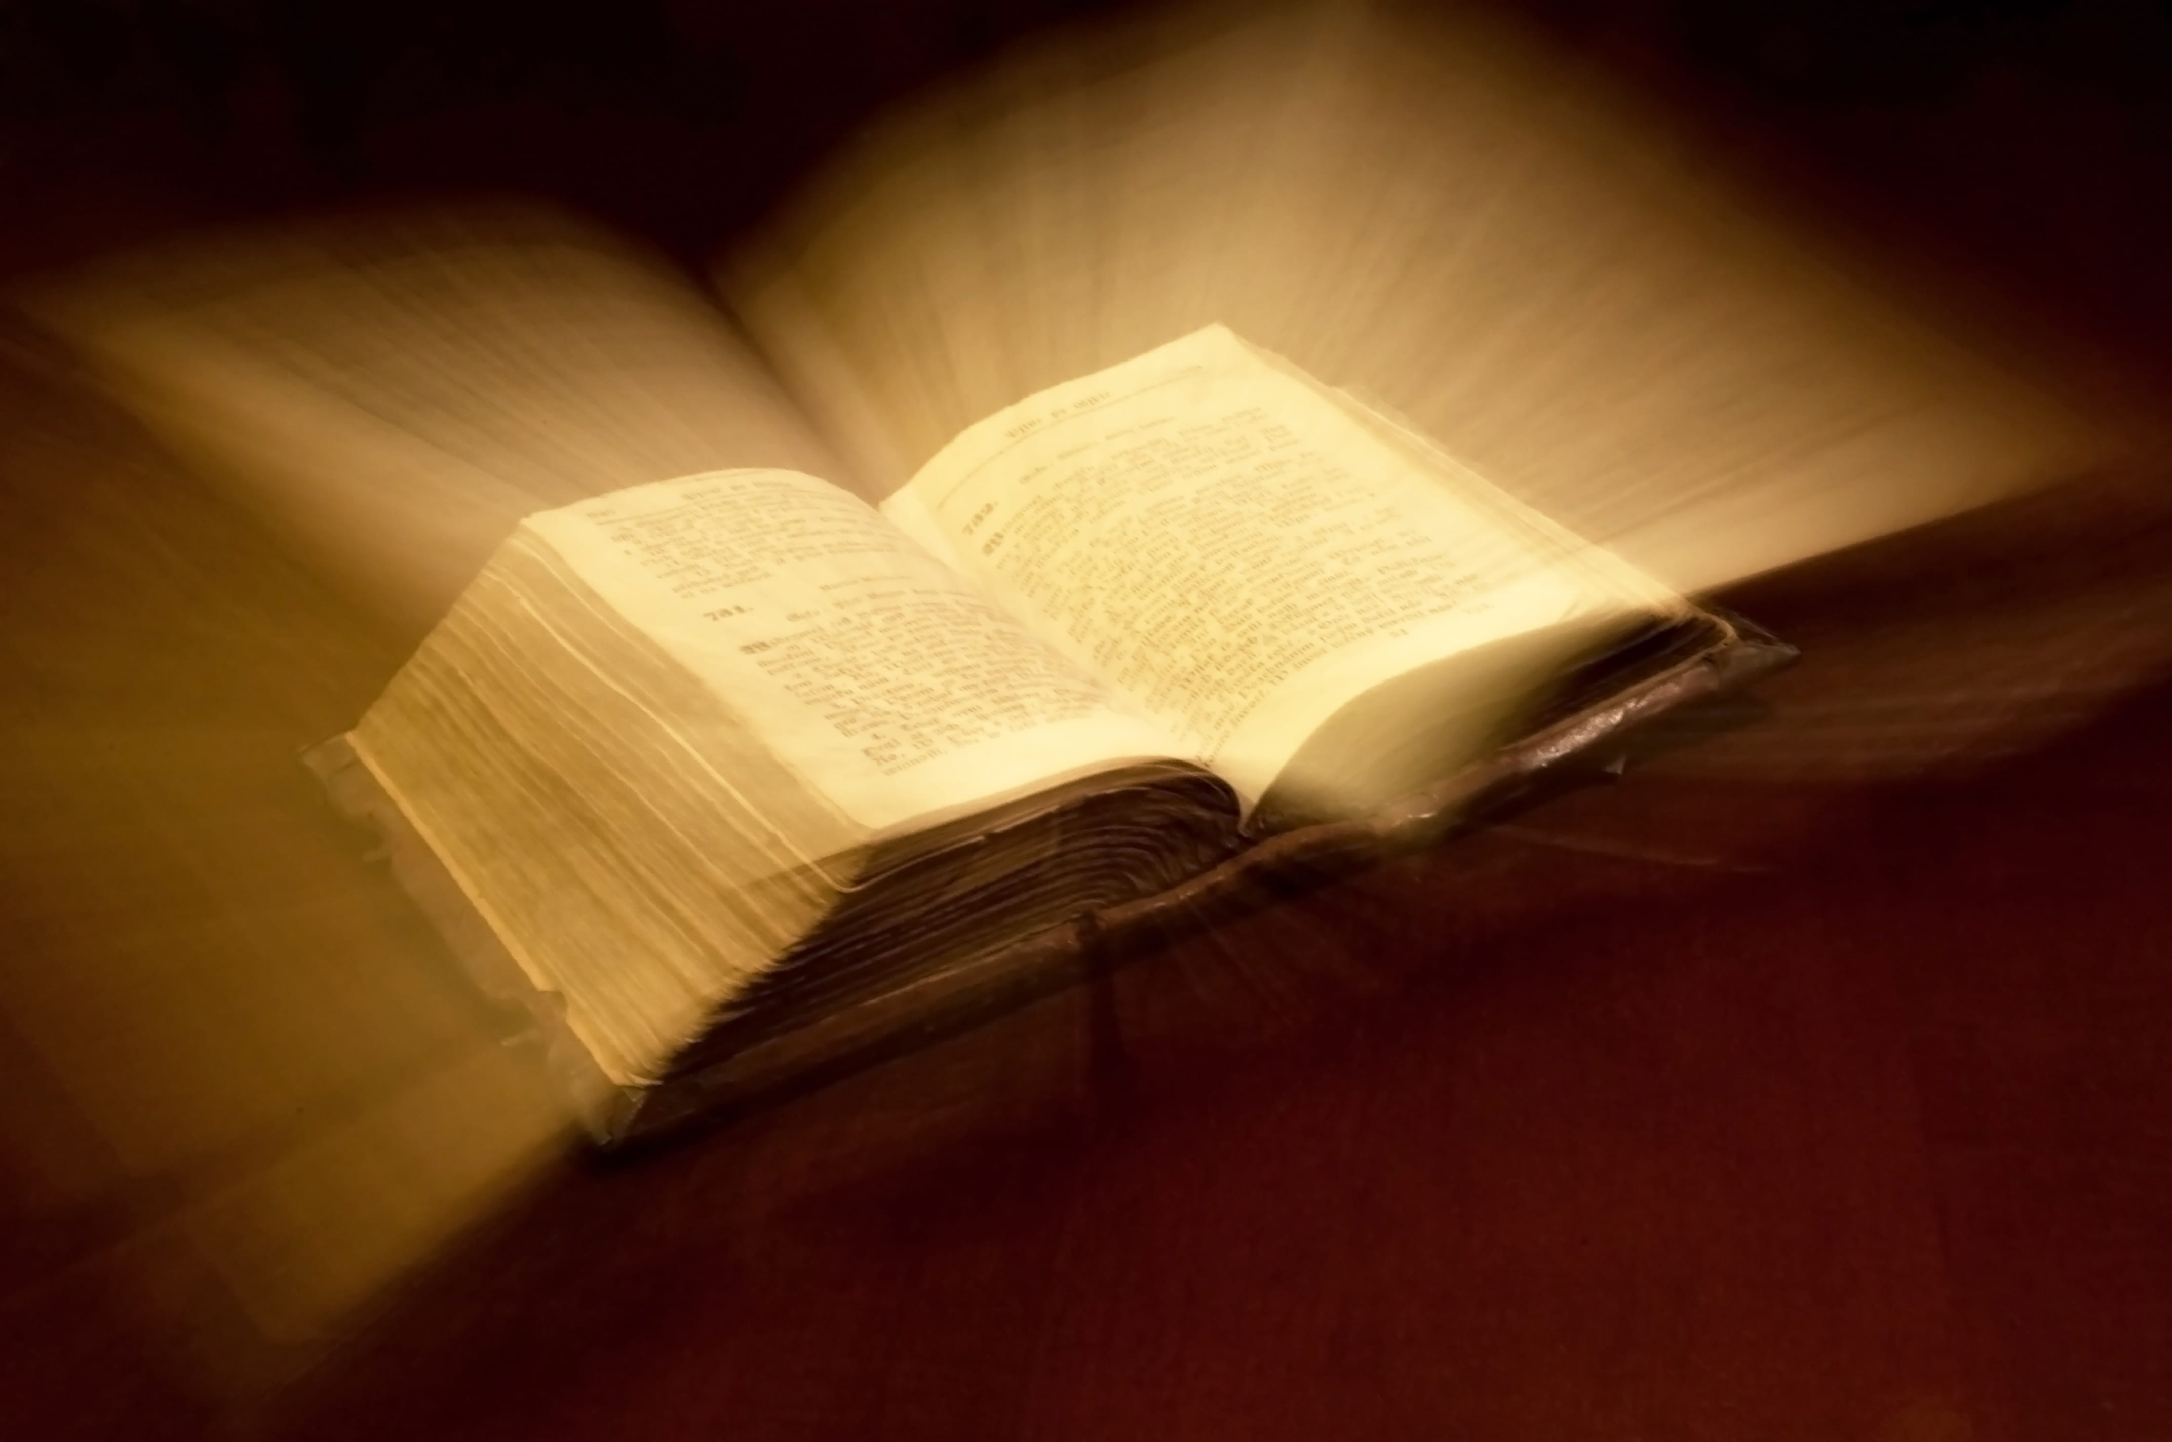
You could help your child by:
• reading some of the stories the children have covered in class

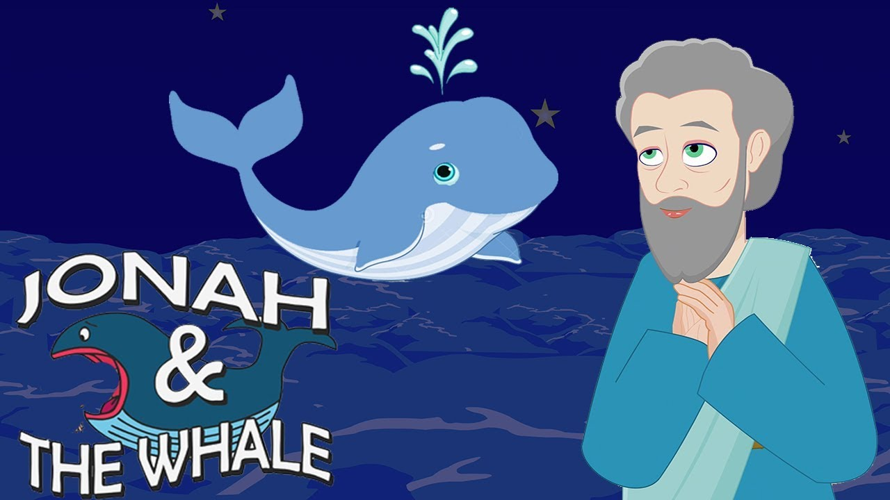

RE Newsletter – Autumn 2

St Joseph’s Catholic Primary School
Woodchurch Road, Birkenhead CH43 5UT
Headteacher.
Mr A. Turner

Dear Parents,
The dark nights have certainly found their way back to us and we return
from half term to the month of November – a time to remember those who have gone before us into the loving embrace of God.
We also find ourselves moving towards the season of Advent when we prepare to celebrate the birth of Jesus, the Son of God, at Christmas.

Below you will find what your child is learning about in RE this half term.

Year 4 – Trust in God
The children will learn about Jesus’ teaching and the importance of trusting in him.
They will learn that it is not always easy to trust in God (e.g. Zechariah).
They will learn about the promise God made to Mary through the angel Gabriel
and learn how Joseph put his trust in God when the angel appeared to him.
They will become familiar with Mary’s song of praise and trust in God (the Magnificat) and learn that God fulfilled his promise to Mary when Jesus, the Son of God, was born.

The children will have a chance to deepen their awareness of God’s love for us and know that he asks us to trust in him. They will reflect on the times it is difficult to trust and on the importance of keeping promises. They will make their own Advent promises. The children will reflect on how Mary and Joseph placed all their trust in God and experience a celebration of the Nativity.
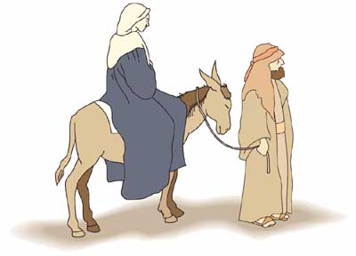
At home:
You could help your child by making an Advent calendar with them.

T.
0151 652 6781
www.stjosephscatholicprimarybirkenhead.co.uk
E. schooloffice@stjosephs-birkenhead.wirral.sch.uk | @stjosephsbh

