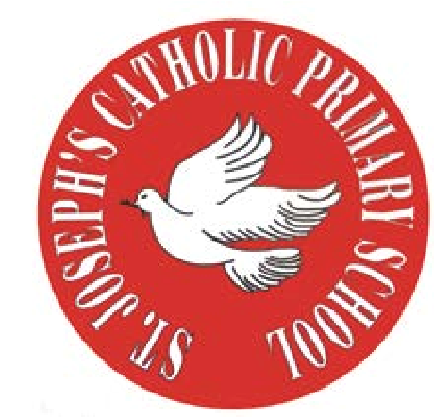
RE Newsletter – Autumn 1

St Joseph’s Catholic Primary School
Woodchurch Road, Birkenhead CH43 5UT
Headteacher.
Mr A. Turner

Dear Parents,
Welcome back to the new academic year. Below you will find information about what your child will be learning in their Religious Education this half term.

We hope you find this newsletter of interest and as always, please keep us in your prayers as we continue to support your child in their religious education.

T.
0151 652 6781
www.stjosephscatholicprimarybirkenhead.co.uk
E. schooloffice@stjosephs-birkenhead.wirral.sch.uk | @stjosephsbh

Year 5 – Creation
“Each human person is unique and made in God’s image and likeness”
Religious Education Curriculum Directory

The children will learn the story of Creation and the Fall in the Book of Genesis. They will learn that we are all created in the image and likeness of God and know that God calls us to care for others and all creation with love and respect. They will learn that there are times when we fail to be good stewards of creation. They will also learn that there are people who show great respect for creation and for the weakest members of society.
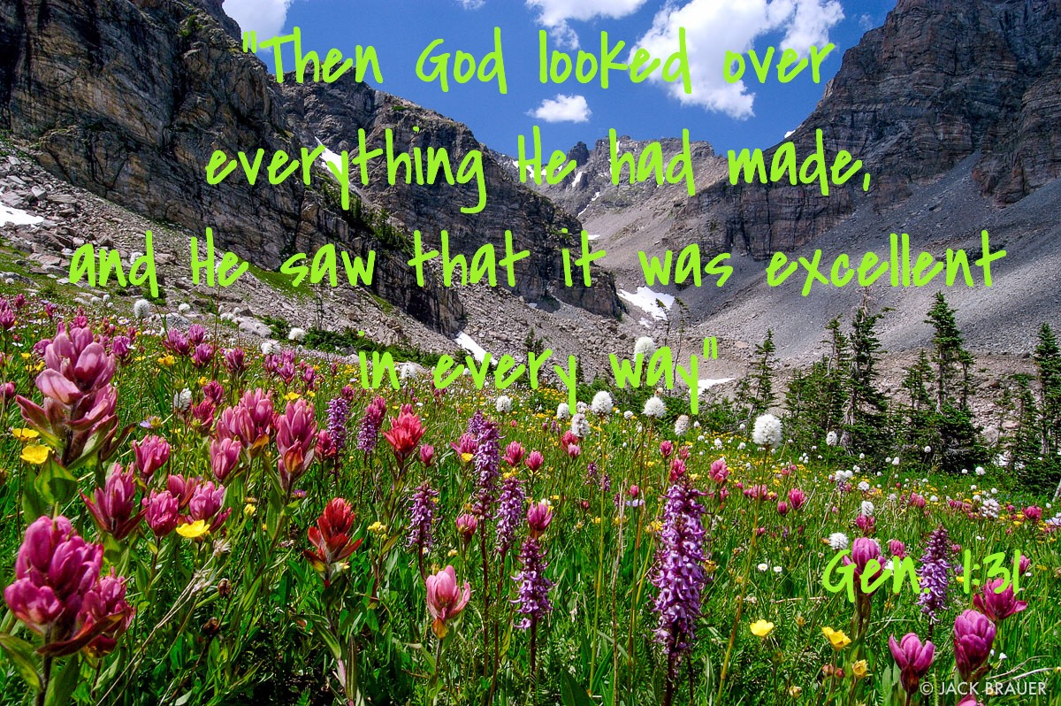
The children will have the chance to:
• appreciate how we can show respect for ourselves,
for others and for God.
• reflect on times we have failed to show respect and reflect
on the gifts and talents God has given each of us.
• reflect on the use and misuse we can make of these gifts.

At home
You could help your child by:
• talking to them about how they could care for creation and the environment

RE Newsletter – Autumn 2

St Joseph’s Catholic Primary School
Woodchurch Road, Birkenhead CH43 5UT
Headteacher.
Mr A. Turner

Dear Parents,
The dark nights have certainly found their way back to us and we return from half term to the month of November – a time to remember those who have gone before us into the loving embrace of God.

We also find ourselves moving towards the season of Advent when we prepare to celebrate the birth of Jesus, the Son of God, at Christmas.

Below you will find what your child is learning about in RE this half term.
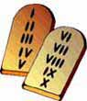
Year 5 – God’s Covenants

The Children will learn that God loves us and calls us
into friendship with him. The children will understand that the
Ten Commandments are a gift from God to help us.
They will learn how Jesus summarised the
Ten Commandments (Matthew 22: 36-40) and
begin to understand how we can show our love for God
by keeping his commandments with his help.

The children will also learn that God sent his Son Jesus into the world because he loves us, and that we celebrate this gift at Christmas

At home
You could help your child by:

• talking to them about how we try to live by the ten Commandments

T.
0151 652 6781
www.stjosephscatholicprimarybirkenhead.co.uk
E. schooloffice@stjosephs-birkenhead.wirral.sch.uk | @stjosephsbh

T.
0151 652 6781
www.stjosephscatholicprimarybirkenhead.co.uk
E. schooloffice@stjosephs-birkenhead.wirral.sch.uk | @stjosephsbh

