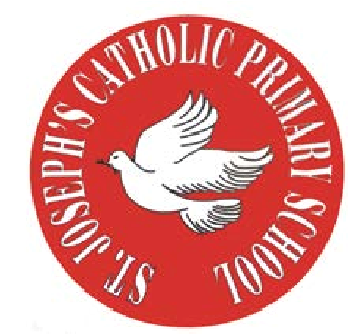
RE Newsletter – Autumn 1

St Joseph’s Catholic Primary School
Woodchurch Road, Birkenhead CH43 5UT
Headteacher.
Mr A. Turner

Dear Parents,
Welcome back to the new academic year. Below you will find information about what your child will be learning in their Religious Education this half term.

We hope you find this newsletter of interest and as always, please keep us in your prayers as we continue to support your child in their religious education.

T.
0151 652 6781
www.stjosephscatholicprimarybirkenhead.co.uk
E. schooloffice@stjosephs-birkenhead.wirral.sch.uk | @stjosephsbh

Year 6 – The Kingdom of God
“Instead, be concerned above everything else with the Kingdom of God and with what he requires of you, and he will provide you with all these other things.” (Matthew 6:33)
The children will be introduced to Jesus’ teaching about the Kingdom of God; a teaching central to his life and mission. They will be taught the concept of the Kingdom of God through some of the parables and miracles of Jesus and will explore the ways in which people respond to Jesus’ invitation to belong to his Kingdom.
The children will have the chance to:
• reflect on what the Kingdom of God is like and is not like
• understand some of the parables of the Kingdom
• reflect on the importance of responding to the invitation to the Kingdom
• reflect on the words and deeds necessary to show commitment to the Kingdom
• know there are three kinds of miracle
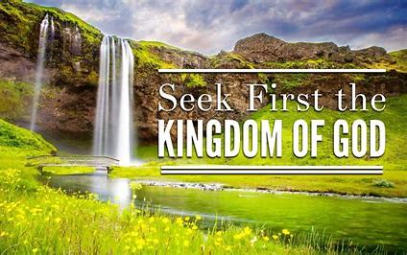
• know that Jesus’ miracles reflected the beginning of the Kingdom and
show us what God is like

At Home
You could help your child by:
• asking them to explain the meaning of the Kingdom of God
• discuss the parables and their meaning
• read a miracle story and discuss what it tells us about God

RE Newsletter – Autumn 2

St Joseph’s Catholic Primary School
Woodchurch Road, Birkenhead CH43 5UT
Headteacher.
Mr A. Turner

Dear Parents,
The dark nights have certainly found their way back to us and we return from half term to the month of November – a time to remember those who have gone before us into the loving embrace of God.

We also find ourselves moving towards the season of Advent when we prepare to celebrate the birth of Jesus, the Son of God, at Christmas.

Below you will find what your child is learning about in RE this half term.

Year 6 – Justice

“Love of neighbour … involves working for a just society, both
Locally and internationally”
Religious Education Curriculum Directory

The children will learn that God called the prophets from the Old Testament and learn about the different ways they responded. They will learn that the prophets spoke out against injustice and that some prophets were persecuted because they spoke out.
They will learn that Christians are called to work for justice and find out about individuals who have been persecuted for speaking out against injustice.
The children will learn that Advent is a time of waiting and hoping for the birth of the Messiah at Christmas and understand that the birth of Jesus fulfilled Old Testament prophecies.

T.
0151 652 6781
www.stjosephscatholicprimarybirkenhead.co.uk
E. schooloffice@stjosephs-birkenhead.wirral.sch.uk | @stjosephsbh

St Joseph’s Catholic Primary School
Woodchurch Road, Birkenhead CH43 5UT
Headteacher.
Mr A. Turner
At home
You could help your child by:

• thinking about how your family could support the work of CAFOD

• visit www.cafod.org.uk to learn more about CAFOD and its work in the developing world

• include an intention for people fighting injustice in your prayers with the children.

