Equality, Diversity and Inclusion Policy

St. Joseph’s

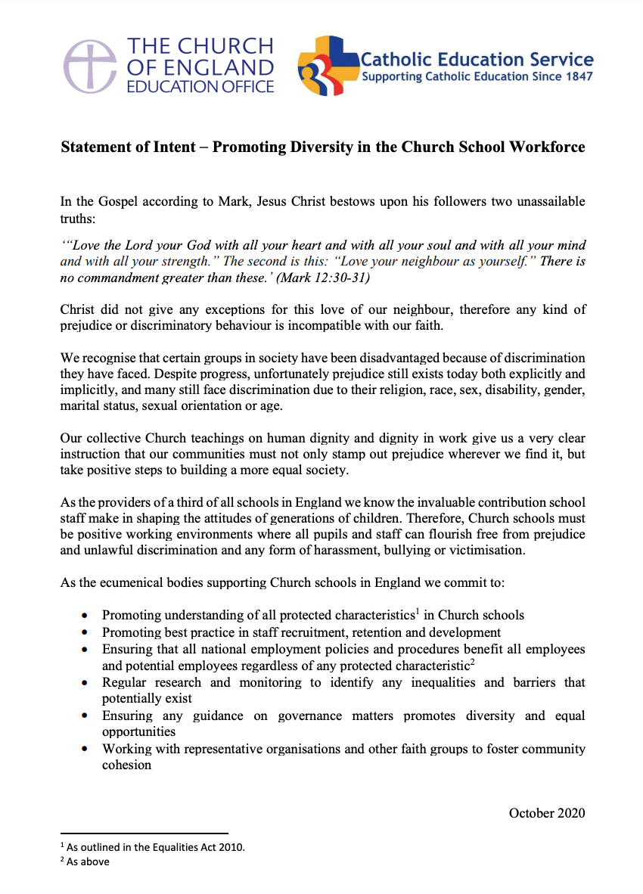

1 - CONTEXT

1.1 Responsibility for Equality cannot be delegated and all staff of HFCMAT must exercise due regard in their day to day operations. The Trust’s commitment to the identification and removal of barriers to success for all is based on the following core values and ethos expressed in our vision statement which can be viewed on our website – www.hfcmat.com

1.2 The Equality Act 2010 (which came into force on April 5th 2011) has replaced and unified all existing equality legislation such as the Race Relations Act, Disability Discrimination Act and Sex Discrimination Act. It aims to ensure that people have equality of opportunity in accessing and experiencing public service. The Act provides a single, consolidated source of discrimination law, covering all the types of discrimination that are unlawful and it extends the protection from discrimination in certain areas.

1.3 Equality of opportunity at HFCMAT is about providing equality and excellence for all in order to promote the highest possible standards of achievement. Equality of opportunity applies to all members of the school community – pupils, staff, governors, parents, directors and local community members.

1.4 The Accessibility Plan is fully consistent with the school’s SEN policies and SEN legislation. It should also be applied consistently within other school and Trust policies.

Public Sector Equality Duty (PSED)

1.5 The General Public Sector Duty of the Equality Act 2010 requires schools, in the exercise of their functions and decisions, to have due regard to the need to:
- Eliminate discrimination, harassment and victimisation and other conduct prohibited under the Act.
- Advance equality of opportunity between persons who share a relevant protected characteristic and persons who do not share it.
- Foster good relations between persons who share a relevant protected characteristic and persons who do not share it.

1.6 The specific duties of the PSED states that academies are required to:
- Publish information to demonstrate compliance with the PSED annually.
- Prepare and publish equality objectives at least every four years.

2 AIMS

2.1 We aim to promote equality of opportunity and good relations across all aspects of school life. We do this by:

- creating an ethos in which pupils and staff feel valued and secure;
- building self-esteem and confidence in our pupils, so they can use these qualities to achieve their full potential and become rounded citizens of the wider community;
- having consistent expectations of the pupils and their learning;
- removing or minimising barriers to learning, so that all pupils can achieve;
- ensuring that our teaching takes into account the learning needs of all pupils through our curriculum and lesson planning;
- actively tackling discrimination and promoting equality through our curriculum;
- making clear to our pupils what constitutes aggressive and discriminatory behaviour;
- ensuring school resources reflect society as a whole;
- having clear procedures for dealing with discriminatory incidents and that these are understood by all; and
- ensuring all pupils develop mutual respect through our school’s ethos, teachings and adult example.

2.2 These aims are designed to ensure that our schools meet their own needs and those of their communities, taking account the nine protected characteristics; race, disability, sex, age, religion or belief, sexual orientation, pregnancy and maternity, marriage and civil partnerships and gender reassignment. The philosophy of HFCMAT is based on inclusive principles which strive to promote equality. Equality of opportunity at HFCMAT is about providing equal access and excellence for all in order to promote the highest possible standards of achievement.

3 RESPONSIBILITIES

3.1 The Trust isresponsible for:
- Ensuring every school within the Trust complies with equality-related legislation.
- Ensuring the policy and its procedures are implemented.
- Ensuring all other school policies promote equality.
- Giving due regard to the Public Sector Equality Duty when making decisions.

3.2 The Headteacher is responsible for:
- Implementing the policy and its related procedures.
- Making all staff aware of their responsibilities and providing training as appropriate to enable them to effectively deliver this policy.
- Taking appropriate action in any case of actual or potential discrimination.
- Ensuring that all staff understand their duties regarding recruitment and providing reasonable adjustments to staff.
- Ensure that all staff and students are aware of the process for reporting and following up bullying and prejudice-related incidents.

3.3 All staff are responsible for:
- Enacting this policy, its commitments and procedures, and their responsibilities associated with this policy.
- Dealing with bullying and discriminatory incidents, and knowing how to identify and challenge prejudice and stereotyping.
- Promoting equality and good relations and not discriminating on any grounds.
- Attending such training and information opportunities as necessary to enact this policy and keep up to date with equality legislation.

4. FORMS OF DISCRIMMINATION

Discrimination by or against an employee is generally prohibited unless there is a specific legal exemption. Discrimination may be direct or indirect and it may occur intentionally or unintentionally.

Direct discrimination occurs where someone is treated less favourably because of one or more of the protected characteristics outlined in Appendix A. For example, rejecting an applicant on the grounds of their race because they would not “fit in” would be direct discrimination.

Indirect discrimination occurs where someone is disadvantaged by an unjustified provision, criterion or practice that also puts other people with the same protected characteristic at a particular disadvantage. For example, a requirement to work full time puts women at a particular disadvantage because they generally have greater childcare commitments than men. Such a requirement will need to be objectively justified.

Harassment related to any of the protected characteristics is prohibited. Harassment is unwanted conduct that has the purpose or effect of violating someone's dignity, or creating an intimidating, hostile, degrading, humiliating or offensive environment for them.

Victimisation is also prohibited. This is less favourable treatment of someone who has complained or given information about discrimination or harassment, or supported someone else's complaint.

5 LEADERSHIP AND MANAGEMENT

5.1 School and Trust policies reflect a commitment to equality.

5.2 Governing bodies and school leadership teams set a clear ethos that reflect our school’s commitment to equality for all members of the school community.

5.3 St. Joseph's and the Trust promote positive approaches to valuing and respecting diversity.

5.4 The school leadership team will work in partnership with others to promote equality of opportunity and oppose all forms of oppressive behaviour, prejudice and discrimination.

5.5 Directors, Governors and Staff contribute to policy documents. Parents can request to see policies and have their views noted. Regular feedback is obtained from a range of stakeholders including:

- School councils, PSHE lessons and student voice surveys;
- Staff surveys, meetings and INSET
- EHCP, IHCP and regular SEND review meetings
- PTA, parents’ evenings and meetings
- Governing body meetings

6 STAFFING, RECRUITMENT AND PROFESSIONAL DEVELOPMENT

6.1 St. Joseph's adheres to recruitment and selection procedures that are fair, equal and in line with statutory duties and guidelines.

6.2 All those involved in recruitment and selection are trained and aware of what they should do to avoid discrimination and ensure equality good practice through the recruitment and selection process.

6.3 Equality policy and practice will be covered in all staff inductions.

6.4 All temporary staff are made aware of equality policy and practice.

6.5 Employment policy and procedures are reviewed regularly to check conformity with legislation and impact.

6.6 Staff training needs and associated development opportunities will be identified through regular staff appraisals, in line with the school’s Teacher Appraisal Policy and Support Staff Performance Management Policy. All staff will be given appropriate access to training to enable them to progress within the organisation and all promotion decisions will be made based on merit. The trust will adopt good practice in terms of data collection and use this data to monitor and measure the attraction, recruitment, retention and progression of staff.

7 CURRICULUM

7.1 Curriculum planning takes account of the ethnicity, backgrounds and needs of all pupils. The curriculum builds on pupils’ starting points and is differentiated where appropriate to ensure the inclusion of all pupils.

7.2 St. Joseph's monitors and evaluates its effectiveness in providing an appropriate curriculum for all pupils.

7.3 Extra-curricular activities and special events cater for the interests and capabilities of all pupils.

7.4 Teachers ensure that the classroom is an inclusive environment.

8. DISABILITY & DISCRIMINATION

8. 1 The school will encourage staff who are disabled or become disabled to inform the headteacher or their line manager about their condition so that the school can support them as appropriate.

8. 2 Staff experiencing difficulties at work because of their disability (physical or otherwise) may wish to contact their line manager or Operations Manager to discuss any reasonable adjustments that would help overcome or minimise the difficulty. Their line manager or HR may wish to consult with the staff member and a medical adviser about possible adjustments.

8. 3 The governing board will monitor the physical environment of the school premises to consider whether certain features place physically disabled staff, job applicants, service users, or other stakeholders at a substantial disadvantage compared to others. Where reasonable, the school will take steps to improve access for disabled staff and service users.

9 BREACHES

9.1 If a member of staff believes that they may have been discriminated against, they will be encouraged to raise the matter through the school’s Grievance Policy. If they believe that they may have been subject to harassment, they will be encouraged to raise the matter with their line manager.

9.2 Allegations regarding potential breaches of this policy will be treated in confidence and investigated in accordance with the relevant procedure. Staff who make such allegations in good faith will not be victimised or treated less favourably as a result. False allegations which are found to have been made in bad faith will, however, be dealt with under our Disciplinary Policy and Procedure.

9.3 Any member of staff who is found to have committed an act of discrimination or harassment will be subject to disciplinary action. Such behaviour may constitute gross misconduct and, as such, may result in summary dismissal. The school takes a strict approach to serious breaches of this policy.

10 MONITORING AND REVIEW

10.1 The Equality Information Advice and Guidance Policy will be reviewed every 2 years.

10.2 Progress towards the Action Plan will be reviewed as part of each school’s annual evaluation of its Improvement Plan.

10.3 The results of that evaluation will be reported to the Governors’ via the Head’s report.

10.4 Evidence for the evaluation will include: actions taken; resources deployed; scrutiny of school communication systems; lesson observations; and a judgement of the impact on teaching and learning. Student/parent/staff and governor voice will be employed as appropriate.

10.5 Each school’s plan is coordinated by the SLT, although other lead staff are identified in the plan.

10.6 School-specific Contextual Notes or Procedures are located on our individual school websites.

Annexe A

EQUALITY OBJECTIVES - Published online at
http://www.stjosephscatholicprimarybirkenhead.co.uk/equality

Every 2 years St. Joseph's will set specific equality targets to improve the provision set out within this policy.

Each individual school within HFCMAT is responsible for producing, implementing and monitoring an Action Plan to address equality objectives. Action Plans are a fundamental part of the Policy. Although an integral part of the Policy, the Action Plans are standalone documents and will change regularly as progress is made on the identified actions and new actions are identified.

Action Plans will link with school improvement, curriculum reviews and annual self-assessment. Whilst the Policy sets out the vision, the Action Plans translate that vision into actions targeted to achieve equality outcomes. The Action Plans detail the actions which will be taken to make the commitments in the Policy a reality.

Annexe B

St. Joseph's Accessibility plan

Published online at

http://www.stjosephscatholicprimarybirkenhead.co.uk/equality

