St Joseph’s Catholic Primary School

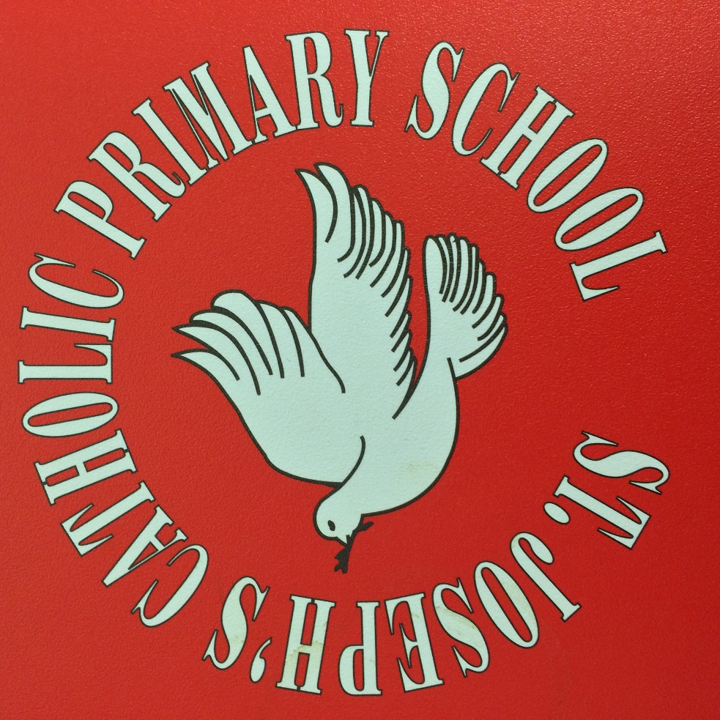

Early Years Foundation Stage (EYFS) F1
Welcome booklet for Parents and Guardians
Our Vision:

“Just like St Joseph the Worker…. Stepping up to achieve excellence”
Worship Opportunity Resilience Knowledge Enjoyment Respect

Excellence
The Quality of being Outstanding or extremely good. From the Latin: Excellentia meaning ‘surpass.’
“ “We are what we repeatedly do. Excellence, then, is not an act, but a habit.” Aristotle

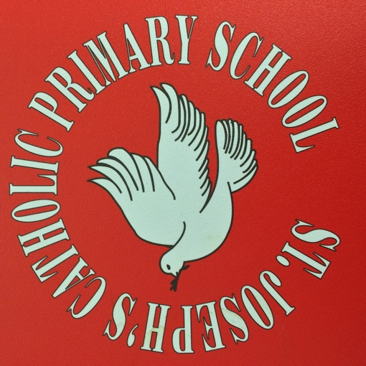
Our Mission:

“Love One Another” John 15:12

Welcome from the Headteacher
On behalf of everybody at St. Joseph’s I would like to extend to you a very warm welcome and thank you for choosing our school. You have chosen to give us your most precious gift; your child. You have placed their learning, development and growth in our hands and this is not a task we take lightly.
At St Joseph’s, everything we do is rooted in our Catholic beliefs; at our heart is our Mission to live the words of Jesus – ‘To Love One Another’. Our school is a place where faith, values, learning and creativity come together as one. Our Vision is set by following the example given by our Patron Saint – Saint Joseph. ‘Stepping up to achieve excellence’. In order to live this vision, we expect excellence from all – staff, governors, parents and children. We are passionate about learning and opportunities and want to give the best possible experience to our children and families. Our core values – Worship, Opportunity, Resilience, Knowledge, Enjoyment, Respect, permeate all we do.
As you start your child’s journey in full time education we want to present this booklet as a way to share some of the details of the path ahead. Please do take the time to read through it, but if there is anything else you would like to know please do contact us and we will be glad to help. We look forward to getting to know your child, and you, as our school family grows together.
Yours
Mr A. Turner
Headteacher

Welcome from the Early Years Team

We would like to wish you a very warm welcome to the Foundation Provision at St Joseph’s Catholic Primary School.

We hope that your children are looking forward to beginning a happy and interesting time at St Joseph’s Catholic Primary School.

The Foundation Stage is a special phase of school life; a time of transition from home to school. During the Foundation 1 Year the children will build on the major steps they have already made at home and other settings.

The Foundation classrooms and outdoor areas reflects the belief that children learn best in a stimulating but structured environment, with a homely atmosphere, in which they can feel secure.

The Foundation unit prides itself on strong home school links.

A strong partnership between school and parents is essential to the development of your child. We are teaching your child how to get along with others, to speak clearly, to listen carefully, to read, to write and to understand numbers and lots more. With your support your children will thrive, enjoy and make great developments during their time in Foundation.

We look forward to getting to know them!

Mrs Lester, (Key Stage Lead) and all in The Early Years Team

The Principles of the Foundation Stage

Much emphasis is given to the Personal, Social and Emotional Development, particularly during the first term. Children need to feel happy, safe, secure and valued to ensure progress in all areas of learning. Priority is given to forming good relationships with peers and adults, discovering their new setting and settling into routines.

Activities are based upon what children already know. Building upon these foundations established through careful, early and continual assessment ensures success.

Once children have developed a strong self-confidence their learning rapidly progresses and they will be stretched and challenged appropriately.

Activities are practical, hands on and most importantly, fun.

There will be a variety of structured play activities to choose from as well as focused ‘work’ led by adults.
Children are encouraged to make their own choices and decisions and to initiate their own activities, developing into creative, independent learners.
They are given time to become engrossed in activities which interest them and opportunities to move on when ready.
As their concentration span develops they will be encouraged to spend more time at a single, focused activity.

We will make observations of your child using the app ‘Tapestry.’ This app allows us to take photos of your child during activities and we will makes notes about about their progress. These will be sent to you via email at regular intervals during the school year. You can also send us observations back to help inform our judgements.

The Early Years Foundation Stage F1 at St Joseph’s

Welcome to the Early Years Foundation Stage (EYFS) F1. We follow ‘Develoment Matters,’ which is aimed at all settings educating children from birth to 5 years. It is the pre-curser to the National Curriculum but is a really important framework in its own right as this is a critical stage of development for children. It ensures that children move through braod ages and stages, and they are ready for F2.

The EYFS Framework explains how and what your child will be learning to support their healthy development.

Your child will be learning skills, acquiring new knowledge and demonstrating their understanding through 7 areas of learning and development.

Children should mostly develop the 3 prime areas first. These are:
- Communication and language.
- Physical development
- Personal, social and emotional development

These prime areas are those most essential for your child’s healthy development and future learning. As children grow, the prime areas will help them to develop skills in 4 specific areas. These are:
- Literacy;
- Mathematics;
- Understanding the world; and
- Expressive arts and design.

All of those areas of learning are connected together. The charateristics of effective teaching and learning weave through them all. That’s because chidren in the Early Years are becoming more powerful learners and thinkers. These characteristics develop as they learn to do new things, acquire new skills, develop socially and emotionally, and become better communicators.

These 7 areas are used to plan your child’s learning and activities. The professionals teaching and supporting your child will make sure that the activities are suited to your child’s unique needs. This is a little bit like a curriculum in primary and secondary schools, but it's suitable for very young children, and it's designed to be really flexible so that staff can follow your child's unique needs and interests.

Children in the EYFS learn by playing and exploring, being active, and through creative and critical thinking which takes place both indoors and outside.

1.Communication & Language.
Children will be supported to communicate with each other effectively. They will be provided with the opportunity and encouragement to use the skills of speaking and listening in a range of situations and for a range of purposes. They will be supported in developing the confidence and disposition to do so.

We are retelling the story of Buster’s Zoo . What are we learning?
We are playing cooperatively as part of a group to act out a narrative.
We are recalling stories.
We are using our imagination and extending our vocabulary.

- Physical Development.
The physical development of our young children will be encouraged through the provision of opportunities for them to be active, interactive and improve their skills of coordination, control, manipulation and movement. They will be supported in using all their senses to learn about the world around them and make connections between new information and what they know already. They will be supported in developing their understanding of the importance of physical activity and making healthy choices in relation to food.
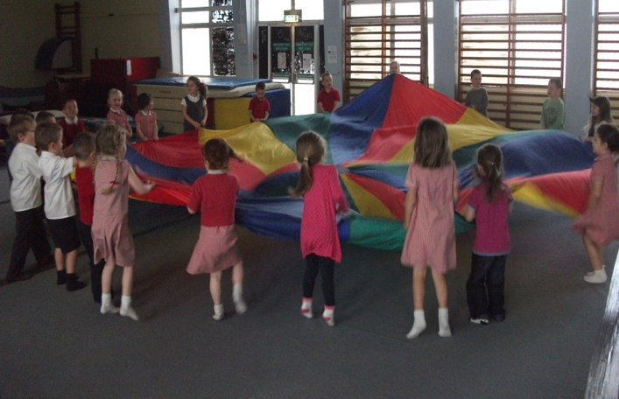

We love to be active in our play. How does this help us to learn?
We are learning to co-ordinate our bodies.
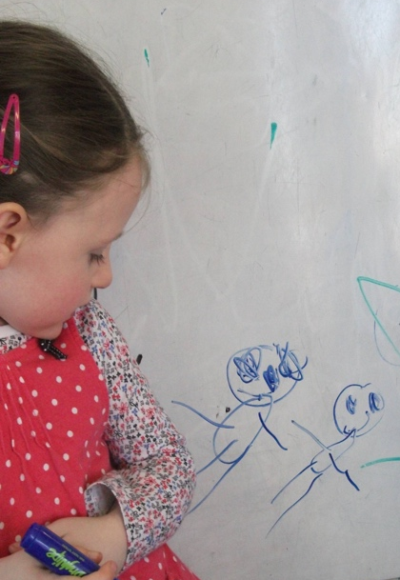
I am drawing a picture of Mummy and Daddy. What am I learning?
I am developing my pencil control.
I am using the pencil to form recognisable shapes.

- Personal Social and Emotional Development
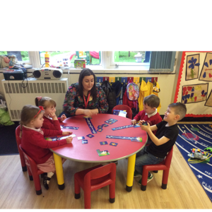
Children will be provided with experiences and support which will help them to develop a positive sense of themselves and of others. They will learn to have respect for others, develop social skills and have a positive disposition to learn. We will strive to ensure support for children’s emotional well- being, to help them to know themselves and what they can do.

I am playing a game with friends. What am I learning to do?
I am learning to take turns.
I am listening to my friends.
I am responding to my friends

- Literacy
Children will develop a love of songs, stories and rhymes. Children will be working with sounds and experimenting with rhyming strings. They will work on reading simple words and sentences.
Children will be encouraged to develop a love of books, enjoying an increasing range of books, listening and recalling stories and showing an interest in illustrations. Whilst developing their pencil control they will distinguish between the different marks they make and give meaning to marks they see in different places.
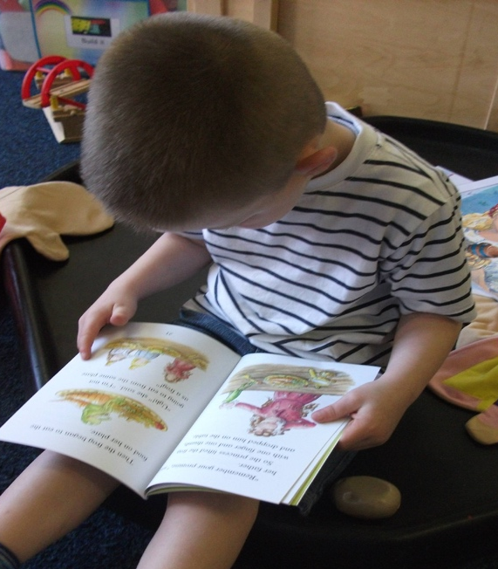

I have chosen a book to read and look at. What am I learning?
I am learning that books are fun.
I am learning that print conveys meaning.
I am building up a knowledge of different stories.
I am extending my knowledge of events I cannot experience first hand.
I am talking about the pictures and what they are telling me about the story.
I am holding a book correctly, turning the pages and taking care of books.

- Mathematics.
Children will be supported in developing their understanding of problem solving, reasoning and numeracy in a broad range of contexts in which they can explore, enjoy, learn, practice and talk about their developing understanding. They will be provided with opportunities to practice these skills and gain confidence and competence in their use.
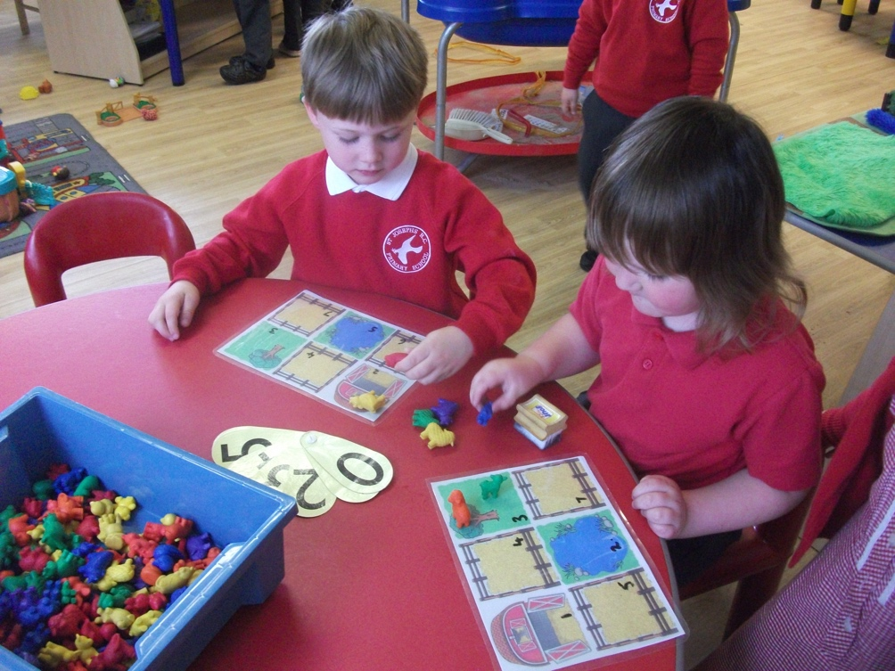

We are counting and sorting the animals into groups.
We are looking for numbers to represent how many we have counted
We are beginning to recognise some numbers.

Understanding of the world
Children will be supported in developing the knowledge, skills and understanding that help them make sense of the world. Their learning will be supported through offering opportunities for them to use a range of tools safely. They will encounter creatures, plants and objects in their natural environments and in real life situations. They will undertake practical experiments and work with a range of materials.
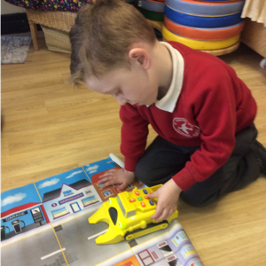

I am using a programmable toy. What am I learning?
I am learning about direction.
I had to listen, watch and remember instructions on how to use the toy, before using it myself.
I am learning how to use a selection of programmable toys including computers and CD players.

- Expressive arts and design.
Children’s creativity will be extended by the provision of support for their curiosity, exploration and play. They will be provided with opportunities to explore and share their thoughts, ideas and feelings through a variety of art, music, movement, dance, imaginative and role-play activities.

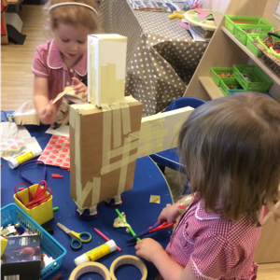
I am making a junk model alien. What am I learning?
I am learning about shapes.
I am discovering the properties of materials.
I am handling tools and materials safely and with increasing control.

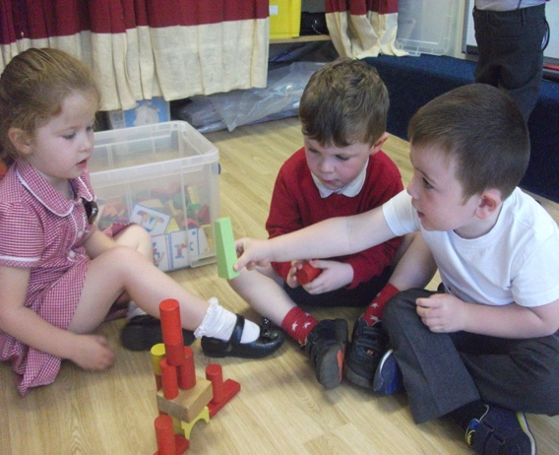

We are building blocks of towers. What are we learning?
We are learning about designing and making structures.
We are exploring concepts of strength and balance.
We are learning to count 1:1 and compare values with our friends.
We are setting ourselves a challenge… and learning to deal with failure too!

Outdoor Classroom

Here children can enjoy the physical freedom of a large, secure outdoor area where they can engage in imaginative role play, use a variety of wheeled toys and large construction sets as well as play with sand and water. The children are able to make choices for independent play either inside or out. Gardening is also a popular activity and we will continue to grow our own vegetables and flowers throughout the school year.

The Way, the Truth and The Life

Religious education is an important part of our life at St Joseph’s Catholic School. We follow the scheme of work The Way, the Truth and the Life. This is followed from Foundation 1 all the way through to Year 6, covering a range of topics each half term. The children will learn about Jesus, his life and how they can be like him.

Your Child and the Early Years Foundation Stage.

The Learning Journey
Learning is a continuous journey through which children build on all the things they have already experienced. As they continue their journey they will come across new and interesting challenges.

The Unique Child
Every child’s learning journey takes a personal path based on their own individual experiences and the curriculum on offer.

Parents as partners
Parents are the children’s first and most enduring educators. When parents and practitioners work together in the early years settings, the results have a positive impact on children’s development and learning.

Key Persons
At St Joseph’s in the Foundation classes there will be key people that will work and play alongside your child. These people will get to know your child as an individual giving them reassurance to feel safe and cared for. Good relationships are fostered between home and school.

Observation and Assessment.
Ongoing observation and assessment is an integral part of the learning and development process. We observe the children in everyday activities to make reliable judgments about each child’s skills, knowledge, understanding and behavior that they demonstrate consistently and independently. We use a program called Tapestry to do this. This enables us to e-mail the observations to your home at regular intervals throughout the year. It also enables you to also make observations and send them back to us in school.
Effective assessment takes account of all aspects of a child’s development and learning. Parents and carers are encouraged to be actively involved.

We will ask for your email address as part of the requested information.

Curriculum Information
Our website contains an overview of the curriculum during the year for parents which explains the predictable themes and some of the skills and knowledge that will be introduced to the children.

Planning
Although there are many predictable themes and celebrations throughout the year we take into account the current needs and interests of the children.

Learning throughout the day

Continuous Provision
Our EYFS is set up using a ‘Continuous Provision’ model. This means that activities are set up and left out by the staff, and the children are free to engage with the different areas. Staff will also participate in the activities, observing and extending the children’s learning. Throughout the day, there are also teacher directed group or whole class sessions:

Funky Fingers
Daily fine and gross motor activities, done to music, which aims to develop the manual dexterity needed as a basis for class room tasks such as using scissors, manipulation of materials and the correct grip for using pencils, pens, paint brushes, etc.

Daily Circle Time/ group focus sessions
In our school, Phonics is taught through the program ‘Read, Write, Inc’. This early knowledge of letters and the corresponding sounds they make will set the foundations for independent reading. We will begin to encourage reading for pleasure as well as teaching to recognise and decode words. We aim to increase the frequency of reading sessions and ask you to help this by ensuring reading is an integral part of your home routines – parents reading to children and asking children to read words back.

We will also be building up their letter formation and writing.
Vocabulary is also really important so we will name and label things and encourage the children to speak in full, descriptive sentences.

The children will also have daily maths focus sessions where we will be developing early understanding of numbers and quantities.

These sessions will be in small groups and include number songs, activities and games .

Physical Education time
Regular sessions will involve music and movement activities, drama and ring games.

Stories, songs or rhymes
Stories will be read daily as an essential part of their routine. Songs and rhymes will be an essential part of the curriculum.

Art and design and creativity
The children have lots of opportunities to develop their creativity through art, design, craft and role play

The EYFS Arrangements

The EYFS unit has its own entrance and exit. This is accessed from Fairview Road.

Morning

Doors open at 8.45am. The children will line up in the garden area, and they will walk into school with their teacher/ TA at 8.50am. Please ensure you are punctual as learning starts promptly.

While we understand you might have messages you need to relay to us, so the TA’s are available at 8.45 to speak to you. If you miss this opportunity, we ask that you are as brief as possible, or ideally write us a note and hand it to us. The problem is we can be delayed getting the children in to start their day. We are more than happy to arrange a time to meet if there is something you do need to discuss, and at the end of the school day we are not as limited for time so are happy to talk then.

The end of the day/session

The timings for the end of the session depend on whether your child attends for 15 hours per week or 30 hours per week.

15 hours
If your child attends nursery for 15 hours, this is counted as ‘universal hours’ and is funded for all children aged 3 – 5. The hours are spread Monday – Friday term time only and the session ends at 11.50am. Please come to the EYFS entrance at 11.50am and your child will be brought out to you.

30 hours
The Government launched a scheme for eligible parents to take up an offer of 30 hours provision. This is made up of the 15 hours Universal hours + an additional 15 hours. The hours are spread Monday – Friday term time only and the session ends at 3.20pm

In order to claim the Government funding, parents are required to use the following link, complete their details and generate a code. This code needs to be provided to school office and a new code is needed every 3 months. More information including eligibity criteria and the link is found here:

www.childcarechoices.gov.uk

If you would like to take the 30 hours funded, we require the full entitlement, although you are free to then use the provision on a flexable basis – e.g. only use full days a few times per week.

If you are not eligible for funded 30 hours, but would like to have your child attend full time, you can pay us directly for the provision.This is charged at £10 per day (remember the morning is the universal 15 hours, so essentially you are paying for the afternoon).

We ask that you let us know in advance whch days you require full days, and ask that payments are made in advance.

Please speak to the office team to book days and make payments.

It is very important you complete the contact information sheet and hand it into the school office, including arrangements for who will be collecting your child.

If you find you are late dropping off or picking up please report to the main office.

Registration and Welcome

Your child will be helped by a member of staff to hang their coat up and find their name card on or near the door. We will quickly develop their independence.

Snack and drinks

Children can have their snack at any time during the day. This consists of a piece of fruit supplied by school and a drink of milk or water. Water is available throughout the day and your child can bring their own water bottle in (Please label the bottle). We also sell water bottles in the school office.

Milk is provided as an option, and is free until your child turns 5. Please note once your child turns 5 years old they are no longer entitled to free milk and you have to pay for it by registering on the cool milk website…www.coolmilk.com

Please make sure you have completed the contact form detailing any allergies and ensure this is updated as required.

Lunch

For F1 children who attend for a full day and have lunch, there are two options for lunch
- You may provide a packed lunch for your child. We do ask that you support us with our healthy eating policy and ensure packed lunches are balanced.
- You can pay for a school meal. The daily cost is £2 and includes a meal option, a cake or biscuit and a drink.
The menu options can be viewed on our website lunch page http://www.stjosephscatholicprimarybirkenhead.co.uk/lunch

We use an app/website called “Parent Pay” across the school – this allows you to make payments for trips, events etc. You can use the site to purchase a school lunch for F1 children (and once your child is in Y3, pay for a school meal). Using the site also allows you to pre order your child’s lunch selection. This can be done a week in advance, the night before, or the same morning up to 8.00am.

We ask all parents to use the site to pre order lunch options as this ensures that we are able to provide your child with their first choice, as well as eliminate waste. You will be provided with a unique code in the first week of school and we ask that you then set up your own Parent Pay account.

Older children in F2, Year 1 and Year 2 are provided with a free school meal under the Government’s Universal Infant Free School Meal system. Some F1 children may be eligible for a Free Meal under the Early Years Pupil Premium scheme. Please use the link below.

Please can we also highlight that we ask all parents to complete the Free School Meals registration form by following https://www.cloudforedu.org.uk/ofsm/sims If eligible, this ensures your child continues to receive a free school meal once they are in Key Stage 2 (Years 3,4,5,6) as well as provides the school with additional funding to help support your child.

SCHOOL UNIFORM

We encourage all children in St Joseph’s to wear their school uniform with pride. We extend this to F1, but are equally aware of the practacalities of dressing such young children.
Our uniform for EYFS is designed to be easy to put on and remove - this is to help the children develop their independence by starting to dress themselves in the morning etc.

Therefore the uniform for F1 consists of
- Black trousers/shorts/skirt
- Red or white polo shirt with or without school badge
- Red sweatshirt/cardigan with or without school badge
- Comfortable slip on/Velcro dark shoes

Please ensure your child is comfortable and avoid any clothing which is difficult for young children to manage independently e.g. belts can be quite difficult for children when going to the toilet

PLEASE LABEL ALL ITEMS WITH YOUR CHILD’S NAME.

We ask that you support our school uniform policy from the beginnings of EYFS and are aware of the different uniforms for various key stages (all uinform information can be found on our website).

On one day each week your child will do PE. Please send your child into school in their PE kit. We will inform you what day it will be when your child starts.

Polo shirts, jumpers, cardigans, and t-shirts are available to buy at THE UNIFORM SHOP in Birkenhead. You can order these via their website www.wirraluniforms.com They operate a click and collect service so you can avoid the queues.

Tesco also hold our school badge to embroid on items

All uniform details can be found on our website
http://www.stjosephscatholicprimarybirkenhead.co.uk/uniform

Jewellery

The children are permitted to wear a small watch. However, please be aware that it is advisable to not be expensive and we cannot be liable for damage or loss.

Please ensure headbands, hair clips or other hair items are kept small.

Small stud earrings may be worn. These must be removed for P.E. and physical session, so please ensure that either the children can remove them themselves, or they are not worn on P.E. days, or we can cover them with bandage tape.
EYFS can be very physical and we are often outdoors or sometimes will have a spontaneous game, so please do ensure earrings and all jewellery/head items are appropriate and safe

Home / School Partnership

Please complete and return your child’s ‘All About Me’ booklet. This can be downloaded from the Website. The ‘All About Me’ booklet helps us get to know your child and allows you and your child to tell us about their interests.

We hold Parent’s Evenings throughout the year to discuss how your child is getting on. The first meetings are usually in the first (Autumn) term. During this meeting we can talk about how your child is settling in to EYFS. We will then have another meeting in the second (Spring) term, followed by a written report in the third (Summer) term.
However you are always welcome to come in and discuss any problems or worries about your child or any circumstance which may affect them. Please speak to a member of EYFS staff or the school office to make an appointment.

Please also ensure you are set up on Tapestry so that we can send you updates and pictures about your child’s progress, as well as you sending us pictures of home learning and progress.

Practical ways to help

- Please label all items of clothing with your child’s full name.
- Help them become independent when they dress and undress by encouraging them to take off and put on their clothes unaided, and zip their coat up etc

- Please keep your child at home for 24 hours following an attack of sickness or diarrhea.
- Due to a small number of children with low immune systems, please inform school as soon as possible if your child contracts any contagious disease or illness, for example chicken pox, measles, mumps etc.

- Please notify school of any absences.
- Please inform EYFS staff if anyone different from usual will be collecting your child. And ensure the contact form held at the School Office is updated with any changes
- Please collect children promptly at the end of the session so they don’t become anxious or upset. If you are late, please try to get a message to the School Office
- Children enter EYFS through the gate on Fairview Road. Sometimes your will find equipment arranged in the garden for a later activity, please ensure the equipment is left undisturbed.
And Finally…

We hope that you have found this booklet informative and that it has answered many of the questions that you may have had. However, if you need clarification on anything at all please do not hesitate to contact us.

Our aim is to provide an environment in which your child can develop into a creative independent learner. Foundation 1 is the beginning of an exciting journey into education. We hope your child has a happy and interesting year and makes new friendships in their new school, where they will be excited and motivated by all the opportunities presented to them and become an active member of the family that is St Joseph’s Catholic Primary School. We hope that you will enjoy this journey with us.
The Foundation Team

