St Joseph’s Catholic Primary School

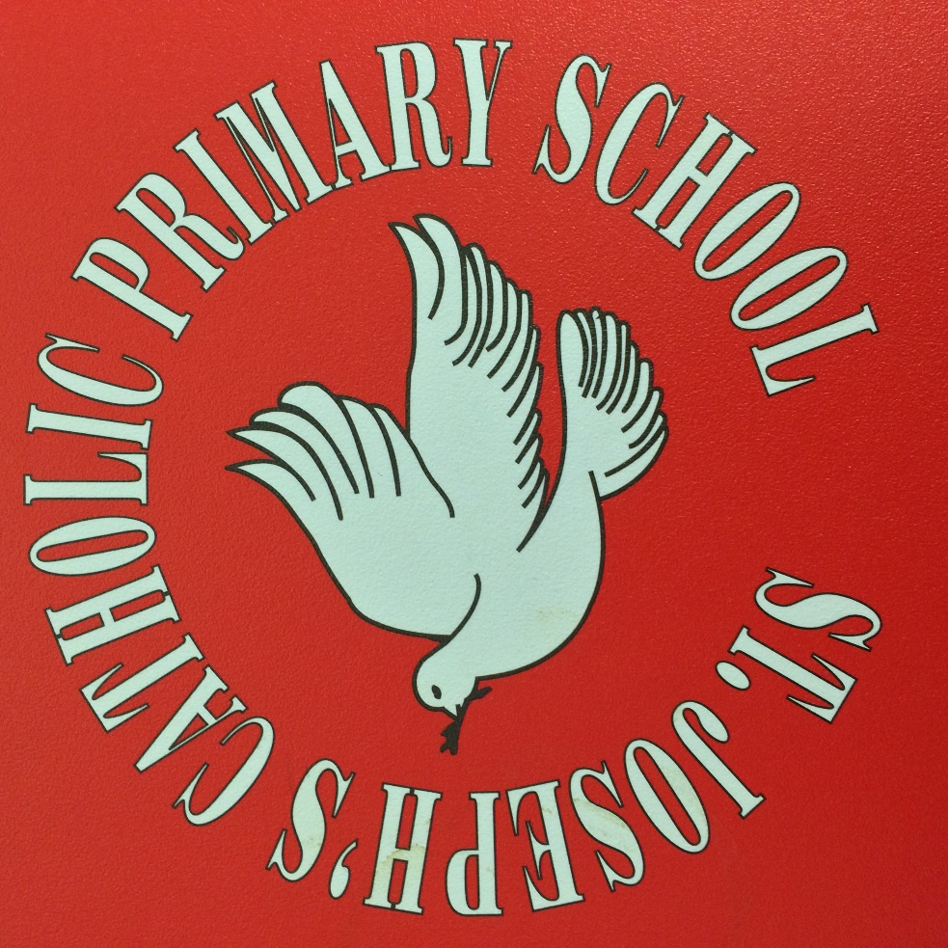

Early Years Foundation Stage (EYFS)
Welcome booklet for Parents and Guardians

Our Vision:

“Just like St Joseph the Worker…. Stepping up to achieve excellence”
Worship Opportunity Resilience Knowledge Enjoyment Respect

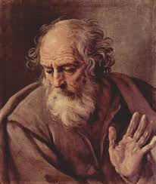

Excellence
The Quality of being Outstanding or extremely good. From the Latin: Excellentia meaning ‘surpass.’
“ “We are what we repeatedly do. Excellence, then, is not an act, but a habit.” Aristotle

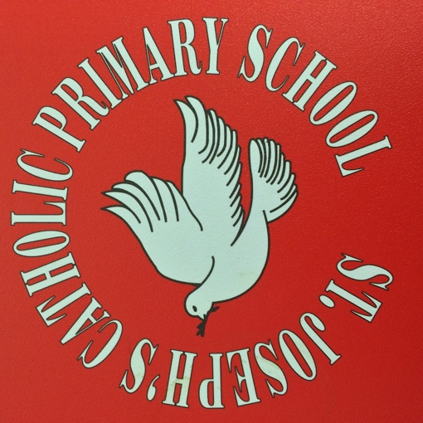
Our Mission:

“Love One Another” John 15:12

Welcome from the Headteacher
On behalf of everybody at St. Joseph's I would like to extend to you a very warm welcome and thank you for choosing our school. You have chosen to give us your most precious gift; your child. You have placed their learning, development and growth in our hands and this is not a task we take lightly.
At St Joseph’s, everything we do is rooted in our Catholic beliefs; at our heart is our Mission to live the words of Jesus - ‘To Love One Another’. Our school is a place where faith, values, learning and creativity come together as one. Our Vision is set by following the example given by our Patron Saint - Saint Joseph. ‘Stepping up to achieve excellence’. In order to live this vision, we expect excellence from all - staff, governors, parents and children. We are passionate about learning and opportunities and want to give the best possible experience to our children and families. Our core values - Worship, Opportunity, Resilience, Knowledge, Enjoyment, Respect, permeate all we do.
As you start your child’s journey in full time education we want to present this booklet as a way to share some of the details of the path ahead. Please do take the time to read through it, but if there is anything else you would like to know please do contact us and we will be glad to help. We look forward to getting to know your child, and you, as our school family grows together.
Yours
Mr A. Turner
Headteacher

Welcome from the Early Years Team

We would like to wish you a very warm welcome to the Foundation Provision at St Joseph’s Catholic Primary School.

We are looking forward to helping your child settle into their first full time year at school.

The Foundation Stage is a very special phase of school life; a time of transition from home to school and a time when your child experiences full days in school. During the Foundation Year(s) the children will build on the major steps they have already made at home and at a nursery.

The Foundation classrooms and outdoor areas reflect the belief that children learn best in a stimulating but structured environment, with a homely atmosphere, in which they can feel secure.

The Foundation unit prides itself on strong home school links. We use a program called Tapestry to make observations of your child inside the classroom and in the outdoor provision. These observations will be e-mailed regularly to you so you can see what your child is learning about and what they need to do next. You can also make observations of things they are able to do and send them to your child’s class teacher.

A strong partnership between school and parents is essential to the development of your child. We are teaching your child how to get along with others, to speak clearly, to listen carefully, to read, to write and to understand numbers and lots more. With your support your children will thrive and achieve their Early Learning Goals at the end of F2.

We look forward to getting to know them!

Mrs Lester, (Key Stage Lead) and all in The Early Years Team

The Early Years Foundation Stage Curriculum at St Joseph’s

Welcome to the Early Years Foundation Stage (EYFS). We follow the New EYFS framework (September 2021) which is aimed at all settings educating children from birth to 5 years. It is the pre-curser to the National Curriculum but is a really important framework in its own right as this is a critical stage of development for children. It ensures that children move through clearly defined ‘Ages and Stages’ towards ‘Early Learning Goals’ (ELGs) and successfully move onto Key Stage 1 having established firm foundations for their future learning.

The EYFS Framework explains how and what your child will be learning to support their healthy development.

Your child will be learning skills, acquiring new knowledge and demonstrating their understanding through 7 areas of learning and development.

Children should mostly develop the 3 prime areas first. These are:
- Communication and language.
- Personal, social and emotional development.
- Physical development.

These prime areas are those most essential for your child’s healthy development and future learning. As children grow, the prime areas will help them to develop skills in 4 specific areas. These are:
- Literacy;
- Mathematics;
- Understanding the world; and
- Expressive arts and design.

These 7 areas are used to plan your child’s learning and activities. The professionals teaching and supporting your child will make sure that the activities are suited to your child’s unique needs. This is a little bit like a curriculum in primary and secondary schools, but it's suitable for very young children, and it's designed to be really flexible so that staff can follow your child's unique needs and interests.

Children in the EYFS learn by playing and exploring, being active, and through creative and critical thinking which takes place both indoors and outside.

EYFS Framework Information for Parents.

The New EYFS framework has put communication and language at the heart of everything we do.
Communication and Language
- Communication and language proficiency underpins all other areas of learning, including mathematical and literacy learning. Language development involves giving children opportunities to experience a rich language environment; to develop their confidence and skills in expressing themselves; and to speak and listen in a range of situations. Children will be taught to hold conversations with their teacher and peers. This will involve back and forth exchanges. New vocabulary will be introduced from stories, non-fiction, rhymes and poems when appropriate.

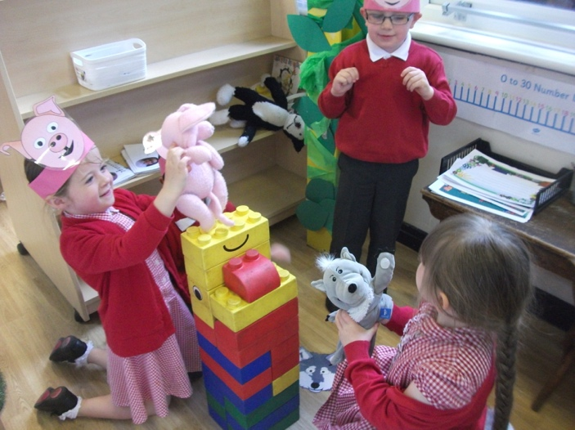

The children are re- telling the story of the 3 Little Pigs. They are listening to each other and responding to each other.
They are playing cooperatively as part of a group to act out a narrative. They are using their imagination and extending their vocabulary.

Physical Development.
• Physical development involves providing opportunities for young children to be active and interactive; and to develop their co-ordination, control, and movement. Children must also be helped to understand the importance of physical activity, and to make healthy choices in relation to food

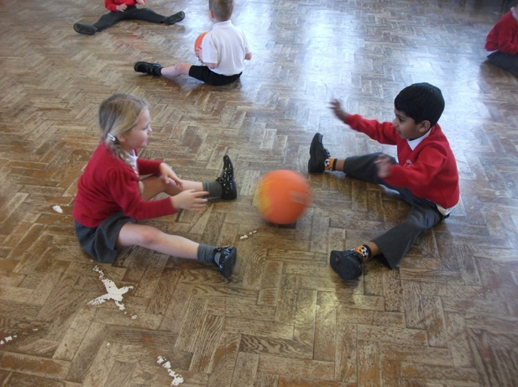

I am learning to show increasing control over an object in pushing and controlling the ball.
I am able to use simple tools to effect changes to materials.

Personal Social and Emotional Development

• Personal, social and emotional development involves helping children to develop a positive sense of themselves, and others; to form positive relationships and develop respect for others; to develop social skills and learn how to manage their feelings; to understand appropriate behaviour in groups; and to have confidence in their own abilities

.
Literacy – Comprehension, Word Reading and Writing.

The children will be taught to read by learning the initial sounds at the beginning of words. At St Joseph’s, we use a phonics scheme called ‘Read, Write, Inc’ to introduce sounds and texts containing those sounds. The children from Early Years through to Year 2 have a daily Read, Write, Inc session. They will learn how to segment the sounds in words and blend them together using ‘Fred talk’ (sounding out and then blending). They will enjoy an increasing range of books and they will use the new vocabulary learnt in their own conversations. They will demonstrate an understanding of what they have read and has been read to them by retelling stories and narratives using their own words and new vocabulary They will use clearly identifiable letters to communicate meaning, representing sounds correctly in a sequence. They will learn to write sentences using words which match their spoken sounds.
.
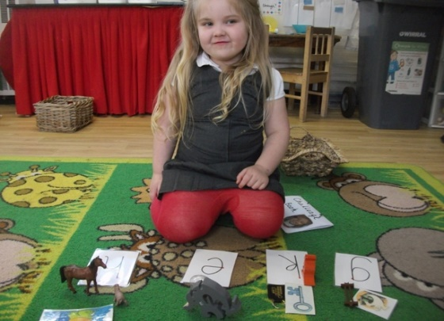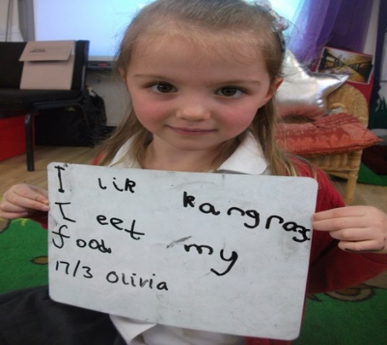

Mathematics – Numbers and numerical patterns.

Children will be supported in developing their understanding of problem solving, reasoning and numeracy in a broad range of contexts in which they can explore, enjoy, learn, practice and talk about their developing understanding. They will be provided with opportunities to practice these skills and gain confidence and competence in their use.
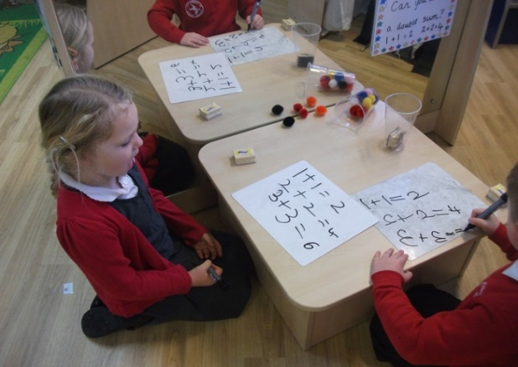
I can use 1p and 2p coins to make different amounts.
I can make doubles using the mirror. I can record my doubles sums in order.

Understanding of the World – Past and Present, People, Culture and Communities, The Natural World.

Children will be supported in learning about some similarities and differences between things in the past and now, drawing on their experiences and what has been read in class. They will learn how to describe their immediate environment using knowledge from observation, discussion, stories, non-fiction texts, and maps. They will explore the natural world around them, making observations and drawing pictures of animals/plants.
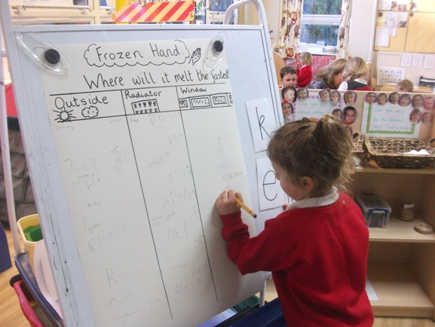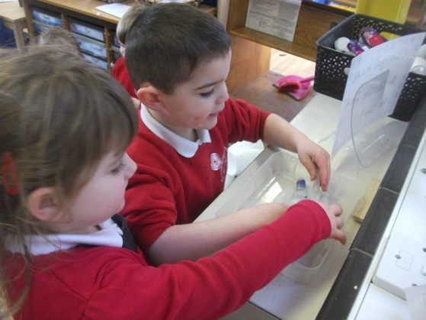
I am investigating where the ice hand will melt the fastest,
I am recording my prediction. I am feeling the ice hand to see if it has melted.

Expressive Arts and Design – Creating with materials and performing.

Children will draw and paint using a range of materials, tools and techniques, experimenting with colour, design, texture, form and function.
They will sing a range of well-known nursery rhymes and songs
- perform songs, rhymes, poems and stories with others, and – when appropriate – move in time with music

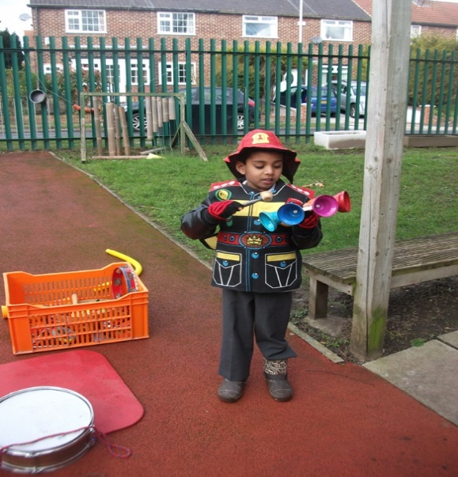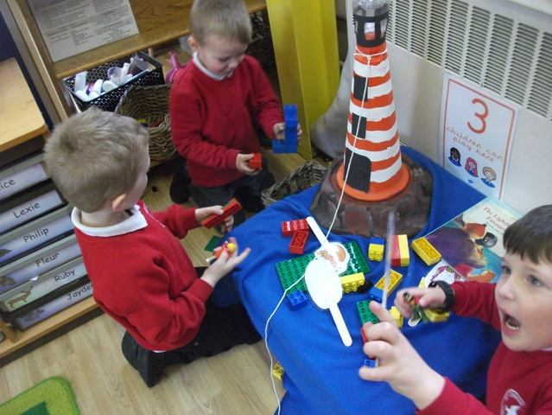
I am exploring the different sounds the instruments make.
I am playing co-operatively as part of a group to develop and act out a narrative.

The Way, The Truth and The Life

As a Catholic school, God is at the heart of all that we do. We follow the Diocesan Scheme called,’The Way, The Truth and The Life.’ We teach the children about Jesus’ life. They hear lots of stories about Jesus and learn how they can be like Jesus.

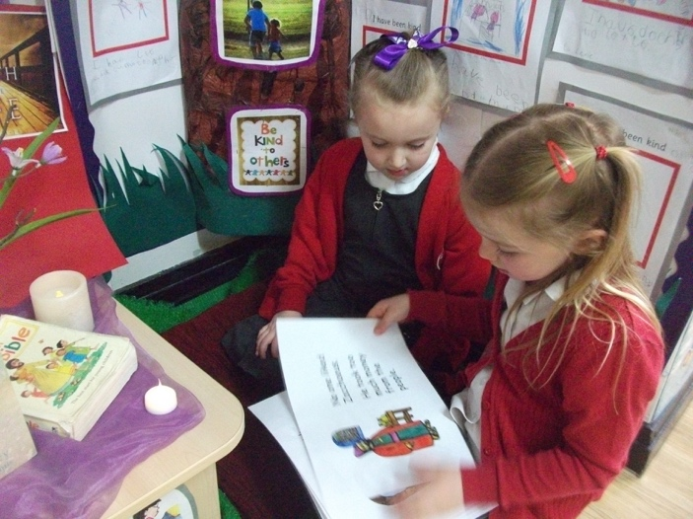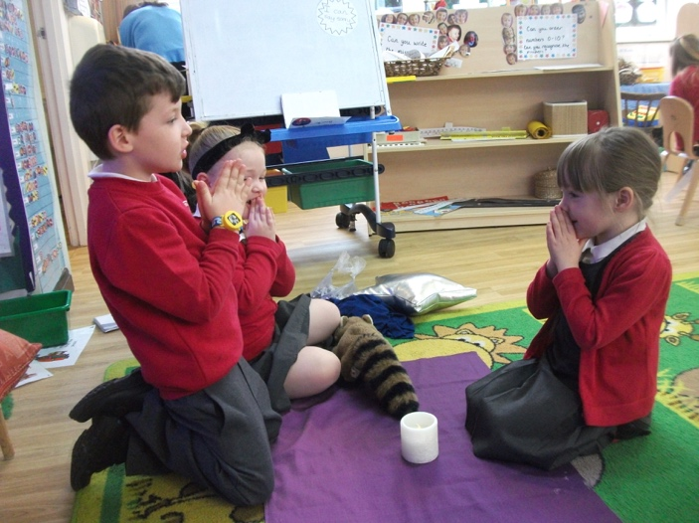
I am reading the story of Zaccahaus with my friend. I am having some time to talk to God.

Outdoor Classroom
Here children can enjoy the physical freedom of a large, secure outdoor area where they can take part in various different structured activities according to their needs including imaginative role play, large scale construction, sand and water.
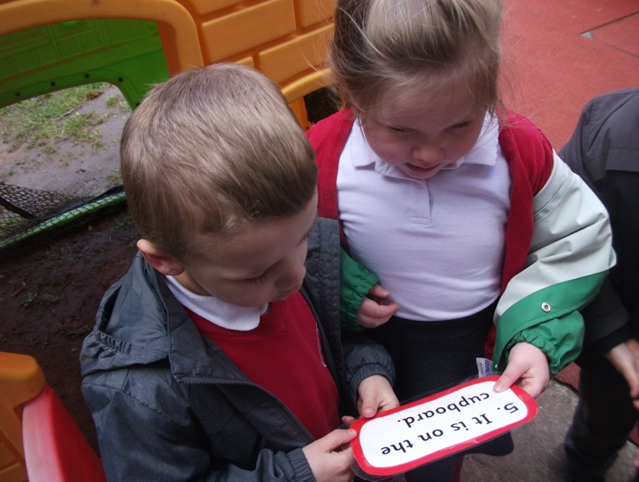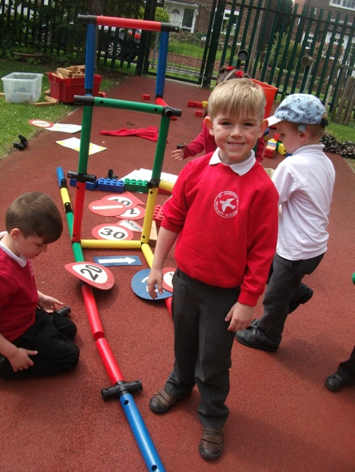

We aim for our outdoor activities to reflect all areas of the curriculum. The children are able to make choices for independent play either inside or out and move freely between the areas when it is their turn.
Learning throughout the day
Continuous Provision
Our EYFS is set up using a ‘Continuous Provision’ model. This means that activities are set up and left out by the staff, and the children are free to engage with the different areas. Staff will also participate in the activities, observing and extending the children’s learning. Throughout the day, there are also teacher directed group or whole class sessions:

Daily Phonics sessions.
Your child will be put into a smaller group for phonics. We follow the ‘Read, Write, Inc’ program. These activities will be available in class for the children to access independently. There will be a reading meeting in the first half term for parents to attend.

Daily Maths sessions.
Your child will be in a smaller group for number. These sessions will be practical and fun. The resources will also be available for the children to access independently.

Daily Literacy/ writing focus sessions.
Your child will have a structured daily teaching session following the Pathways literacy scheme.

Reading
Reading with your child is one of the most enjoyable and rewarding activities you can do. It is so important to make time to find a book and enjoy talking about the pictures and listening to the story. This is also when you can introduce new vocabulary to your child. This love of reading is essential when your child starts to read themselves and it is the perfect way to end the day before bedtime. Your child will be able to pick a book from the class library to share at home. They can change this book every morning if they wish to or keep it for up to 1 week. This book will be in the SHARED reading book bag.

When we feel your child is ready to read independently we will start them off with a school reading book. This book might be a single letter sound book, or a word book to blend the words, a ditty sheet with phrases to read or a reading book. Each book will have instructions inside the front cover about how to use it.
This book will be in the READING book bag.

P.E.
We have P.E. sessions in the hall or on the playground or the field. We teach the children gym, dance and games.
The children are required to wear their PE kits on their PE day.

The school PE kit is:
- a red polo shirt
- black shorts
- black pumps.

The timetabled sessions for P.E will be confirmed when your child starts.

Stories, songs or rhymes and circle time.
This is incorporated into each day. Again, we encourage you to share the ‘traditional’ stories, songs and rhymes with your child and get them to learn them ‘off by heart’. This knowledge base of tradition comes in very useful as they continue their oral and written story telling.

Your Child and the Early Years Foundation Stage.

The Learning Journey.
Learning is a continuous journey through which children build on all the things they have already experienced. As they continue their journey they will come across new and interesting challenges. You will be able to access key learning moments through our observations on Tapestry.

The Unique Child.
Every child’s learning journey takes a personal path based on their own individual experiences and the curriculum on offer.

Parents as partners
Parents are the children’s first and most enduring educators. When parents and practitioners work together in the Early Years settings, the results have a positive impact on children’s development and learning.

Key Persons.
At St Joseph’s in the Foundation classes there will be key people that will work and play alongside your child. These people will get to know your child as an individual, giving them reassurance to feel safe and cared for. Good relationships are fostered between home and school.

Observation and Assessment.
Ongoing observation and assessment is an integral part of the learning and development process. We observe the children in everyday activities to make reliable judgments about each child’s skills, knowledge, understanding and behavior that they demonstrate consistently and independently. We use a program called ‘Tapestry’ to do this. This enables us to e-mail the observations to your home at regular intervals throughout the year. It also enables you to also make observations and send them back to us in school.
Effective assessment takes account of all aspects of a child’s development and learning. Parents and carers are encouraged to be actively involved.

We will ask for your email address as part of the requested information.

Curriculum Information
Our website contains an overview of the curriculum during the year for parents which explains the predictable themes and some of the skills and knowledge that will be introduced to the children.

Planning
Although there are many predictable themes and celebrations throughout the year we take into account the current needs and interests of the children.

The Foundation Arrangements

There are two Foundation classes, with places for 30 children in each. Throughout the year we keep the classes fluid and move the children around. This is so that we can provide more targeted learning, as well as developing the early social skills as children get used to being around different children and constantly forming new relationships.

The EYFS unit has its own entrance and exit. This is accessed from Fairview Road.

Morning

Doors open at 8.45am. The children will line up in the garden area, and they will walk into school with their teacher/ TA at 8.50am. Please ensure you are punctual as learning starts promptly.

While we understand you might have messages you need to relay to us, so a TA will be available at 8.45 to take messages. If you miss this slot then please write a note or speak to the TA briefly on the gate. We are more than happy to arrange a time to meet if there is something you do need to discuss at the end of the school day. We are not as limited for time so are happy to talk then.

The end of the day

Doors open at 3:20pm. The children will be brought to the gate and handed over to you. It is very important you complete the contact information sheet and hand it into the school office, including arrangements for who will be collecting your child.

If you find you are late dropping off or picking up please report to the main office.

Registration and Welcome

Your child will be helped by a member of staff to hang their coat up and find their name card on or near the door. We will quickly develop their independence.

Snack and drinks

Children can have their snack at set times during the day. This consists of a piece of fruit supplied by school and a drink of milk or water. Water is available throughout the day and your child can bring their own water bottle in (Please label the bottle).

Milk is provided as an option, and is free until your child turns 5. Please note once your child turns 5 years old they are no longer entitled to free milk and you have to pay for it by registering on the cool milk website…www.coolmilk.com

Please make sure you have completed the contact form detailing any allergies and ensure this is updated as required.

Lunch

All children in infants (EYFS, Year 1 and Year 2) are entitled to a free school lunch under the Universal Infant Free School Meals Scheme (UIFSM). The menu options can be viewed on our website lunch page http://www.stjosephscatholicprimarybirkenhead.co.uk/lunch
Alternatively, you are free to provide your child with a packed lunch but we ask you to ensure a healthy and balanced diet is provided.

We use an app/website called “Parent Pay” across the school – this allows you to make payments for trips, events etc (and once your child is in Y3, pay for a school meal). Using the site also allows you to pre order your child’s lunch selection. This can be done a week in advance, the night before, or the same morning up to 8.00am.

We ask all parents to use the site to pre order lunch options as this ensures that we are able to provide your child with their first choice, as well as eliminate waste. You will be provided with a unique code in the first week of school and we ask that you then set up your own Parent Pay account.

Please can we also highlight that we ask all parents to complete the Free School Meals registration form by following https://www.cloudforedu.org.uk/ofsm/sims If eligible, this ensures your child continues to receive a free school meal once they are in Key Stage 2 (Years 3,4,5,6) as well as provides the school with additional funding to help support your child.

SCHOOL UNIFORM

We ask that you support our school uniform policy from the beginnings of EYFS. Our uniform for EYFS is designed to be easy to put on and remove - this is to help the children develop their independence by dressing themselves in the morning and getting themselves changed for P.E. etc. However, it is advised that shoes are Velcro rather than laces as the children do struggle initially with the fine motor skills needed to tie laces. You may wish to transition later in the year and help teach them to tie laces.

For girls it is:
- grey skirt/ pinafore/ trousers
- white shirt or
- red/white polo shirt with school badge
- red jumper/ cardigan with school badge
- black shoes
- optional tie

For boys it is:
- grey trousers/shorts
- white shirt or
- red/white polo shirt with school badge
- red jumper with school badge
- black shoes
- optional tie

The school PE kit for all is:
- a red polo shirt
- black shorts
- black pumps.

Please ensure all items of clothing are labeled with your child’s name

The jumpers, cardigans, polo shirts and ties with school badge are available to buy at THE UNIFORM SHOP in Birkenhead. You can order these via their website www.wirraluniforms.com They operate a click and collect service so you can avoid the queues.

Tesco also hold our school badge to embroid on items.

All uniform details can be found on our website
http://www.stjosephscatholicprimarybirkenhead.co.uk/uniform

Jewellery

The children are permitted to wear a small watch. However, please be aware that it is advisable to not be expensive and we cannot be liable for damage or loss.

Please ensure headbands, hair clips or other hair items are kept small.

Small stud earrings may be worn. These must be removed for P.E., so please ensure that either the children can remove them themselves, or they are not worn on P.E. days, or we can cover them with bandage tape.
EYFS can be very physical and we are often outdoors or sometimes will have a spontaneous game, so please do ensure earrings and all jewellery/head items are appropriate and safe

Practical ways to help

Home / School Partnership

Please complete and return your child’s ‘All About Me’ booklet. This can be downloaded from the Website. Please bring it with you when your child visits their new classroom. The ‘All About Me’ booklet helps us get to know your child and allows you and your child to tell us about their interests.

We hold Parent’s Evenings throughout the year to discuss how your child is getting on. The first meetings are usually in the first (Autumn) term. During this meeting we can talk about how your child is settling in to EYFS. We will then have another meeting in the second (Spring) term, followed by a written report in the third (Summer) term.
However you are always welcome to come in and discuss any problems or worries about your child or any circumstance which may affect them. Please speak to a member of EYFS staff or the school office to make an appointment.

Please also ensure you are set up on Tapestry so that we can send you updates and pictures about your child’s progress, as well as you sending us pictures of home learning and progress. We will need your email address to send you the link.

- Please label all items of clothing with your child’s full name.
- Help them become independent when they dress and undress by encouraging them to take off and put on their clothes unaided, and zip their coat up etc

- Please keep your child at home for 24 hours following an attack of sickness or diarrhea.
- Due to a small number of children with low immune systems, please inform school as soon as possible if your child contracts any contagious disease or illness, for example chicken pox, measles, mumps etc.

- Please notify school of any absences.
- Please inform EYFS staff if anyone different from usual will be collecting your child. And ensure the contact form held at the School Office is updated with any changes
- Please collect children promptly at the end of the session so they don’t become anxious or upset. If you are late, please try to get a message to the School Office
- Children enter EYFS through the gate on Fairview Road. Sometimes your will find equipment arranged in the garden for a later activity, please ensure the equipment is left undisturbed.

And Finally…

We hope that you have found this booklet informative and that it has answered many of the questions that you may have had. However, if you need clarification on anything at all please do not hesitate to contact us.
Our aim is to provide an environment in which your child can develop into a creative independent learner. Foundation is the beginning of an exciting journey into education. We hope your child has a happy and interesting year and makes new friendships in their new school, where they will be excited and motivated by all the opportunities presented to them and become an active member of the family that is St Joseph’s Catholic Primary School. We hope that you will enjoy this journey with us.

The Foundation Team.

