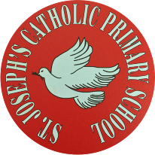

St Joseph’s Catholic Primary School - LEARNING AT HOME PLANNING
YEAR EYFS Foundation 1
Date wb 20.4.20
Weekly Mathematics Tasks  (Aim to do 1 per day) | Weekly Reading Tasks  (Aim to do 1 per day)
- Watch a Number blocks clip each day. Learn about number 2 and explore everything about this number. Talk about 1 more than and 1 less than any number up to 10. Make sure your child understands the words more and less by using objects. ( 2 piles ,which one has more?, which one has less?)  - Watch Number Jacks.  - Practice counting 1-10 forwards and backwards from different starting numbers.  - Look for numbers on houses, can you recognise them?  - sing number songs to practice one more and one less than numbers - 10 green bottles, 5 little ducks, 5 little monkeys etc | - Read a variety of books at home. talk about the story structure and the characters in the story.  - Read Hansel and Gretel or watch the story on you tube. Talk about the story. Talk about why the house would appeal to children. Talk about the beginning, middle and end of the story. Try to introduce new adjectives to describe the house. Write these words on pieces of paper. Everyday look and read these new words and talk about their meaning.  - Visit Oxford Owl for free eBooks. You can create a free account. Choose a book to enjoy together. Have a look at the linked play activities.
Weekly Phonics / Spelling Tasks  (Aim to do 1 per day) | Weekly Writing Tasks  (Aim to do 1 per day)
- Sing nursery rhymes and songs together with actions.  - Learn a new nursery rhyme with actions and talk about the words that rhyme.  - Practice hearing sounds in the environment. Sounds taught are s,a,t,p,i n. Practice these sounds and think of things beginning with those letters .  - Play I spy using the letters learnt – s,a,t,p,i,n,.  - Try to find objects and pictures starting with each of the sounds. Can they tell you the sound each object begins with?  If your child is finding hearing he sounds too tricky at the moment just look at and recognise environmental sounds and animal sounds. When they are ready just do one letter at a time. If it’s the letter ‘s’, try to find things and say words beginning with this letter all week.  Go to ‘jolly phonics’ on youtube for catchy songs for each letter sound. | - Practice letter formation for the curly letters c, a , g and new letter d. Each letter starts off as a curly c). Make sure each letter starts at the top and you don’t take your pencil off the paper. ( see packs for correct letter formation)  - Practice writing your name. Are all the letters formed correctly? If this is too tricky just practice one letter and get that right before moving onto the next one.  - Draw a picture of your house. Can you say what each part of your drawing is. Ask an adult to label your drawing. Can you make it look like Hansel and Gretel’s house?

Foundation subjects and Learning Project - to be done throughout the week
This week’s aims are to provide opportunities for your child to learn about the area they live in and their homes.

- Draw a picture of how you spent your Easter Sunday- Can you post it on the school twitter page? We would love to see your drawings!

- What can you see out of your window ?- Ask your child to look out of a window in the house and draw what they can see . . Look out of a different window (e.g. back or side of the house), draw what they can see. Look at the two pictures together and discuss what is the same in both pictures (e.g. the sky) and what is different.
- How do we differ from others ?- Ask your child to look in a mirror at their hair colour, eye colour, skin colour. Ask them to create a self-portrait using either felt-tips, crayons or paint. Look at some pictures in books and magazines. Does everyone look the same way as them? How do people look different?
Let’s get physical!
Joe Wicks every morning 9am on You tube
Cosmic Yoga- on You tube
Practice playing Simon Says.
Pray together
Practice our lunchtime prayer before you eat your lunch.
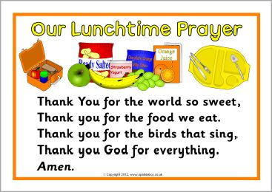

Additional learning resources parents may wish to engage with
You tube : 3D and 2D shape song, Numberblocks (Number 1)
Alphablocks initial sounds Jolly Phonics - youtube
Top marks (Maths Website)
Phonics Play (Phonics Website)
Classroom Secrets (Learning Packs)
Bigeyedowl.co.uk.
Teacher Tips
In Early Years a lot of learning is done through purposeful play, so please don’t worry if your child is just ‘playing’- encourage them to talk about what they are doing. They will be developing a number of skills through their play, such as speech and language, imagination, fine and gross motor and creativity.
We hope you are all well. Stay safe xxx

