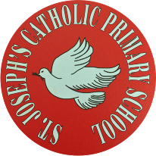

St Joseph’s Catholic Primary School - LEARNING AT HOME PLANNING
YEAR EYFS Foundation 1
Date wb 1.6.20
Weekly Mathematics Tasks  (Aim to do 1 per day) | Weekly Reading Tasks  (Aim to do 1 per day)
- New number lucky number 7 to explore. Watch number blocks number 7.song.  - Revise the numbers 1 to 6. Which ones do we recognise? Can we count accurately 6 objects?  - Practice reciting numbers 1to 10 and beyond. Can we start counting from different numbers?  - .Go to NRich for Maths based games and activities for learners aged 3 up wards. | - Read a book called CORONAVIRUS- a book for children. It’s an information book illustrated by the Gruffalo co- creator Axel Scheffler. It’s free to read on screenor to print out. google  bit.ly/2V2w3mM  - Visit BBC sounds. There is more than 100 short stories to listen to for free as well as many books.  bbc.co.uk/sounds/category/audiobooks
Weekly Phonics / Spelling Tasks  (Aim to do 1 per day) | Weekly Writing Tasks  (Aim to do 1 per day)
- New sound this week is the letter ‘o’. What begins with the letter ‘o’? Write them down and draw pictures for each one. Find things in the house, garden or park beginning with the letter ‘o’.  - Continue to practice hearing sounds in the environment. Sounds taught are s,a,t,p,i n,m,d, g . Practice these sounds and think of things beginning with those letters .  - Play I spy using the letters learnt – s,a,t,p,i,n, m,d, g.  Remember :If your child is finding hearing he sounds too tricky at the moment just look at and recognise environmental sounds and animal sounds. When they are ready just do one letter at a time. If it’s the letter ‘s’, try to find things and say words beginning with this letter all week.  Go to ‘jolly phonics’ on youtube for catchy songs for each letter sound. | - New long letters to practice ‘n’. Remember start at the top , draw a line down then up and round. Keep practising this letter and revise all the things that begin with a ‘n’ sound.  - Keep practising the long ladder letters :p, b, t  - Encourage any form of mark making. Maybe you could write a shopping list together. Emergent writing is always the first step towards writing so any squiggles on a sheet are great. Ask your child what does that say? Hopefully they will tell you all the wonderful things they would like from the shops.

Foundation subjects and Learning Project - to be done throughout the week
As the weather is so beautiful try to get out and enjoy it as much as you can.
Natural bracelets
Either in your garden or out on a walk, can you make a natural bracelet? Use some sticky tape or cut up a toilet/kitchen roll and see what lovely things you can find to stick on it! I would love to see what you make so please post on our twitter or PTA Facebook page.
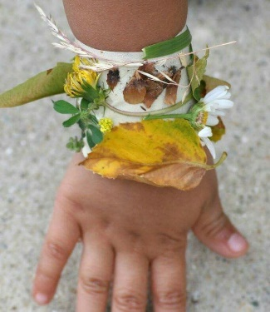 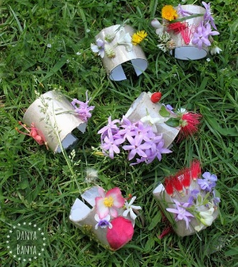
Sunflower
Check on your sunflower each day- does it need watering? Has it started to grow?
Maybe you could have a go at measuring the size of your sunflower, what will you use ?
Talk about why it is growing and what it is going to grow into
Thinking about sunflowers- can you look up some sunflower art? Which artists have painted pictures of sunflowers, can you find out? Have a go at painting your own sunflower picture!

Don’t forget about the music packages I’ve put online using YUMU. These are really fun activities and songs just for you.

Let’s get physical!
Enjoy being outside and looking at nature. Digging up weeds in the garden and watering plants is a great help for your parents
Google:Funky Finger activities to keep those fingers moving to help you build up strength in your hands and fingers.
Pray together
Lord in heaven, hear my prayer, Keep me in your loving care. Be my guide in all I do. Bless all those who love me, too.”
Additional learning resources parents may wish to engage with
.
Classroom secrets – kids.classroomsecrets.co.uk
CBeebies Radio – bbc.co.uk/cbeebies/radio
Keep Early Years Unique – keyu.co.uk/new-learning-at-home-together
Teacher Tips
We would love to see any work you have completed on the school twitter or you can put your work in an envelope and bring it into school. Any pictures, letters or cards are gratefully received by Mrs Lester and Mrs Langan.

