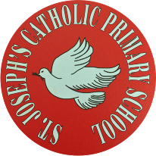

St Joseph’s Catholic Primary School - LEARNING AT HOME PLANNING
YEAR EYFS Foundation 1
Date wb 25.5.20
Weekly Mathematics Tasks  (Aim to do 1 per day) | Weekly Reading Tasks  (Aim to do 1 per day)
- Revise the numbers 1 to 6. Which ones do we recognise? Can we count accurately 6 objects?  - Practice reciting numbers 1to 10 and beyond. Can we start counting from different numbers?  - Do a scavenger hunt. Can you find 6 biscuits, can you find 4 toilet rolls, 3 cans, 2 teddies etc  - Listen to this song and watch a short video to learn positional language.  https://safeyoutube.net/w/ScT5  - https://www.bbc.co.uk/bitesize/clips/zy26sbk | - Read your favourite book at home. talk about the story structure and the characters in the story.  - Visit Oxford Owl for free eBooks. You can create a free account. Choose a book to enjoy together. Have a look at the linked play activities.  - Listen to the story Handa’s surprise.
Weekly Phonics / Spelling Tasks  (Aim to do 1 per day) | Weekly Writing Tasks  (Aim to do 1 per day)
- Continue to practice hearing sounds in the environment. Sounds taught are s,a,t,p,i n,m,d, g . Practice these sounds and think of things beginning with those letters .  - Play I spy using the letters learnt – s,a,t,p,i,n, m,d, g.  Remember :If your child is finding hearing he sounds too tricky at the moment just look at and recognise environmental sounds and animal sounds. When they are ready just do one letter at a time. If it’s the letter ‘s’, try to find things and say words beginning with this letter all week.  Go to ‘jolly phonics’ on youtube for catchy songs for each letter sound. | - We will revise all the curly letters and the long ladder letters.  - C,a,d,g,o  - P, b, t  - Listeni to or reading the story Handa’s Surprise, ask your child to name and draw different fruits that they know. Help them to label them.  - Talk about the different fruits in the story. Have you tried any of them?

Foundation subjects and Learning Project - to be done throughout the week
This week we are going to look at different fruits. Talk about the different countries they have come from.

Have a go at making Pleasing Puppets
● Make your own Handa’s Surprise character puppet. Click here for more ideas- https://littleangeltheatre.com/wp-content/uploads/2012/11/Education-Pack-2014_Handas-Surprise.pdf

Look at the fruits in your fruit bowl. What could you make out of them? Could we make a cake or a smoothie or a milk shake.
Google : BBC good food guide., look for simple recipes were everyone can help.

Go to your local park and look for signs of new life. There are ducklings in my park, what’s in yours?
Let’s get physical!
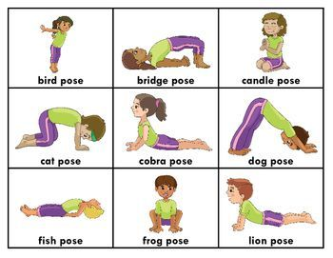
Can you do any of these YOGA poses?
Pray together
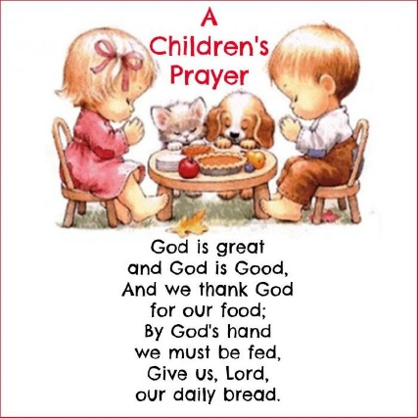
Let’s all say thank you for our lovely meals.
Additional learning resources parents may wish to engage with
. Doyogawithme.com/yoga-class
youtube.com/user/JamieOliver
Classroom secrets – kids.classroomsecrets.co.uk
CBeebies Radio – bbc.co.uk/cbeebies/radio
Keep Early Years Unique – keyu.co.uk/new-learning-at-home-together
Teacher Tips
Try to have a routine each week day so that the weekend feels a bit different. We don’t expect you to complete all the activities on this sheet but please try to do the phonics, maths and the reading tasks. We would love to see any work you have completed on the school twitter or you can put your work in an envelope and bring it into school. Any work, letters or cards are gratefully received by Mrs Lester and Mrs Langan.

