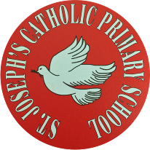
St Joseph’s Catholic Primary School - LEARNING AT HOME PLANNING
EYFS F2
Date: 06.07.20 – Olympics Week
Weekly Mathematics Tasks  (Aim to do 1 per day) | Weekly Reading Tasks  (Aim to do 1 per day)
Download the Classroom Secrets Learning Pack for Week 9 and complete the tasks for each day.  https://classroomsecrets.co.uk/free-home-learning-packs/  __________  Watch Numberjacks on the link below:  https://www.youtube.com/watch?v=RrLIai7Wtls&feature=share  Ask an adult to gather a range of heavy and light objects from around their home or garden. They vary in size, shape and weight. For example, a toothbrush, bag of pasta, an apple, a 2 litre bottle of juice, a soft toy, a stick, a plant pot, a feather etc  Once your adult has gathered the objects, look at them and decide which are things are heavy, and which are light. You could make ‘heavy’ and ‘light’ labels. Talk to your adult about why you think something will be heavy or light.  Now hold each object, do you still think it is heavy or light? Are you surprised by the weight of an item compared to its size? Re-order them if you need to.  Take two objects and decide which is heavier and which is lighter?  Draw a labelled picture of the heaviest and lightest objects you found.  __________  This week, we would like you to revise doubling and halving numbers to 10. Complete the ladybird doubles activity (see below). | Share a story with someone in your family. Write a Book Review together (see below)  __________  Ask an adult to use the link to listen to the story of What the Ladybird Heard  https://www.youtube.com/watch?v=Eu9mPX7DuLA  Are there any words that you haven’t heard before? Discuss what they mean with an adult. Can you say a sentence of your own with that word in?  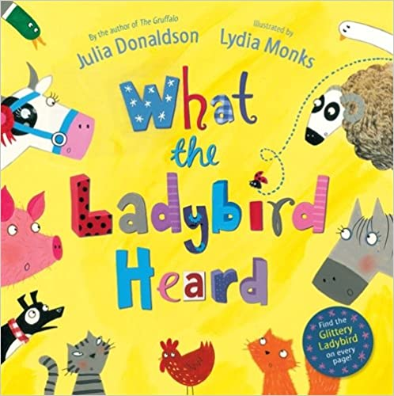  __________  Think of some speech bubbles to show what the ladybird might be thinking at each point in the story.  __________  Look at the pictures of the farm at the start and end of the book. Can you describe how they are different?  __________  How many different animals appear in the story? How are they similar / different? Can you use some adjectives to describe them? E.g. the fluffy sheep
Weekly Phonics Tasks  (Aim to do 1 per day) | Weekly Writing Tasks  (Aim to do 1 per day)
Read the Phase 3 Flashcards on the site below – how many do you know?  https://www.phonicsbloom.com/uk/game/flash-cards?phase=3  __________  Play Phonics Frog and revise the sounds ure and ng.  Practice the sounds ure and ng  Geraldine the giraffe/Mr Thorne’s phonics  ure - https://www.youtube.com/watch?v=IK8m-5JQmso  ng - https://www.youtube.com/watch?v=8v7Yl4phJcg  __________  Practice writing words that contain this week’s sounds ure and ng. Add sound bars and buttons to help you recognise the different sounds in each word.  __________  Complete the Find and Write ure words activity below.  ___________  Complete the Real and Nonsense ng words activity below.  ___________  Match the captions to the pictures (see below) | This week we will be focussing on What the Ladybird Heard, a lovely rhyming story. Do you know any other stories that rhyme?  __________  Once you’ve heard the story once, listen to it again and this time listen out very carefully for any rhyming words you hear. Have a go at making a list of rhyming pairs - can you try to write the rhyming words? You might want to draw a picture to go with each word as well.  __________  Play the Rhyming Pairs Game (see below) Cut out the picture cards and try to find pairs of words that rhyme. You might want to stick them on a piece of paper to make a rhyme poster, or add them on to your rhyming list. When you’ve done that, have a go at playing the game again, but this time with words. What do you notice about the letters in the rhyming words? Which letters are the same? Which are different?  __________  Write a book review for What the Ladybird Heard (see below).  ___________  Practice forming the One Armed Robot letters using the attached mat. These letters are r, n, m, h, b, k and p.

Foundation subjects and Learning Project - to be done throughout the week
Olympics Week
This week we are focussing on the Olympic Games, which should have been held in Japan this year but has now been postponed until 2021 due to COVID-19.
Geography: With an adult, find where Japan is on a world map. What continent is Japan in? What is the name of the water that surrounds Japan? Research and write some facts about Japan.
Art: Origami is the art of paper-folding. Its name is from the Japanese words ori (“folding”) and kami (“paper”). Make a cat using origami (see below).
Medals are given out at the Olympics. Design a medal (see below).
History: Find out when and where the first Olympic Games was held.
Music: Can you make up a song which includes lots of examples of animal sounds? Get some ideas by watching this performance of a song by the author and her husband:
https://youtu.be/7NbyiDpY6Ww

Let’s get physical!
Look at this range of free activities, challenges and learning resources for you to do indoors or in their garden with your family. Don’t stop getting active! https://www.getset.co.uk/resources/travel-to-tokyo/indoor-activity

As the Merseyside School Games County Festival is unable to go ahead this year, the Merseyside School Games Organisers have created a fantastic week of virtual challenges and activities. All details are in the attached poster below. Each day has a set theme and a set challenge. These activities are for all ages and abilities. They can be enjoyed at school or at home with family.

As you can see, each day has a different focus. At the beginning of the week we will be sharing, via our school’s Twitter page, a breakdown of each day with a 'Challenge Card' so look out for these. You can share and post all of your involvement on the @stjosephsbh Twitter page and also tag, using the hashtag #MerseysideSG and @WirralSG

Pray Together
We need to ask Jesus to help us to be kind to others. Watch the story of when Jesus fed 5000 people with 2 fishes and 5 loaves of bread.
https://www.youtube.com/watch?v=S6rj9cAJrWE

Continue to learn the morning prayer ready for September:

Oh my God I give to you,
All that I think or say or do
All my work and all my happy play
My God I give to you today
Amen

Additional learning resources parents may wish to engage with
School Twitter page - this will keep you up to date with challenges set by the teachers and let you see what other pupils have been up to. Follow us @stjosephsbh
- www.phonicsbloom.co.uk phonics games/ activities
- www.phonicsplay.co.uk Username: mach20. Password: home for free access
- http://www.phonicsplaycomics.co.uk/comics.html Reading Activities
- www.twinkl.co.uk lots of resources in a variety of subjects. Code: UKTWINKLHELPS for free access.
- www.ictgames.co.uk maths and English games
- www.topmarks.co.uk online games
- www.bbc.co.uk/cbeebies educational games and activities
- www.classroomsecrets.co.uk home learning packs for year 1
- www.oxfordowl.co.uk phonic and reading resources and ebooks.
- https://www.bbc.co.uk/cbeebies/shows/numberblocks sing and learn about Numberblocks from Cbeebies

Teacher Tips
The work above is an idea of activities you could try at home.
The most important thing at the moment is keeping your child happy and healthy.
Any learning at home is learning, so if that takes a more practical approach then that’s fine. Bake a cake, play a board game together, build with Lego - your child is learning important maths and communication skills doing these things.
Take the work at their own pace. If it is too much stop, if they want to do more let them.
Remember we have breaks during the school day too, a little bit of fresh air in the garden is helpful for a ‘brain break’.
We would really like to see what they’re doing. If you have any photographs then please send them into the school via Twitter @stjosephsbh if its building a den in the garden, creating a banner for the NHS, or spending time with the family we want to see it.
Stay safe everyone!

