St Joseph’s Catholic Primary School - LEARNING AT HOME PLANNING
F2
Date 13.07.20
Weekly Mathematics Tasks  (Aim to do 1 per day) | Weekly Reading Tasks  (Aim to do 1 per day)
By the end of EYFS, the expectation is that children can use everyday language to talk about capacity and solve problems. Most children love water play, so just let them experiment with pouring water and using a  variety of different sized containers to help to develop their understanding. Any jugs, tubs, empty shampoo bottles etc. will do! They could do this with a bucket of water outside, in the bath/shower, or just at the sink.  Try Ordering the Magic Potions (see attached)  Colour in the Pizza Shapes activity (see below). Can you describe how many sides and corners a triangle, circle, square and rectangle have?  Look at the calendar below and discuss how to complete it with an adult. We want you to hear the days of the week, months of the year and the seasons as much as possible because talking about these will help you to learn them.  Practise the days of the week by singing the Days of the Week song https://www.youtube.com/watch?v=oKqAblcwFOA | Share a story with someone in your family. It could be a picture book, or a chapter in a longer story book. Think of any new words that you have learnt. What do they mean?  Remember, you can still read ‘Oxford reading tree’ books online for free: https://www.oxfordowl.co.uk/for-home/find-a-book/  You are going to learn a nursery rhyme by heart! You are going to learn Hey Diddle Diddle. Have you heard this before? Are there any words in this nursery rhyme are you are unsure of? Do you know what a fiddle is? What is another word for dish?  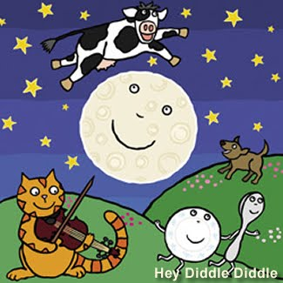  https://www.youtube.com/watch?v=Lsbr7a5MVOk  Say the nursery rhyme aloud to other people, draw a picture, write out the lines and stick them on the fridge door. Repeat the lines while you’re walking the dog...if you have one! Recite it to the dog or in the bath or in front of a mirror. Give someone else the nursery rhyme and get them to test you!  Once you know the words, think about how you want to say them. When starting to recite poetry, everyone goes too quickly – slow right down! Think about the ending – you want to keep your listeners hanging on the last word for one more second, thinking about what they’ve heard before they all start clapping.
Weekly Phonics Tasks  (Aim to do 1 per day) | Weekly Writing Tasks  (Aim to do 1 per day)
This week, we would like you to focus on ‘tricky words’. Remember: these words are not  phonetic and so they cannot be sounded out. You have to learn and try to remember them,  so you can read the whole word by sight.  The tricky words we’ve learned so far are: I the to no go into he she we me be  The new tricky words to learn this week are: was my you  - Have a go at making a poster for each word—write the word as big and as colourful as you can. Stick it on the wall somewhere at home, where you will see it a lot, (maybe in your bedroom, above the sink or on the fridge) and say the word out loud each time you walk past it. Do this for any of the other tricky words you’re not yet sure of too.  - Be a tricky word detective by looking for these words in books you have at home. Keep a tally chart of how many times you find each word. Which word did you find the most? Can you find any word 20 times?  - Play the tricky word bingo game we’ve made -see separate document. Have fun!  Practise reading Phase 3 sounds here https://www.phonicsbloom.com/uk/game/flash-cards?phase=3 Don’t worry if you can’t remember some of the sounds – you will revise them again in Year 1. | This week we want you to complete a fact file about yourself and send it to your new teacher! This is a chance for you to say a little bit about yourself so your new teacher can start getting to know you. If you email us your letter, we will print it off and make sure we give it to your next teacher. They are very excited about receiving their facts files!  First, complete the All About Me sheet (see attached). If you haven’t got a printer, ask your adult to copy out some of the headings for you. You can fill in the fact file with your adult. Remember to sound out words and use the letters that you have been taught. You could even make a poster!  You may want to draw a picture of yourself in the photo section. Remember to use lots of colour.  When you have completed the sheet, you could write a short letter to your new teacher about yourself using the paper provided. Don’t forget to add a colourful drawing at the top of the page.  Practice forming the Zig Zag Monster letters using the attached sheet. These letters are v, w, x, and z

Foundation Subjects and Learning Project - to be done throughout the week
This week is Transition Week. You may have already met your new teacher via Zoom. Your new teacher is very excited about seeing you in September and is looking forward to teaching you fun new things!

Your new teacher wants to know all about you so why not try a few of these projects at home to show to your teacher.

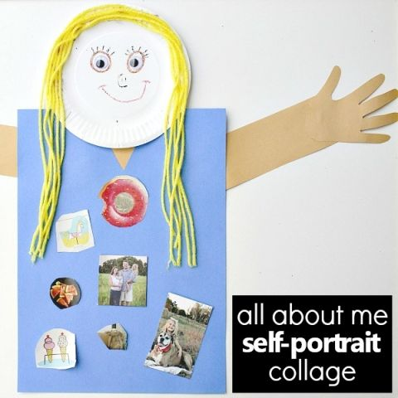

Art
Use a paper plate for your head or ask an adult to help you to
cut out a circle shape from some card (an old cereal box).
Use what you have around your house to create a collage.
On the body, you can add pictures and photos that tell
your new teacher all about you. You may wish to draw some
of these, e.g. stick on a LFC picture if that is the football team
that you support or add a picture of your favourite book.

History
Our families are very important. All families are different and are very special. Create a family tree with an adult to help you. Here are some examples below to help you.

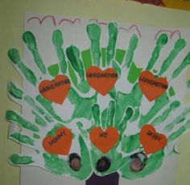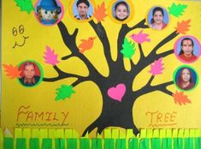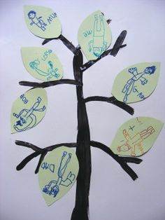

Geography
Draw a picture of where you live and then with an adult.
If you’d like to, you could then create a My Place in the
World flip book.
My House
My Town
My County
My Country
My Continent
My Planet

Let’s Get Physical!
Joe Wicks PE will now take place Mondays, Wednesdays and Saturdays at the usual time of 9am. Can you create your own training sequence?

YouTube- Go Noodle
YouTube- Just Dance

Pray Together
Let’s learn the morning prayer ready for September:
Oh my God I give to you,
All that I think or say or do
All my work and all my happy play
My God I give to you today
Amen

Additional Learning Resources
- www.phonicsbloom.co.uk phonics games/ activities
- www.phonicsplay.co.uk Username: mach20. Password: home for free access
- http://www.phonicsplaycomics.co.uk/comics.html Reading Activities
- www.twinkl.co.uk lots of resources in a variety of subjects. Code: UKTWINKLHELPS for free access.
- www.ictgames.co.uk maths and English games
- www.topmarks.co.uk online games
- www.bbc.co.uk/cbeebies educational games and activities
- www.classroomsecrets.co.uk home learning packs for year 1
- www.oxfordowl.co.uk phonic and reading resources and ebooks.
- https://www.bbc.co.uk/cbeebies/shows/numberblocks sing and learn about Numberblocks from Cbeebies

Teacher Tips
The most important thing at the moment is keeping your child happy and healthy.

Any learning at home is learning, so if that takes a more practical approach then that’s fine. Bake a cake, play a board game together, build with Lego - your child is learning important maths and communication skills doing these things.

Take the work at their own pace. If it is too much stop, if they want to do more let them.

Remember we have breaks during the school day too, a little bit of fresh air in the garden is helpful for a ‘brain break’.

We would really like to see what they’re doing. If you have any photographs then please send them into the school via Twitter @stjosephsbh if its building a den in the garden, creating a banner for the NHS, or spending time with the family we want to see it.

Stay safe everyone!

