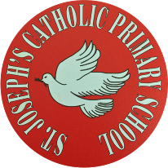
St Joseph’s Catholic Primary School - LEARNING AT HOME PLANNING
EYFS F2
Date: 29.06.20
Weekly Mathematics Tasks  (Aim to do 1 per day) | Weekly Reading Tasks  (Aim to do 1 per day)
Download the Classroom Secrets Learning Pack for Week 8 and complete the tasks for each day.  https://classroomsecrets.co.uk/free-home-learning-packs/  __________  Practise counting backwards from 20. Can you try starting at a different number each time? 15,14,13 etc.  __________  Have a go at practising doubling and halving.  https://www.ictgames.com/mobilePage/archeryDoubles/index.html  __________  Sing along with the following counting songs:  https://www.youtube.com/watch?v=7D4K9oi7oBM  __________  Play Caterpillar Counting and set the n umbers to count from 0-10 https://www.ictgames.com/mobilePage/countingCaterpillar/index.html  __________  Count the Rainbow Fish’s scales (see below)  __________ | Share a story with someone in your family. Write a Book Review together (see below)  __________  Ask an adult to use the link to listen to the story of The Rainbow Fish https://www.youtube.com/watch?v=QFORvXhub28 Are there any words that you haven’t heard before? Discuss what they mean with an adult. Can you say a sentence of your own with that word in?  What words can you spot that describe the Rainbow Fish’s scales as shiny?  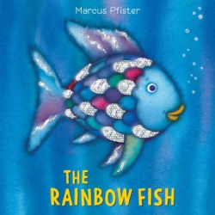  __________  If you haven’t already, ask an adult to sign up to https://www.teachyourmonstertoread.com/accounts/sign_up This is a really good website that is totally FREE. You can play games and read at the same time.  __________
Weekly Phonics Tasks  (Aim to do 1 per day) | Weekly Writing Tasks  (Aim to do 1 per day)
Visit Phonicsbloom.com- Play Yes/No Yeti game  https://www.phonicsbloom.com/uk/game/yes-no-yeti?phase=3  Can you practice the sounds oi and er- use YouTube to help you with the correct pronunciation.  YouTube-  Geraldine the giraffe/Mr Thorne’s phonics  Alpha blocks  Jolly Phonics phase 3  __________  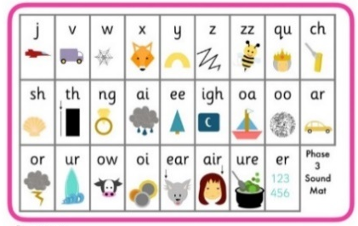  Practice writing words that contain this week’s sounds oi and er. Add sound bars and buttons to help you recognise the different sounds in each word.  __________  Complete the Find and Write oi words activity below.  ___________  Complete the Real and Nonsense words er activity below.  ___________  Match the captions to the pictures (see below) | This week we will be focussing on The Rainbow Fish, a lovely story with fabulous illustrations for our Art Week. Do you know any other stories that have fish in them?  __________  Look at the picture on the front cover. Describe the Rainbow Fish using his name, colours and where he is. Use the word mat below to help you.  __________  Where does the Rainbow Fish live? Have a go at drawing a picture of The Rainbow Fish.  Write some simple sentences about the setting using the word mat below.  __________  Put the pictures from the story into the correct sequence. Say or write a sentence to go with each picture.  ___________  Practice forming the Curly Caterpillar letters using the attached mat. These letters are c, a, d, g, o

Foundation subjects and Learning Project - to be done throughout the week
National Art Week (29th June-19th July)
https://engage.org/happenings/childrens-art-week-2020/
Visit this site for more information!
Rainbow Fish Art:
Using resources from in and around your home, attempt to create one of the following creations or think of your own idea. Ask an adult to take a photo of your finished masterpiece and send it to our school office so that we can put it onto our school Twitter page!
If you have paint at home, the end of a stick of celery stick is perfect to make the Rainbow Fish’s scales. Can you include all of the colours of a rainbow?

Find pieces of paper, fabric, etc from around your house and cut and stick them onto a template to make the scales for the Rainbow Fish.

Use a paper plate to make a Rainbow Fish like this. Cut scale shapes out of pieces of paper and glue them onto your painted paper plate. Don’t forget to cut out the shape to make the mouth and the tale.

Let’s get physical!
Joe Wicks PE will now take place Mondays, Wednesdays and Saturdays at the usual time of 9am. Can you create your own training sequence?

YouTube- Go Noodle
YouTube- Just Dance

Pray Together
Let’s learn the morning prayer ready for September:
Oh my God I give to you,
All that I think or say or do
All my work and all my happy play
My God I give to you today
Amen

Additional learning resources parents may wish to engage with
School Twitter page - this will keep you up to date with challenges set by the teachers and let you see what other pupils have been up to. Follow us @stjosephsbh
Twinkl – to access these resources click on the link and sign up using your own email address and creating your own password. Use the offer code UKTWINKLHELPS.
Headteacherchat - This is a blog that has links to various learning platforms. Lots of these are free to access https://www.headteacherchat.com/post/corona-virus-free-resources-for-teachers-and-schools
Teacher Tips
Remember when in school children have lots of breaks during the day, so try and factor in some ‘relaxation’ time for both the children and you!

