St Joseph’s Catholic Primary School - LEARNING AT HOME PLANNING
YEAR EYFS Foundation 2
Date wb 20.4.20
Weekly Mathematics Tasks  (Aim to do 1 per day) | Weekly Reading Tasks  (Aim to do 1 per day)
- Watch a numberblocks 16- tell a grown up what you noticed. How was numberblock 16 made?  Can you find 16 objects in your house and count them carefully.  - Practice counting in 2’s, 5’s and 10’s- find video’s on youtube to help you!  - Can you write some sums to make the number 11?  - Look out of the window and count how many houses or buildings can be seen.  - Play a shape game on TopMarks – did you learn any 3D shapes last week? | - Read a variety of books at home. Favourites can be repeated. Hearing the patterns of language in a story will support your child’s language development.  - Read the story of The Three Little Pigs (or watch on youtube)- Discuss the choices the little pigs make about the materials they use to build their houses. Can children figure out the material their own house is made from?  - Practice reading these phase 3 tricky words-  he  she  we  me  be  you  are  her  was  they  my  all
Weekly Phonics / Spelling Tasks  (Aim to do 1 per day) | Weekly Writing Tasks  (Aim to do 1 per day)
- Play a phonics game online!  - Practice all the Phase 3 sounds we have learnt so far- can you write them down? Watch Jolly Phonics Phase 3 on youtube to remind you!  - In the phase 3 sounds we are up to ear this week. ear is a trigraph- this means it has 3 letters that make up 1 sound.  fear  Watch a video on youtube- phase 3 ear sound  Can you copy these ear words and read them? Add your bars and buttons to help you!  hear  dear  gear  tear  rear  near | ● Practice forming the letters of the alphabet.  ● Ask your child to draw or write a shopping list to help plan for the weekly shop. Encourage them to ask all family members views on what they would like to eat that week. Sound out each word carefully!  ● Ask your child to help plan a movie night/ afternoon. Select two films from a streaming service or DVD’s you have in the house.  Write down the names of the films and get your family to vote which one they would like to watch. Write their names underneath their choice.  After watching your movie ask your child to draw a picture and write a sentence about it. What did they like/dislike? What was their favourite part or character?  - Practice sitting correctly at a table and using the correct pencil grip- this is something we work on during F2. 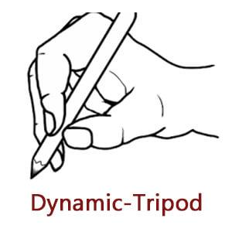

Foundation subjects and Learning Project - to be done throughout the week
The project this week aims to provide opportunities for your child to learn more about different viewpoints.
● What can you see out of your window ?- Ask your child to look out of a window in the house and draw what they can see and label it. Look out of a different window (e.g. back or side of the house), draw what they can see. Look at the two pictures together and discuss what is the same in both pictures (e.g. the sky) and what is different.
● How do we differ from others ?- Ask your child to look in a mirror at their hair colour, eye colour, skin colour. Ask them to create a self-portrait using either felt-tips, crayons or paint. Look at some pictures in books and magazines. Does everyone look the same way as them? How do people look different?
● Imagine another world outside the window- Close the curtains and ask your child to imagine that the house is in a new imagined world. What do they imagine? Is it snowy? Are there dinosaurs/ monsters in the new world? Ask them to tell you a story about it… Your child could create a story map to show what happens in their imaginary world (see right). Make sure you try to label your story map!
- Draw a picture of how you spent your Easter Sunday- Can you post it on the school twitter page? We would love to see your drawings!

Let’s get physical!
Joe Wicks every morning 9am on You tube
Cosmic Yoga- on You tube
Pray together
Practice our lunchtime prayer before you eat your lunch.
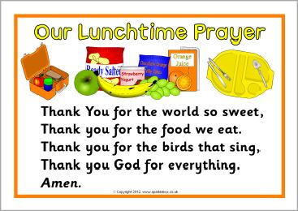

Additional learning resources parents may wish to engage with
You tube : Numberblocks (Number 16) and Alphablocks (ear) Counting in 2’s,5’s and 10’s
Top marks (Maths Website)
Phonics Play (Phonics Website)
Classroom Secrets (Learning Packs)
Bigeyedowl.co.uk
Teacher Tips
- When working on number allow your child to use whatever is available to support them- You can count anything! Toys, cutlery, shoes etc.
- When writing encourage your child to sound out carefully using their phonics- trying their best is what we love to see.
- Remember allowing your child to play is fine, please do not worry about trying to recreate the school setting.

