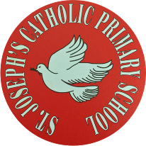

St Joseph’s Catholic Primary School - LEARNING AT HOME PLANNING
YEAR EYFS Foundation 2
Date wb 25.5.20
Weekly Mathematics Tasks  (Aim to do 1 per day) | Weekly Reading Tasks  (Aim to do 1 per day)
- Practice counting from 0-20 forwards and backwards  - Write all the numbers from 0-20  You could do this in chalk in the garden, using felt tips, crayons or anything that will engage your child.  - Listen to this song and watch a short video to learn positional language.  https://safeyoutube.net/w/ScT5  https://www.bbc.co.uk/bitesize/clips/zy26sbk  - Listen to ‘We’re Going on a Bear Hunt’  https://www.youtube.com/watch?v=0gyI6ykDwds  Talk about the positional language used in the story – through, over, under. Create a story in the house using these words-over, under, though, behind, next to, opposite, around.  - Encourage your child to jump, hop or skip. Give them directions as they do this e.g. jump forwards 5.  - Make a positional language picture- cut out a selection of 2d shapes. Give your child positional instructions to create a picture e.g. put the square in the middle of your page. | - Have a go at reading all of these tricky words!  Play tricky word bingo with the words above  Also Look at newspapers, magazines or leaflets together and circle these words with a felt tip pen or highlighter.  - Listen or read some stories from around the world - including: Handa's Surprise, The Tiger’s Child and If The World Were a Village.  - Choose one of the above stories to share again. Ask your child to retell the story in their own words once they are familiar.  - Play memory games, ‘I went to the market, I bought… The next person repeats the above sentence remembering the items bought already and adding a new one to the list each time. Use fruits like in Handa’s Surprise.
Weekly Phonics / Spelling Tasks  (Aim to do 1 per day) | Weekly Writing Tasks  (Aim to do 1 per day)
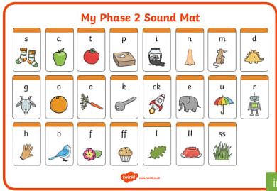  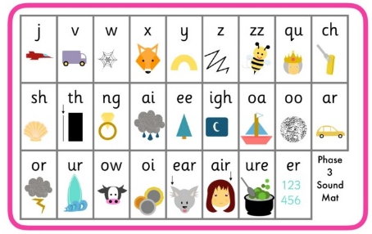  Now that we have worked our way through each sound, we would now usually consolidate.  Ask your child to read each sound in phase 2 and phase 3 (images below). If they struggle with some sounds have a go at practising recognising the sound, writing and reading it in some words. | - Encourage your child to look at the food in your kitchen and find out what countries some of it comes from. Search on a map for those countries. Help your child to trace the letter with which the name of those countries start.  - After listening to or reading the story Handa’s Surprise, ask your child to name and draw different fruits that they know. Label them using describing words.  - Ask your child to play in role as Handa from Handa’s Surprise. Ask them questions and they must answer as Handa e.g. ‘Handa, what is your favourite fruit?’ They might answer by saying ‘My favourite fruit is tangerines. I was very excited to find lots of them’. Can they write their response down?
Foundation subjects and Learning Project - to be done throughout the week
The project this week aims to provide opportunities for your child to learn more about countries and cities around the world. Learning may focus on different cultures and traditions, famous landmarks, food and clothing.
Flags
● Look at flags from around the world. Discuss which are your child’s favourites and why? Ask your child to design and make their own flag using 2d shapes. https://www.worldometers.info/geography/flags-of-the-world/
Pleasing Puppets
● Make your own Handa’s Surprise character puppet. Click here for more ideas- https://littleangeltheatre.com/wp-content/uploads/2012/11/Education-Pack-2014_Handas-Surprise.pdf
Toys from Around the World
● Look at this photography project of children with their toys from around the world. Discuss how life is the same and how life is different in other countries. Can your child draw their favourite toy and write a sentence explaining why this is their favourite? https://www.gabrielegalimberti.com/toy-stories/
Where in the World?
● Discuss with your child where your family comes from in the world. If you have them available, show your child photographs of where you, or their grandparents, grew up. This might be similar to where they live now or completely different. Encourage your child to think about the differences between the places.
Engineering Around the World –
Bridges
● A bridge helps people move over obstacles like a river, a valley or a busy road. The world’s longest bridge is in China and is 164.8km long. It would take more than two days to walk the length of this bridge. Do you have any bridges near your home? What do they look like?
● Try building a bridge out of paper, Lego or any other building materials you might have at home. Your bridge needs to be big enough for a toy car or small toy to travel over
Let’s Celebrate!
Sunday 31st May is Pentecost Sunday and the end of Easter time. Below are some activities you might like to join in with to celebrate.
●Bake a cake to celebrate the Church's birthday and have a little party at home.
●Make an origami dove or a dove from a paper plate.
●One of the significant parts of the Pentecost story is that people who spoke different languages were able to understand one another. Take that idea and learn something in a different language together as a family. Perhaps you could learn " I love you" in different languages. How many could your family learn?

Let’s get physical!
Can you have a go at some of these yoga poses?
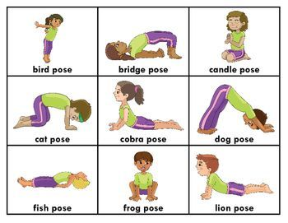

Pray together
Have a go at saying this prayer before you eat your dinner.
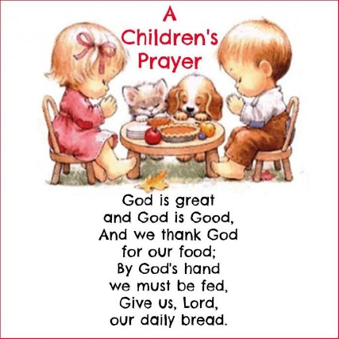
Additional learning resources parents may wish to engage with
Doyogawithme.com/yoga-class
youtube.com/user/JamieOliver
historystorytime.podbean.com
mathletics.com/uk
Teacher Tips
A big thank you for all of the lovely messages sent via the twitter and PTA Facebook page. It really brightens our day to see some of the children’s faces. We are missing them all so much.
Remember that you are all doing a brilliant job at home and please pass any messages to Miss McNeil if you need any help or guidance with the activities or if you have any questions.
Keep safe and enjoy the sunshine!

