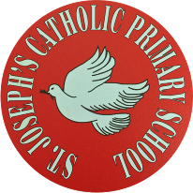

St Joseph’s Catholic Primary School - LEARNING AT HOME PLANNING
YEAR EYFS Foundation 1
Date wb 18.5.20
Weekly Mathematics Tasks  (Aim to do 1 per day) | Weekly Reading Tasks  (Aim to do 1 per day)
- Watch a Number blocks clip each day. Learn about number 6 and explore everything about this number. Watch you tube number blocks song for the numbers 1 to 6. With the number 6 song watch it a couple of times and pause it to count the objects or look at the shape. Play a game where they have to find 5 of something. Can they find 6 of something else? Keep the number 6 as a special number to think about every day. If they don’t already recognise it, draw it and put it around the house to remind them. (the same for 1,2,3,4,5, 6 if they don’t recognise them). Take a clock and look at the numbers 1 to 6. Talk about what you do at each hour of the day.  - Play snap the number. Write the numbers 1,2,3,4,5, 6 on pieces of paper and play snap with them.  - Go on the Topmarks website and look for 2D shape games. Talk about how a 6 sided shape a HEXAGON. | - Read a variety of books at home. talk about the story structure and the characters in the story.  - Read a non fiction book about a sport your child is interested in. Or google your chosen sport and find out a bit more about it.  - . Try and lean new words about your favourite sport.  - . Visit Oxford Owl for free eBooks. You can create a free account. Choose a book to enjoy together. Have a look at the linked play activities.
Weekly Phonics / Spelling Tasks  (Aim to do 1 per day) | Weekly Writing Tasks  (Aim to do 1 per day)
- Continue to practice hearing sounds in the environment. Sounds taught are s,a,t,p,i n,m,d . Practice these sounds and think of things beginning with those letters .  - New sound this week is g. What can you find in your house beginning with this letter sound? Draw pictures of things beginning with this sound.  - Play I spy using the letters learnt – s,a,t,p,i,n, m,d.  Remember :If your child is finding hearing he sounds too tricky at the moment just look at and recognise environmental sounds and animal sounds. When they are ready just do one letter at a time. If it’s the letter ‘s’, try to find things and say words beginning with this letter all week.  Go to ‘jolly phonics’ on youtube for catchy songs for each letter sound. | - Continue with letter formation for the curly letters c, a , g and d. Each letter starts off as a curly c). Make sure each letter starts at the top and you don’t take your pencil off the paper. ( see packs for correct letter formation).  - If your child is able to do this try the long ladder letters, start with the letter P then try b. And the new letter t.  - Continue writing your name. Are all the letters formed correctly? If this is too tricky just practice one letter and get that right before moving onto the next one..  - Ask your child to draw a picture of themselves doing something sporty. i.e. running, jumping, a cartwheel. Can you label the picture for them and write a simple sentence e.g. I can hop on one leg.

Foundation subjects and Learning Project - to be done throughout the week
Ball Games
● Play a game of catch with a ball - when you drop the ball, you lose a point. You could record points using a tally chart and count up who has the most points at the end.

Play Skittles
● If you have a set of skittles, you’re ready to go, if not you can make your own skittles using plastic bottles. Take a plastic bottle and partly fill with soil/ stones or sand to weigh it down. If you don’t have plastic bottles available, you could use tin cans for an alternative version. Ask your child to count how many skittles there are to begin with. Roll the ball at the skittles and ask your child to count how many they have knocked over. Can they work out how many are left?
Competition Time
● Have a time challenge. Give your child an action to do e.g. hop, skip, jump, clap or star jump. How many can they do in one minute? Keep a record of the scores. Ask everyone in the house to have a go! Share a photograph of your time challenge on Twitter to motivate everyone to get moving using.

Parts of the Human Body
● Ask your child which parts of their body they use to run? To do a handstand?
Sunflowers!
This week you will have received a little surprise pot with some sunflower seeds. Follow the instructions and see what happens to the seeds! Maybe you could write a diary of what happens each day (with lots of help) . We would love to see your sunflowers when they start to grow so don’t forget to send some pictures to our twitter page. Good Luck!
Let’s get physical!
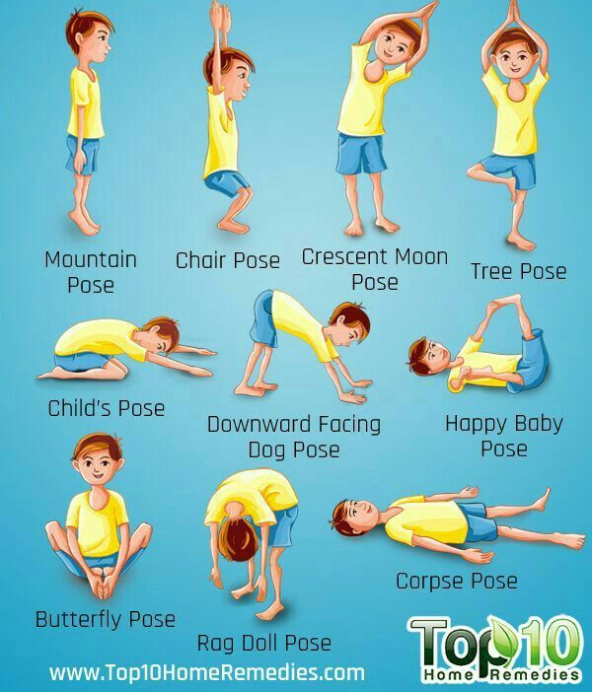
Can you have a go at some of these yoga poses?

Pray together
Say this prayer with your family.
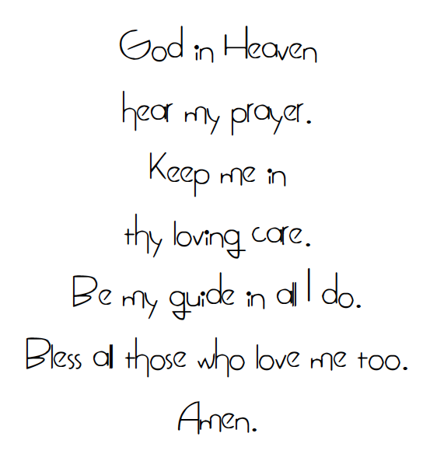
Additional learning resources parents may wish to engage with
Busy Toddler 40 indoor activities – busytoddler.com/2020/03/indoor-activities.
Classroom secrets – kids.classroomsecrets.co.uk
CBeebies Radio – bbc.co.uk/cbeebies/radio
Keep Early Years Unique – keyu.co.uk/new-learning-at-home-together
Teacher Tips
Hello, hope you are all okay and keeping safe.
Keep looking on the school twitter website and facebook page for any updates and messages . . Take care xxx

