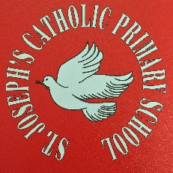

Geography Curriculum
In Geography we focus on teaching children the geographical skills and knowledge that are needed to understand both places and issues, including learning about the processes and consequences of change in different environments. The local environment is frequently used as a learning resource, with children looking at how the area of Birkenhead has changed. Investigating some of the problems that local, national and international areas face, both at present and in the future.

The Geography delivered at St. Joseph's is designed to enable children:

a) To investigate places and things across an extending environment, from the classroom, through the local area, to the world beyond.

b) To undertake studies that focus on geographical questions that develop the ability to recognise patterns and increase awareness of the global nature of Geography.

c) To study environmental issues and attempts to manage the environment sustainability.

Children are also taught skills associated with Geography, such as recognising some countries flags, being able to locate countries on a map, map reading skills, how to use coordinates and how to compare and contrast different locations, climates and zones.

