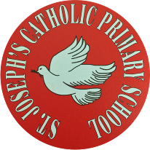
St Joseph’s Catholic Primary School - LEARNING AT HOME PLANNING
YEAR 2
Date - WC 8th June 2020
Weekly Mathematics Tasks  (Aim to do 1 per day) | Weekly Reading Tasks  (Aim to do 1 per day)
- Working on Times Table Rockstars - your child will have an individual login to access this (20 mins).  - Continue to practise daily calculations. Use the website below to set the calculations. Remember when adding and subtracting set it to 2-digit numbers on the website.  https://www.topmarks.co.uk/maths-games/daily10  Shape – identifying how patterns have been created through rotation.  - Children complete the lesson from The Oak National Academy  https://www.thenational.academy/year-2/maths/to-identify-how-patterns-have-been-created-through-rotation-year-2-wk3-3#slide-3  Volume  - Children to explore the volume of different containers. Try and provide your child with different size containers. E.g. tall and narrow, and short and wide. Fill each the narrow container ¾ full of water and the wide container ½ full. Children to compare the container by stating which container has more water. Check their answer by pouring the water into equal sized cups.  - Children to continue to compare volume by completing the attached sheet.  - Try and complete these maths challenges from BBC Bitesize  https://www.bbc.co.uk/bitesize/articles/z7txhbk | - Your child could read a story/ poem / nursery rhyme to another family member. This could be to a younger sibling before bedtime or they may wish to Facetime an elderly relative (with adult supervision of course).  - Listen to your child read and let them discuss what they have read. Encourage them to read with expression and intonation.  - Get your child to read a book on Oxford Owl, discuss what your child enjoyed about the book.  - NEW PICTURE  Find a part of your story that doesn’t  already have a picture. Draw a new  picture to show what happens.  - Complete the attached reading comprehension.
Weekly Spelling Tasks  (Aim to do 1 per day) | Weekly Writing Tasks  (Aim to do 1 per day)
What is this week’s focus? The /u/ sound spelt o.  - mother  - brother  - cover  - other  - another  - Monday  - above  - monkey  - dove  - love  Can they improve their score each day?  Can you include any of these words in a sentence?  Children could use the ‘pyramid method’ to help learn their spellings  e.g.  b  be  bec  beca  becau  becaus  because  Another method the children could use is ‘rainbow colours’.  e.g the children use a different colour for each letter in the word.  because | - Discuss with your child the importance of helping others. Children to create a leaflet all about themselves and how they can help others. The children could start by writing a description of themselves along with a picture and then write about what they are good at and how they can help others.  Throughout their writing encourage the children to use apostrophes for contracted forms correctly.  e.g Don’t worry if you find your maths work hard because I’m very good at math and can help you.  - Children to write a letter to their teacher about what they would like to be when they grew up. Children to think about what skills they may need and why they would like to do that particular job.  - Adjective challenge  children to write a list of animals starting with each letter of the alphabet. Then put an adjective in front of each animal that starts with the same letter (e.g amazing alligator, bashful bear, curious cat).  - http://www.pobble365.com/  Follow the link to Pobble 365 website. Look at the picture for the day and choose one of the suggested activities. Pictures are changed daily.  - Grammar – Revision

Foundation subjects and Learning Project - to be done throughout the week
History –– Create a fact file about William Hesketh Lever

Music – Continue to access the website www.charanga.com/yumu. Remember once you have logged in, there are two sections for you to access and work through. Click on either ‘Friendship song’ or ‘Song Packages’ and follow the instructions.

Art – Murals
Design a wall moral with a focus on sunflowers. See below for some inspiration.
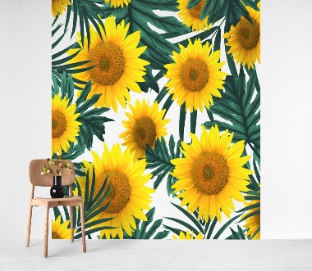
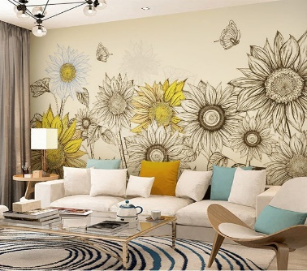

Science – This half term we are going to be continuing with the focus on plants and trees.
I would like you to keep a diary of what you do each day to look after your sunflower. Try and take weekly measurements of your sunflower and record it somewhere in your diary.

Think about what you did when you planted your sunflower seeds and write a set of instructions for how to plant a sunflower seed. Remember to include everything that will be needed to plant the seed.

- Let’s get physical!
Join in with Joe Wicks – The Body Coach on YouTube each day
or
Do something active with your family once a day- maybe you could learn a new skill/game!

Cosmic yoga - https://www.youtube.com/watch?v=LhYtcadR9nw

Pray Together
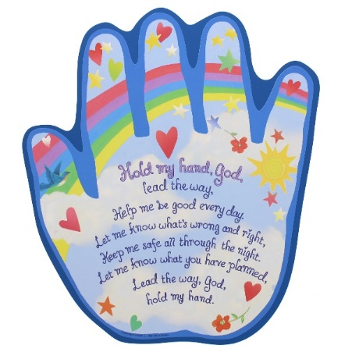

Additional learning resources parents may wish to engage with
Classroom Secrets Learning Packs - These packs are split into different year groups and include activities linked to reading, writing, maths and practical ideas you can do around the home.
Twinkl - to access these resources click on the link and sign up using your own email address and creating your own password. Use the offer code UKTWINKLHELPS.
Oxford Owl – eBooks for children aged 3-7 (free but need to register)
EducationQuizzes.com – Lots of different quizzes in all subjects for KS1 (free with no login)
www.ictgames.co.uk - maths and English games
www.topmarks.co.uk - online games
Explorify – Science quizzes (free but need to register).
Headteacherchat - This is a blog that has links to various learning platforms. Lots of these are free to access.

Teacher Tips
- Remember - in a normal school day, there are several ‘break times’ throughout the day, so make sure as well as ensuring they complete their work, you build in ‘relaxation’ time. For you as well as the children!

- If the children are really engaged and interested in something, see what cross curricular links you can make. If they are in to trains, could they design a poster for a train exhibition, build a train out of cardboard, write an adventure story about a train journey, research facts about railways etc Capitalise on their interests and don't worry too much if it ‘fits’ into their weekly learning.

