St Joseph’s Catholic Primary School - LEARNING AT HOME PLANNING
YEAR 2
Date - WC 27th April 2020
Weekly Mathematics Tasks  (Aim to do 1 per day) | Weekly Reading Tasks  (Aim to do 1 per day)
- Working on Times Table Rockstars - your child will have an individual login to access this (20 mins).  - Continue to practise daily calculations. Use the website below to set the calculations. Remember when adding and subtracting set it to 2-digit numbers on the website.  https://www.topmarks.co.uk/maths-games/daily10  - Investigate different ways to make £1.16. e.g 50p + 50p + 10p + 5p +1p. Remember you can only use real coins. There is no 6p coin!  - Exchanging coins – Find the smallest amount of coins you could exchange for £1.00 and the largest amount of coins. E.g. if exchanging 10p the smallest amount of coins would be 2 5pence coins and largest amount of coins would be 10 1pence coins.  - Complete the attached resource for exchanging money.  - Children to compare the different amounts of money shown on the attached resources. | - Your child could read a story/ poem / nursery rhyme to another family member. This could be to a younger sibling before bedtime or they may wish to Facetime an elderly relative (with adult supervision of course).  - Listen to your child read and let them discuss what they have read. Encourage them to read with expression and intonation.  - Get your child to read a book on Oxford Owl, discuss what your child enjoyed about the book.  - Complete the attached common exception wordsearch.  - Complete the attached reading comprehension.
Weekly Spelling Tasks  (Aim to do 1 per day) | Weekly Writing Tasks  (Aim to do 1 per day)
What is this week’s focus? the /r/ sound spelt ‘wr’ at the beginning or words.  - wrong  - wrap  - wrote  - wreck  - write  - wrist  - wreath  - wrinkle  - wren  - wriggle  Can they improve their score each day?  Can you include any of these words in a sentence? | - Invent a new animal. Draw and describe what it looks like, what it sounds like, how it moves, and what it eats. Is it scary or cuddly or something else altogether? Would it be a pet or live in the wild?  - Plan and write a story about the animal that you have created. Remember the structure of a good story.  - Set the scene and introduce the character.  - Problem.  - Problem resolved.  Try and include as many of the skills we had learnt in school. E.g. expanded now phases, writing in the correct tense, suffixes and adverbs.  I would love to see some of these stories shared on twitter.  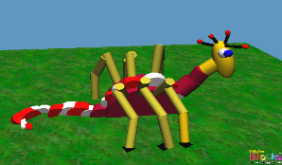  - Write a set of instructions for looking after the animal you have created.  - Complete the attached grammar sheet.

Foundation subjects and Learning Project - to be done throughout the week
- Art – Children to create their own piece of artwork that is inspired by Banksy. Get the children to make their own stencil and spray paint. The spray paint can be made by mixing some paint and water and then pouring it into a spray bottle.
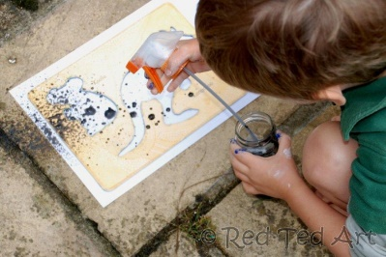
Follow the link provided for more information.
https://www.redtedart.com/kids-get-arty-exploring-street-art-banksy/

- Geography – Use the attached sheet to think of your own
human and physical features. Then try and create a miniature
model of a place and include both physical and human
features.

- Science – Research what plants need to grow and why they ae important. You could watch the video clip in the link provided. https://www.bbc.co.uk/bitesize/topics/zpxnyrd/articles/zxxsyrd
Children can then complete the sentences on the attached sheet.

- Let’s get physical!
Join in with Joe Wicks – The Body Coach on YouTube each day
or
Do something active with your family once a day- maybe you could learn a new skill/game!

Pray Together
The Gospel for the coming Sunday can be found at http://universalis.com/mass.htm

Read it together. What do you think it tells us about how we can live our lives?

Additional learning resources parents may wish to engage with
Classroom Secrets Learning Packs - These packs are split into different year groups and include activities linked to reading, writing, maths and practical ideas you can do around the home.
Twinkl - to access these resources click on the link and sign up using your own email address and creating your own password. Use the offer code UKTWINKLHELPS.
Oxford Owl – eBooks for children aged 3-7 (free but need to register)
EducationQuizzes.com – Lots of different quizzes in all subjects for KS1 (free with no login)
www.ictgames.co.uk - maths and English games
www.topmarks.co.uk - online games
Explorify – Science quizzes (free but need to register).
Headteacherchat - This is a blog that has links to various learning platforms. Lots of these are free to access.

Teacher Tips
- Remember - in a normal school day, there are several ‘break times’ throughout the day, so make sure as well as ensuring they complete their work, you build in ‘relaxation’ time. For you as well as the children!

- If the children are really engaged and interested in something, see what cross curricular links you can make. If they are in to trains, could they design a poster for a train exhibition, build a train out of cardboard, write an adventure story about a train journey, research facts about railways etc Capitalise on their interests and don't worry too much if it ‘fits’ into their weekly learning.

