St Joseph’s Catholic Primary School - LEARNING AT HOME PLANNING
YEAR 2
Date - WC 11th May 2020
Weekly Mathematics Tasks  (Aim to do 1 per day) | Weekly Reading Tasks  (Aim to do 1 per day)
- Working on Times Table Rockstars - your child will have an individual login to access this (20 mins).  - Continue to practise daily calculations. Use the website below to set the calculations. Remember when adding and subtracting set it to 2-digit numbers on the website.  https://www.topmarks.co.uk/maths-games/daily10  2D Shapes  - Children to recognise how many sides different shapes have. Discuss with the children if all four sided shapes have to look the same.  Children to draw as many shapes as they can that have 4 sides. Discuss with the children that 4 sided shapes are also called quadrilaterals. Then try and draw as many shapes as they can that have 5 sides.  e.g. 4 sides  5 sides  - Discuss with the children what a polygon is. Ask the children to draw a range of shapes that are polygons and shapes that are not polygons.  - Identifying vertices  Discuss with the children what vertices are on 2D shapes and explore different shapes couting the sides and vertices. Give the children clues such as how many sides and vertices a shape has and see if they can guess the shape correctly. You could even swap roles.  - Children could complete the attached sheet to show their understanding of counting the sides and vertices of 2D shapes.  - Lines of symmetry  Children could you a small mirror if you have one available to investigate lines of symmetry on different 2D shapes (children could draw the 2D shapes but may need some help ensuring they are accurate ready for identifying the lines of symmetry). If you don’t have a small mirror available, the children could cut the shapes out and fold the shape where they think the line of symmetry is. | - Your child could read a story/ poem / nursery rhyme to another family member. This could be to a younger sibling before bedtime or they may wish to Facetime an elderly relative (with adult supervision of course).  - Listen to your child read and let them discuss what they have read. Encourage them to read with expression and intonation.  - Get your child to read a book on Oxford Owl, discuss what your child enjoyed about the book.  - MISSING POSTER  Create a wanted poster for a  character from a book that you are  reading. Include a description, what they did and a reward.  - Complete the attached reading comprehension.
Weekly Spelling Tasks  (Aim to do 1 per day) | Weekly Writing Tasks  (Aim to do 1 per day)
What is this week’s focus? The /l/ or /ul/ sound spelt el (this spelling is less common than le and is used often after m, n, r, s, v, w and more often than not after s.  - camel  - tunnel  - squirrel  - travel  - tinsel  - level  - channel  - towel  - diesel  - shovel  Can they improve their score each day?  Can you include any of these words in a sentence? | - Read "The True Story of the Three Little Pigs" (by Jon Scieszka). This tells the "Three Little Pigs" story from the wolf's point of view.  You can listen to the story using the link below  https://www.youtube.com/watch?v=vB07RfntTvw  Ask the children to think of a story that they know well, and to write another version from another point of view.  e.g. Write "Cinderella" from the point of view of one of the ugly sisters,  OR Write "The Three Billy Goats Gruff" from the point of view of the troll,  OR Write "Goldilocks and the Three Bears" from the point of view of Goldilocks.  - Watch the video “The Way Back Home”  https://www.literacyshed.com/thewaybackhome.html.  Children to then write a diary in role of the young boy.  - Grammer – children to complete the attach sheet which focuses on verbs and adverbs.

Foundation subjects and Learning Project - to be done throughout the week
Art – A new Banksy artwork has appeared at Southampton General Hospital. The artwork shows a young boy kneeling by a wastepaper basket dressed in dungarees and a T-shirt. He has discarded his Spiderman and Batman model figures in favour of a new favourite action hero - an NHS nurse
Could you try and design your own piece of artwork to support the NHS?
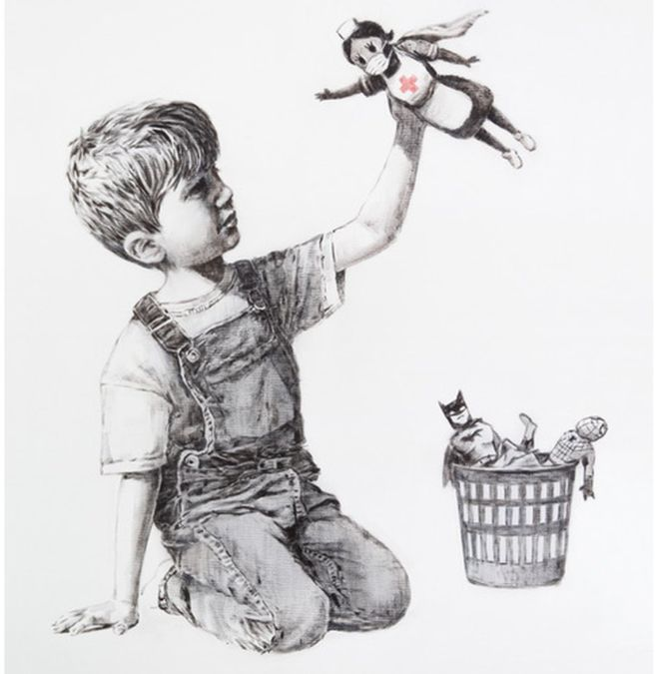

Geography – Show children the map of the UK on the attached power point and ask them how many of the labels can they fill in? Then explain that even though each of the countries belongs to the UK, they all have their own features and characteristics.
Children to use the information on the power point and the facts provided to answer the questions about the different countries on the attached sheet.

- Science – Watch the video using the link below, which explains a little about deciduous and evergreen trees. Then if you go for a walk with your family look for how many different types of trees you can find and try and decide if they are evergreen or deciduous. Maybe you could draw what a deciduous tree looks like during the different seasons.
https://www.bbc.co.uk/teach/class-clips-video/science-ks1-ks2-ivys-plant-workshop-are-plants-the-same-all-year-round/zdvct39

- Let’s get physical!
Join in with Joe Wicks – The Body Coach on YouTube each day
or
Do something active with your family once a day- maybe you could learn a new skill/game!

Pray Together
Additional learning resources parents may wish to engage with
Classroom Secrets Learning Packs - These packs are split into different year groups and include activities linked to reading, writing, maths and practical ideas you can do around the home.
Twinkl - to access these resources click on the link and sign up using your own email address and creating your own password. Use the offer code UKTWINKLHELPS.
Oxford Owl – eBooks for children aged 3-7 (free but need to register)
EducationQuizzes.com – Lots of different quizzes in all subjects for KS1 (free with no login)
www.ictgames.co.uk - maths and English games
www.topmarks.co.uk - online games
Explorify – Science quizzes (free but need to register).
Headteacherchat - This is a blog that has links to various learning platforms. Lots of these are free to access.

Teacher Tips
- Remember - in a normal school day, there are several ‘break times’ throughout the day, so make sure as well as ensuring they complete their work, you build in ‘relaxation’ time. For you as well as the children!

- If the children are really engaged and interested in something, see what cross curricular links you can make. If they are in to trains, could they design a poster for a train exhibition, build a train out of cardboard, write an adventure story about a train journey, research facts about railways etc Capitalise on their interests and don't worry too much if it ‘fits’ into their weekly learning.

