CORE  THEME |  | MODULE 1  CREATED & LOVED BY GOD |  |  |  | MODULE 2  CREATED TO LOVE OTHERS |  |  | MODULE 3  CREATED TO LIVE IN COMMUNITY
 |  | Autumn |  |  |  | Spring |  |  | Summer
TOPIC |  | Unit 1  Religious Understanding | Unit 2  Me, my body, my health | Unit 3  Emotional well-being | Unit 4  Life-cycles | Unit 1  Religious Understanding | Unit 2  Personal Relationships | Unit 3  Keeping Safe | Unit 1  Religious Understanding | Unit 2  Living in the Wider World
EYFS |  | Unit Prayer  Assessment Activity | Unit Prayer  Assessment Activity | Unit Prayer  Assessment Activity | Unit Prayer  Assessment Activity | Unit Prayer  Assessment Activity | Unit Prayer  Assessment Activity | Unit Prayer  Assessment Activity | Unit Prayer  Assessment Activity | Unit Prayer  Assessment Activity
 |  | Story Sessions:  Handmade with  Love  *NEW* | Session 1  I Am Me  *NEW*  Session 2  Heads, Shoulders, Knees and Toes  *NEW*  Session 3  Ready Teddy?  *NEW* | Session 1  I Like, You Like, We All Like!  *NEW*  Session 2  Good Feelings, Bad Feelings  *NEW*  Session 3  Let's Get Real  *NEW* | Session 1  Growing Up  *NEW* | Session1  Role Model  *NEW* | Session 1  Who’s Who?  *NEW*  Session 2  You’ve Got a Friend in Me  *NEW*  Session 3  Forever Friends  *NEW* | Session 1  Safe Inside and Out *NEW*  Session 2  My Body, My Rules *NEW*  Session 3  Feeling Poorly  *NEW*  Session 4:  People Who Help Us *NEW* | Session 1  God is Love  *NEW*  Session 2  Loving God, Loving Others  *NEW* | Session 1  Me, You, Us  *NEW*
 |  | 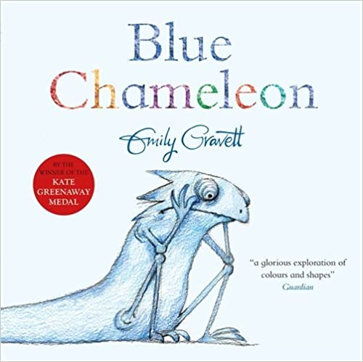 |  |  |  | 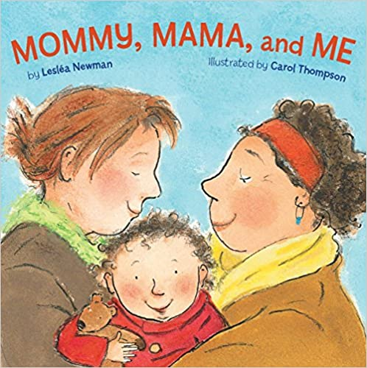 |  |  | 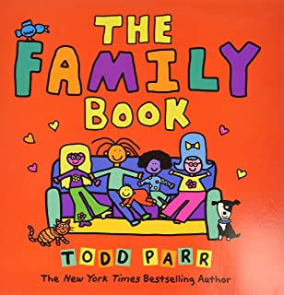
CORE  THEME | Year 1 | MODULE 1  CREATED & LOVED BY GOD |  |  |  | MODULE 2  CREATED TO LOVE OTHERS |  |  | MODULE 3  CREATED TO LIVE IN COMMUNITY
KEY  STAGE  ONE |  | Autumn |  |  |  |  |  | Spring | Summer
 |  | Unit 1  Religious Understanding | Unit 2  Me, my body, my health | Unit 3  Emotional well-being | Unit 4  Life-cycles | Unit 1  Religious Understanding | Unit 2  Personal Relationships | Unit 3  Keeping Safe | Unit 1  Religious Understanding | Unit 2  Living in the Wider World
 |  | Unit Prayer  Assessment Activity | Unit Prayer  Assessment Activity | Unit Prayer  Assessment Activity | Unit Prayer  Assessment Activity | Unit Prayer  Assessment Activity | Unit Prayer  Assessment Activity | Unit Prayer  Assessment Activity | Unit Prayer  Assessment Activity | Unit Prayer  Assessment Activity
 |  | Story Sessions:  Let the Children  Come  *NEW* |  |  |  | Session 1:  God Loves You | Session 1:  Special People  Session 2:  Treat Others Well…  Session 3:  …and Say Sorry | Session 1:  Being Safe  Session 2:  Good Secrets & Bad Secrets  Session 3:  Physical Contact  Session 4:  Harmful Substances *NEW*  Session 5:  Can You Help Me? (can be split into 2)  *NEW* | Session 1:  Three in One  *Updated*  Session 2:  Who Is My  Neighbour? | Session 1:  The Communities We Live In
 |  | 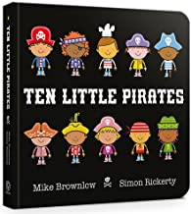 |  |  |  |  |  | 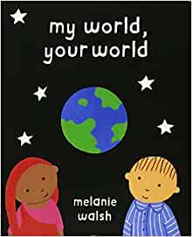 | 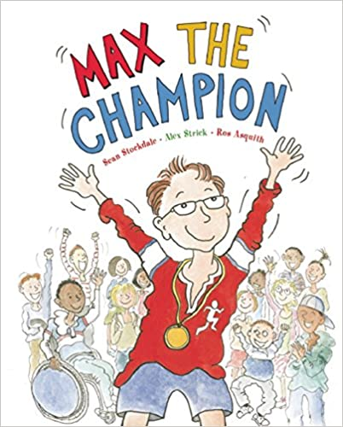
 | Year 2 | MODULE 1  CREATED & LOVED BY GOD |  |  |  | MODULE 2  CREATED TO LOVE OTHERS |  |  | MODULE 3  CREATED TO LIVE IN COMMUNITY
 |  | Unit 1  Religious Understanding | Unit 2  Me, my body, my health | Unit 3  Emotional well-being | Unit 4  Life-cycles | Unit 1  Religious Understanding | Unit 2  Personal Relationships | Unit 3  Keeping Safe | Unit 1  Religious Understanding | Unit 2  Living in the Wider World
 |  | Autumn |  | Spring |  |  |  |  | Summer
 |  | Story Sessions:  Let the Children  Come  *NEW* | Session 1:  I am Unique  Session 2:  Girls and Boys  Just teach the vocab ‘PENIS & VAGINA’ not the other genitalia  Session 3 & 4  (two sessions):  Clean & Healthy  *Updated* | Session 1:  Feelings, Likes and Dislikes  Session 2:  Feeling Inside Out  Session 3:  Super Susie Gets Angry | Session 1:  The Cycle of Life  *Updated* |  |  |  | Session 1:  Three in One  *Updated*  Session 2:  Who Is My  Neighbour? | Session 1:  The Communities We Live In
 |  |  |  | 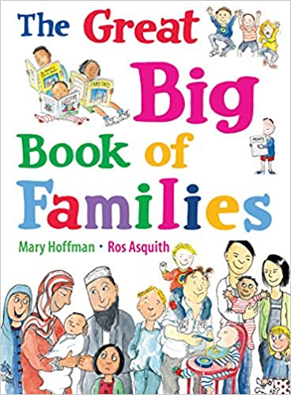 |  |  |  |  | 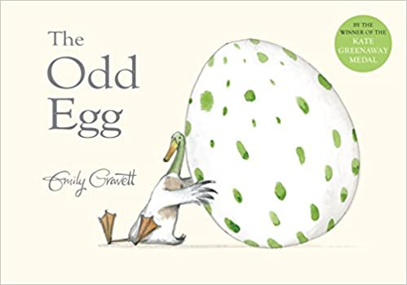
CORE  THEME | Year 3 | MODULE 1  CREATED & LOVED BY GOD |  |  |  | MODULE 2  CREATED TO LOVE OTHERS |  |  | MODULE 3  CREATED TO LIVE IN COMMUNITY
 |  | Autumn |  |  |  |  |  | Spring | Summer
LOWER  KEY  STAGE  TWO |  | Unit 1  Religious Understanding | Unit 2  Me, my body, my health | Unit 3  Emotional well-being | Unit 4  Life-cycles | Unit 1  Religious Understanding | Unit 2  Personal Relationships | Unit 3  Keeping Safe | Unit 1  Religious Understanding | Unit 2  Living in the Wider World
 |  | Unit Prayer  Assessment Activity | Unit Prayer  Assessment Activity | Unit Prayer  Assessment Activity | Unit Prayer  Assessment Activity | Unit Prayer  Assessment Activity | Unit Prayer  Assessment Activity | Unit Prayer  Assessment Activity | Unit Prayer  Assessment Activity | Unit Prayer  Assessment Activity
 |  | Session 1:  Get Up!  *NEW*  Session 2:  The Sacraments  *Updated* |  |  |  | Story Sessions:  Jesus, My Friend | Session 1:  Friends, Family and Others  Session 2:  When Things Feel Bad | Session 1:  Sharing Online  Session 2:  Chatting Online  Session 3:  Safe in My Body  Session 4:  Drugs, Alcohol and Tobacco  *NEW*  Session 5:  First Aid Heroes  *NEW* | Session 1:  A Community of  Love  *Updated*  Session 2:  What is the Church? | Session 1:  How Do I Love  Others?
 |  | 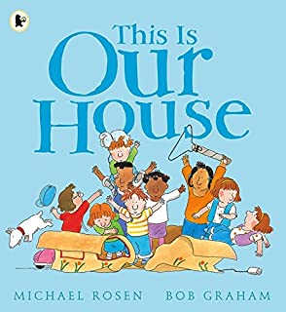 |  |  |  |  |  | 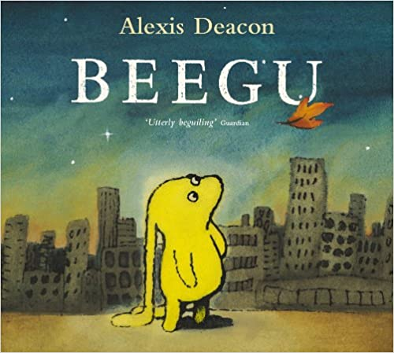 | 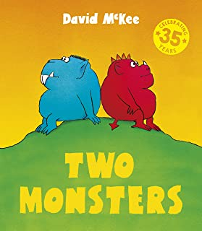
 | Year 4 | MODULE 1  CREATED & LOVED BY GOD |  |  |  | MODULE 2  CREATED TO LOVE OTHERS |  |  | MODULE 3  CREATED TO LIVE IN COMMUNITY
 |  | Unit 1  Religious Understanding | Unit 2  Me, my body, my health | Unit 3  Emotional well-being | Unit 4  Life-cycles | Unit 1  Religious Understanding | Unit 2  Personal Relationships | Unit 3  Keeping Safe | Unit 1  Religious Understanding | Unit 2  Living in the Wider World
 |  | Autumn |  | Spring |  |  |  |  | Summer
 |  | Session 1:  Get Up!  *NEW* | Session 1:  We Don’t Have To Be The Same  Session 2:  Respecting Our  Bodies | Session 1:  What Am I Feeling?  Session 2:  What Am I Looking At?  Session 3:  I Am Thankful! | Session 1 (Yr4+): Life Cycles |  |  |  | Session 1:  A Community of  Love  *Updated*  Session 2:  What is the Church? | Session 1:  How Do I Love  Others?
 |  | 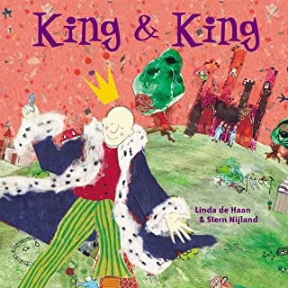 |  | 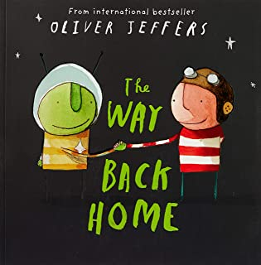 |  |  |  |  | 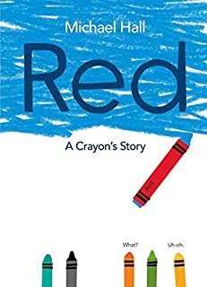
CORE  THEME |  | MODULE 1  CREATED & LOVED BY GOD |  |  |  | MODULE 2  CREATED TO LOVE OTHERS |  |  | MODULE 3  CREATED TO LIVE IN COMMUNITY
UPPER  KEY  STAGE  TWO | Year 5 | Unit 1  Religious Understanding | Unit 2  Me, my body, my health | Unit 3  Emotional well-being | Unit 4  Life-cycles | Unit 1  Religious Understanding | Unit 2  Personal Relationships | Unit 3  Keeping Safe | Unit 1  Religious Understanding | Unit 2  Living in the Wider World
 |  | Autumn |  |  |  | Spring |  | Summer
 |  | Unit Prayer  Assessment Activity | Unit Prayer  Assessment Activity | Unit Prayer  Assessment Activity | Unit Prayer  Assessment Activity | Unit Prayer  Assessment Activity | Unit Prayer  Assessment Activity | Unit Prayer  Assessment Activity | Unit Prayer  Assessment Activity | Unit Prayer  Assessment Activity
 |  | Story Sessions:  Calming the Storm *NEW* | From LKS2 Planning:  Session 3 (Yr4+) What is Puberty?  Session 4 (Yr4+) Changing Bodies |  |  | Session 1:  Is God Calling You? | Session 1:  Under Pressure  Session 2:  Do You Want a  Piece of Cake?  Session 3:  Self-Talk | Session 1:  Sharing Isn’t Always Caring  Session 2:  Cyberbullying  Session 3:  Types of Abuse  Session 4:  Impacted Lifestyles  Session 5:  Making Good  Choices  *NEW*  Session 6:  Giving Assistance *NEW* | Session 1:  The Trinity  *Updated*  Session 2:  Catholic Social  Teaching | Session 1:  Reaching Out
 |  | 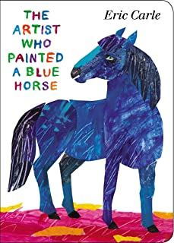 |  |  |  | 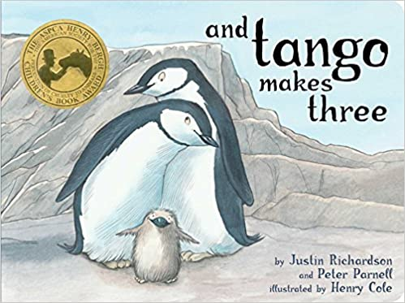 |  | 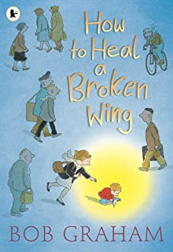
 | Year 6 | MODULE 1  CREATED & LOVED BY GOD |  |  |  | MODULE 2  CREATED TO LOVE OTHERS |  |  | MODULE 3  CREATED TO LIVE IN COMMUNITY
 |  | Unit 1  Religious Understanding | Unit 2  Me, my body, my health | Unit 3  Emotional well-being | Unit 4  Life-cycles | Unit 1  Religious Understanding | Unit 2  Personal Relationships | Unit 3  Keeping Safe | Unit 1  Religious Understanding | Unit 2  Living in the Wider World
 |  | Autumn |  | Spring |  |  |  |  | Summer
 |  | Story Sessions:  Calming the Storm *NEW* | Session 1:  Gifts and Talents  Session 2:  Girls’ Bodies  Session 3:  Boys’ Bodies  Session 4:  Spots and Sleep | Session 1:  Body Image  Session 2:  Peculiar Feelings  Session 3:  Emotional Changes  Session 4:  Seeing Stuff Online | Session 1:  Making Babies (P1)  NOT Session 2  Session 3:  Menstruation |  |  |  | Session 1:  The Trinity  *Updated*  Session 2:  Catholic Social  Teaching | Session 1:  Reaching Out
 |  | 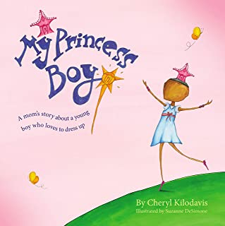 |  | 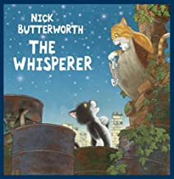 |  |  |  |  | 