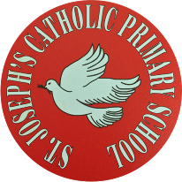
St Joseph’s Catholic Primary School - LEARNING AT HOME PLANNING
YEAR 3
Date WC 15th June 2020
Weekly Mathematics Tasks  (Aim to do 1 per day) | Weekly Reading Tasks  (Aim to do 1 per day)
- Continue to play on Times Table Rockstars! It would lovely to see some more of you joining in with our sessions. Why not challenge one of your friends to a Rock Slam? You can even challenge your teacher!  Remember we are also looking at the scores and choosing Stars of the week!  - Well done to everybody who completed a challenge on Numbots last week. Can you complete a different challenge this week?  - Complete the next pages from the multiplication and division booklet (attached below).  - https://www.youtube.com/watch?v=ZWvp2TQ428Q  Watch this video. Can you create your own tally chart and bar chart based on the traffic you see?  - Answer the questions about the bar graph on the worksheet below. | - Complete the 60 second read attached below ‘The Rosetta Stone’.  - Complete the reading comprehension attached below to learn more about the artist Steven Brown.  - Choose a book and then write a new blurb for it. Can you summarise what happens in the story in 5 sentences?  - Read chapter 1 of ‘The Story of Osiris’ attached below (alternatively you can listen to the first chapter being read here https://www.youtube.com/watch?v=VQgO9e8b314&feature=youtu.be) then complete the sheets attached below.
Weekly Spelling Tasks  (Aim to do 1 per day) | Weekly Writing Tasks  (Aim to do 1 per day)
Words in ending in –ary  library February  dictionary boundary  salary summary  primary secondary  ordinary necessary  - Write a sentence with 5 of these words.  - Complete the ‘Which Word Where?’ sheet. | Activity 1  - Look at the clip The Journey https://www.youtube.com/watch?v=DRsmuveKWuk 1.11-1.56  - Look at the part where the girl goes through the door into a woods.  What would the atmosphere be like? How would she feel? Imagine you are the girl at this point in the story, write a short diary entry.  - Watch this video to recap what an expanded noun phrase is.  https://www.youtube.com/watch?v=4fCk8ye4jio  - Now use the method from the video to write some expanded noun phrases to describe what the girl can see in the woods.  - Use the grid attached below to help you to add even more information to your sentences to make them more interesting.  Activity 2  - Fill in the grid below to describe what the girl saw as she approached the Citadel and how she felt at each point. There are some ideas from the story to help you underneath.  - Recap on how to use inverted commas. https://www.bbc.co.uk/bitesize/topics/zvwwxnb/articles/ztcp97h  - Write a conversation between one of the guards and the girl. Was he friendly or bossy?  - Login to SPAG.com (see last week’s sheet for login details) and complete the direct speech task that has been set for you.
Foundation subjects and Learning Project - to be done throughout the week
- RE- This week is Refugee Week – ‘Help Them Feel at Home’ tells the story of a young refugee named Sana and a toy dinosaur named Dino and their difficult journey to find safety in the UK. Watch the animated poem before you complete the activity attached below – ‘Feeling Safe and Happy.’ https://vimeo.com/418420320

- Art- Look at Steven Brown’s picture of giraffes.
Practise drawing giraffes in different poses using these videos to help you.
- https://www.howtodrawanimals.net/how-to-draw-a-giraffe for a step by step guide for full size giraffe or watch this video
- https://www.youtube.com/watch?v=4ibTTtEHjNA and take it step by step for the giraffes face.

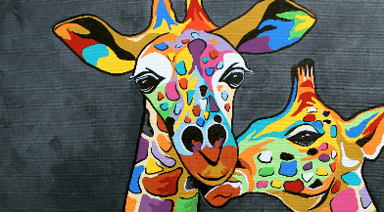

- Geography
This week we are looking at settlements and why people settled where they did.
- Complete the starter activity.
- Look at the information given about the 4 different settlements below and decide which one you would like to build your settlement in. Give reasons why.
- Draw a plan of your settlement. Think about what you would need to survive- a home, food, water etc.

- History
This week we are thinking about what it was like to live in Ancient Egypt.
- Look at the timeline attached below. Can you sort the events into the correct order?
- Watch this clip and read the information provided below to find out what life was like in Ancient Egypt.
https://www.bbc.co.uk/bitesize/topics/zg87xnb/articles/zr4s8xs/
- Imagine you were a child in that time make a fact file about your home and what you ate for different meals.

- Science
Complete this lesson about the conditions a plant needs.
https://classroom.thenational.academy/lessons/plants-what-conditions-could-we-change-to-investigate-the-growth-of-a-pl

- Music
Login to ‘YUMU’ and continue the assignment ‘Reflect, Rewind and Replay – Step 2’

Let’s get physical!
Follow these links to find lots of different activities and challenges.
https://primarypeplanning.com/home-pe-ks2-activities/

https://www.chancetoshine.org/staying-active-during-the-covid-19-outbreak#h_66039831311586267782474

Also keep up practising your cricket skills that you have learnt over the previous weeks!

Pray together
Jesus, friend and brother,
You know how it feels to leave your home and family,
To carry nothing with you, to travel as a stranger.
Help all refugees far from home, driven out by war and hunger.
Lead them safely on.
They are our sisters and brothers.
Inspire us to show our love and a true welcome.
Amen.

Additional learning resources parents may wish to engage with
Duolingo – A free app for your phone for students to work on their language skills, or try a new language.

YouTube has Learn@Home, a website with learning resources and content for families – from popular learning channels such as Khan Academy, Sesame Street and code.org – for help with maths, science, history and arts. You can also visit the YouTube Learning destination for more videos and helpful resources.

https://act.friendsoftheearth.uk/act/sign-get-your-free-planet-friendly-activities

Teacher Tips
We hope you are all okay. We are missing the children very much and would love to hear how they are getting on. If you are able to tweet any of their work, we would love to see it!

Keep looking on the school twitter page for any updates and messages.
Take care xxx

Can you use the partitio ning method to solve these division problems?

Interpreting data from a graph

- On which day were the most ice creams sold? How many were sold?

- When were the least ice creams sold? How many were sold?

- How many more ice creams were sold on Sunday than Friday?

- What was the second most popular day for buying ice creams?

- Why do you think ice creams were most popular at the weekend?

- Why do you think there were so few ice creams sold on Monday and Thursday?

What other questions could we ask about this graph? Think of 3 of your own.

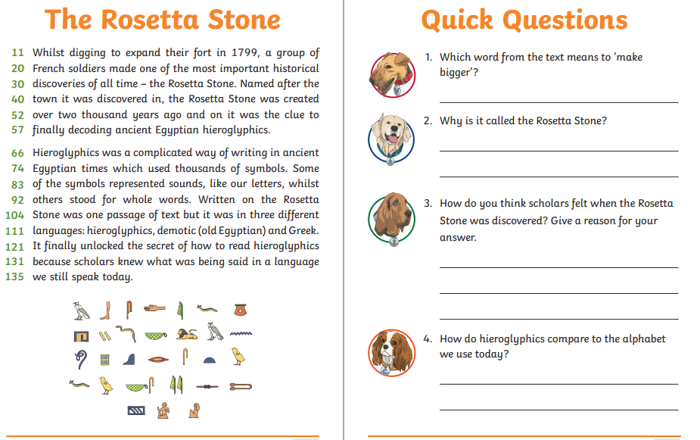

Geography- Settlements

