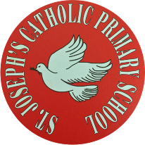
St Joseph’s Catholic Primary School - LEARNING AT HOME PLANNING
YEAR 3
Date WC 1st June 2020
Weekly Mathematics Tasks  (Aim to do 1 per day) | Weekly Reading Tasks  (Aim to do 1 per day)
- Continue to play on Times Table Rockstars! It would lovely to see some more of you joining in with our sessions and battles. We have set up a boys v girls battle between Year 3 over the next 2 weeks. Remember we are also looking at the scores and choosing Stars of the week!  Continue to play on Numbots daily as well.  - Complete the 5-a day for 2nd June at https://corbettmathsprimary.com/wp-content/uploads/2018/06/bronze-june-2.pdf  - Complete the three pages below from the Multiplication and Division booklet. Use equipment (e.g. beads, pasta pieces) to help you if you need to.  - Watch this video about creating pictograms. https://www.youtube.com/watch?v=mSk5MnkHJao  Then complete the worksheets below to create your own pictograms. | - Read a few pages from ‘The Book of Hopes’ each day. This is a collection of short stories and poems to comfort, inspire and entertain children during school closures.  https://literacytrust.org.uk/family-zone/9-12/book-hopes/  - Complete the reading comprehension attached below - The Friendly Feline  - You should all now have received your  sunflower gift (please let us know if not).  Read some interesting facts about sunflowers https://kids.kiddle.co/Sunflower
Weekly Spelling Tasks  (Aim to do 1 per day) | Weekly Writing Tasks  (Aim to do 1 per day)
- What sound does the ‘ou’ make in each of these words?  young country  double rough  trouble tough  touch cousin  enough courage  In these words the short sound /u/ is spelt with the letters ou.  - Play one of these spelling games to practise the sound /u/ when spelt ou.  https://www.spellzone.com/word_lists/games-180.htm  - Complete the wordsearch attached below to practise this week’s spellings. | - Complete the handwriting sheet below for the ‘ou’ grapheme.  - Watch this short video to learn about the present perfect tense.  https://www.youtube.com/watch?v=LWubbhIr0Og  - Complete the worksheet attached and sort the sentences into present perfect and simple past. Sounds tricky so look at these examples to help you. I walked past the cricket club.  (walked - past tense)  I have walked past the cricket club. (have walked - present perfect tense)  - This week, watch the first 55 seconds of  the video telling the story of our book ‘Journey’.  https://www.youtube.com/watch?v=DRsmuveKWuk  Write a diary entry by the little girl about her day so far. Look at the pictures below and use the planner to help you. Can you use the present perfect tense in your writing?

Foundation subjects and Learning Project - to be done throughout the week
RE
- On the day of Pentecost, the Holy Spirit came in the form of wind and tongues of fire. St Paul uses the image of fruits to explain to us the type of help that the Holy Spirit gave to the disciples and to us today. Look at this power point and find out what the fruits of the Spirit are - https://www.twinkl.co.uk/resource/roi2-re-241-the-fruits-of-the-holy-spirit-powerpoint
- Think about the things that you can do or say that will show others the Holy Spirit is alive in you. Write your own prayer to the Holy Spirit asking for his help during these times.

Music
- Well done to those children who have finished the assignment -‘Bringing Us Together’. Celebrate by performing the song to someone in your family.

History: Ancient Egypt
This week we are looking at what is inside a pyramid. What was discovered?
- Watch this clip and go inside an Egyptian pyramid. What will you discover there? https://www.bbc.co.uk/teach/class-clips-video/history-social-studies-ks2-tombs-in-ancient-egypt/zh276v4
- Use the information attached to help you design your own pyramid for a pharaoh. What will you put into your pyramid?

Geography: Rivers
This week we will continue looking at places along the route of the River Mersey.
- Can you add any more information to your booklet? Use the information below to find out any other facts about the places the Mersey flows through.

Let’s get physical!
- Cricket skills – Continue to practise bowling with a straight arm. It would be great to see a video of you practising your cricket skills on twitter.
Continue to practise your bowling.
Find something safe to bowl towards, maybe a bin or a wall.
No broken flowers or gnomes please!

- Physical Skills Challenge – Look at the activities below. How many challenges can you complete?

Pray together
The 5 Finger Prayer
- Thumb – Your thumb is the closest to your heart. So, start here by praying for those closest to you.
- Index Finger – Pray for those who teach and guide.
- Middle Finger – Pray for leaders. This is your tallest finger and reminds us to pray for those in charge.
- Ring Finger – Your ring finger (the fourth finger) is your weakest finger. This one reminds us to pray for the weak and needy.
- Pinkie Finger – Pray for yourself.

- We would love for all of Year 3 to learn how to sign the Hail Mary.
Watch the you tube clip and follow the children.
https://www.youtube.com/watch?v=PglEF7mTf2E

Additional learning resources parents may wish to engage with
- BBC Bitesize – Lots of free resources here with videos and quizzes, too.

- Purple Mash – Resources aimed at primary school-aged children have been made free now schools have closed.

- ReadingWise has made their literacy materials free during the school closures.

Teacher Tips
Mindfulness – Taking care of our mental wellbeing is VERY important.
Find a quiet moment and follow the instructions on this link. You could ask your family to join in with you:
https://family.gonoodle.com/activities/from-mindless-to-mindful
Choose a Mindfulness Challenge card to complete each day.

Journey by Aaron Becker

Plan together a short diary entry in role as the girl. Talk about what the girl does during the day. Who does she talk to? What are they doing?
Paragraph 1 | Paragraph 2 | Paragraph 3
What I have done today | How I feel | Hopes and Wishes

Now use your plan to write the diary entry. Remember to try and use some present perfect tense.

Geography – River Mersey
Use the information below to add facts to your booklet about the River Mersey.

History – Ancient Egypt
Now imagine you are designing a pyramid for a pharaoh. What would the chambers be like? What treasures would you put inside your pyramid?

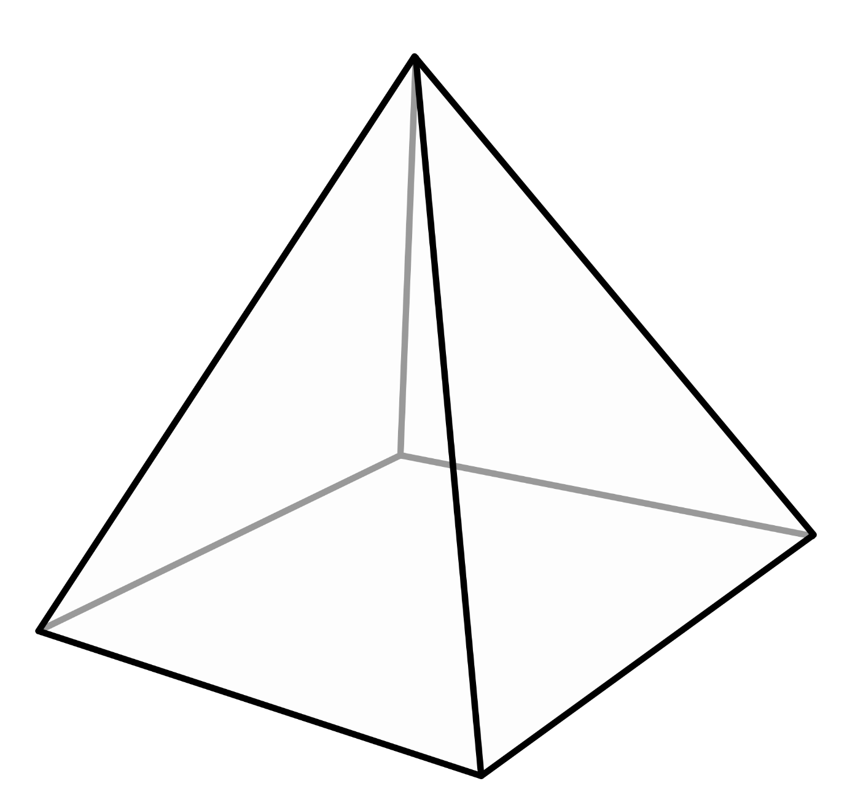

Physical Skills Challenge

