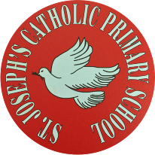
St Joseph’s Catholic Primary School - LEARNING AT HOME PLANNING
YEAR 3
Date WC 22nd June 2020
Weekly Mathematics Tasks  (Aim to do 1 per day) | Weekly Reading Tasks  (Aim to do 1 per day)
- Continue to play on Times Table Rockstars! It would be lovely to see some more of you joining in with our sessions. Why not challenge one of your friends to a Rock Slam? You can even challenge your teacher!  Remember we are also looking at the scores and choosing Stars of the week!  - Well done to everybody who completed a challenge on Numbots last week. This is the last week that it will be available to us so please make the most of it and see how many challenges you can complete!  - Complete the next pages from the multiplication and division booklet (attached below).  - This week we are moving on to learning about fractions.  Watch this video https://www.youtube.com/watch?v=6yj-nTVFvKQ to complete the maths lesson on counting in tenths.  - Complete the worksheets attached below. | - Read chapter 2 of ‘The Story of Osiris’ attached below (alternatively you can listen to the first chapter being read here https://www.youtube.com/watch?v=VQgO9e8b314&feature=youtu.be) then complete the sheets attached below.  - This is our new book!  What do you think this book is about?  Where do you think this story takes place?  Now listen to this music.  https://www.youtube.com/watch?v=W05LPtVm5hY  - Open this link and listen to the first part of the story.  https://www.youtube.com/watch?v=cbDoohUikyE
Weekly Spelling Tasks  (Aim to do 1 per day) | Weekly Writing Tasks  (Aim to do 1 per day)
- Practise this week’s spellings below using – Look, Cover, Write, Check  - Complete the sentences attached below and fill in the missing words. | - Look at all the pictures attached below. Is this story fact or fiction? How do you know?  - Write about the first chapter - Describe the setting and feelings of the characters.  - Login to SPAG.com and complete the ‘prefixes’ task that has been set for you.  - Practise your handwriting using ‘Writing Repeater’ on ICT Games. www.ictgames.co.uk/literacy.html  Choose a few of your spellings that you find tricky and practise them in joined up handwriting.
Foundation subjects and Learning Project - to be done throughout the week
It is ‘National Picnic Week’ this week so why not make the most of it and help your family to prepare a picnic and then think of somewhere nice to go to eat it? This could even be your garden! Use the planning sheet attached below.

- Science – Plants - Can you investigate what a plant needs to grow?
https://www.bbc.co.uk/bitesize/topics/zy66fg8/articles/zcmtk2p
We are setting up an investigation using 2 broad bean plants.
Both beans are planted at the same time, in a same size pot with the same amount of water each day. However, we are now taking one plant and putting it in the sunlight and plant 2 will be put in a dark place. What do you predict will happen to the plants? Can you write up the investigation?

Sunflower Picture Competition - Just a reminder that your sunflower pictures need to be sent in by Monday 29th June. Everyone who sends in a picture will go into a prize draw to win a voucher. Good Luck!

- Geography- This week we will be learning about countries in Europe. Can you locate 15 countries in Europe on the map attached below? Can you find their flag as well?

- History - Ancient Egypt
Find out about mummification on BBC Bitesize website.
https://www.bbc.co.uk/bitesize/articles/zrcg2sg

- Music - Login to ‘YUMU’ and continue the assignment ‘Reflect, Rewind and Replay.

- RE – Being a Christian St. Paul – Convert or traitor? Find out what these words mean.
Watch this short video and then choose which one you think is right for Saul. https://youtu.be/9eRXq-cKmr0

Complete the activity attached on St. Paul’s conversion.

Let’s get physical!
- Free videos and activity cards to help you plan a series of challenges across National School Sport Week at Home. https://www.youthsporttrust.org/national-school-sport-week-home

- Cricket skills Chance to Shine

https://www.bbc.co.uk/bitesize/articles/zrcg2sg

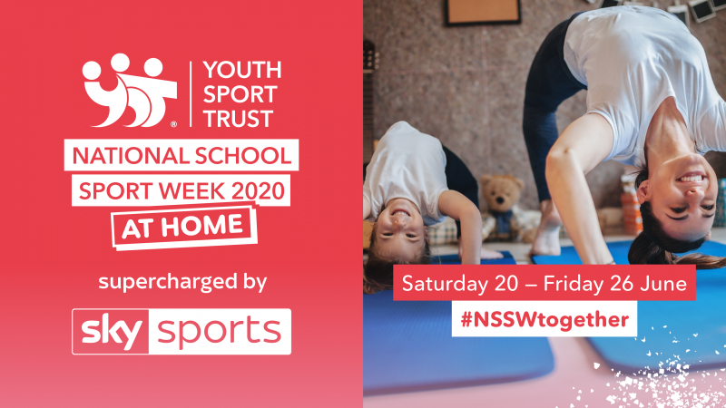

Pray together
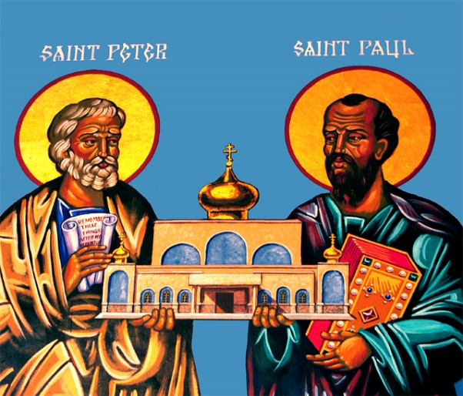
Christ Jesus,
Help us to be faithful to you, like Saint Peter and Saint Paul. Inspire us to show that faith in everything we do.
Amen.

Sunday 28th June – Feast of St. Peter & St. Paul

Additional learning resources parents may wish to engage with
World Geography Games - https://world-geography-games.com/

Outdoor lesson ideas - https://www.ltl.org.uk/free-resources/

Teacher Tips
We hope you are all okay. We are missing the children very much and would love to hear how they are getting on. If you are able to tweet any of their work, we would love to see it!

Keep looking on the school twitter page for any updates and messages.
Take care xxx

Multiplication and Division Booklet
Remember division is repeated subtraction- use the number lines to find the answers to the division problems below.

Counting in Tenths Activity

Spelling

English

Science: I can investigate what plants need to grow well.
Perhaps you could set up your own investigation. Think about a fair test and
only change 1 thing. I am investigating what happens when a plant has no light.
I will record what happens to both plants.

1.Pink plant ….in the dark
2. Orange pot….in light

This is our investigation
Pink plant is in the dark and orange one is in light.
Both plants are in the same pots with same soil. They will have same amount of water.
What do you predict will happen?

Geography:- Name the 15 countries in Europe
Can you find their capital cities? Find their flags.

History

Now make and decorate your own….

