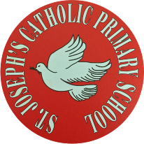
St Joseph’s Catholic Primary School - LEARNING AT HOME PLANNING
YEAR 3
Date WC 25.05.20
Weekly Mathematics Tasks  (Aim to do 1 per day) | Weekly Reading Tasks  (Aim to do 1 per day)
- Continue to play on Times Table Rockstars- Don’t forget the Class v Class battle between Year 3 as well as the sessions that your teacher has set for you. We will be looking at the scores and choosing Stars of the week!  Continue to play on Numbots daily as well.  - Complete the 5-a day for 25th May at https://corbettmathsprimary.com/wp-content/uploads/2018/06/bronze-may-25.pdf  - Complete the three pages below from the Multiplication and Division booklet.  - Watch the videos through the links below to learn how to convert between seconds and minutes.  https://www.youtube.com/watch?v=gEStq1e1Qrc  https://www.youtube.com/watch?v=ImVe0ed4fVM (skip to 2:54 for minutes to seconds)  Then complete the worksheets below to convert the time between seconds and minutes.  - Keep practising telling the time on a digital and analogue clock throughout the day! Maybe you could include the time in your daily diary! | - Encourage your child to continue reading daily, a mixture of independently and to somebody else. When reading with you, continue asking questions from the sheet attached last week.  - Complete the Howard Carter’s Diary reading comprehension.  - Read the two fact files about the River Nile and the Pyramids attached below. For each fact file, make a poster to share some of the facts that you have learnt from them. Also, think of 3 questions that you would like to know the answers to about both.  - We are looking at the book called The Journey by Aaron Becker  This week:-  - Watch the first 20 seconds of this video.  https://www.youtube.com/watch?v=DRsmuveKWuk  Then look at the task below with the picture of the girl sitting on the steps.  - Watch the video again but this time up to 1.15.  - Listen to the author talk about how he created the book then see below for the activity on creating your own drawing.  https://www.storybreathing.com/the-making-of-journey/
Weekly Spelling Tasks  (Aim to do 1 per day) | Weekly Writing Tasks  (Aim to do 1 per day)
- Complete the activity mats below for 2 of the Year 3 & 4 spellings.  - Complete the Year 3 & 4 spellings wordsearch attached below then practise spellings these words using the pyramid strategy.  - Recap on the Y3/4 words that we have already looked at on the cover and trace sheet attached below.  - Write some sentences using the words from above. Make sure you spell each of the words correctly! | - Complete the handwriting sheet below for the ‘ear’ sound.  - Play one of these games online to practise using punctuation correctly. https://www.topmarks.co.uk/english-games/7-11-years/punctuation  - Watch the video and complete the activity here to remind yourself of the rules for using inverted commas. https://www.bbc.co.uk/bitesize/topics/zvwwxnb/articles/ztcp97h  - Watch the first 45 seconds of this video telling the story of our book ‘Journey’.  https://www.youtube.com/watch?v=DRsmuveKWuk  Write a conversation between the main character and one of her family members that are seen in those first 45 seconds. Remember the rules of using inverted commas!

Foundation subjects and Learning Project - to be done throughout the week
History
For the next few weeks we are going to be looking at the Pyramids and discovering why they were built? Who built the pyramids?
- Watch this clip about how some people think the Pyramids were built then read the information sheets below.
https://www.youtube.com/watch?v=nxP46jWYglI
- Fill in the sheet below about the Pyramids.

Geography
We are going to be learning about the River Mersey.
Last week we looked at the route the River Mersey takes and which towns it passes through.

This week we will be looking at all more information about the River Mersey.
- Can you make an information booklet or brochure showing the different towns that the River Mersey passes through? Write what is special about each town/area. You decide how you would like to present your booklet.
- Can you find out who uses the river and what they use it for?

Next week we will continue to look at other places along the route of the River Mersey.

RE
- This Sunday is the Feast of Pentecost - https://www.youtube.com/watch?v=J5tr4pqWIo4
Bake a cake to celebrate the Church’s birthday and have a little party at home.
- One of the significant parts of the Pentecost story is that people who spoke different languages were able to understand one another. Take that idea and learn something in a different language together as a family. Perhaps you could learn " I love you" in different languages. How many could your family learn?

Science: Plants
- Make observations of your sunflower and keep a record of the plant’s growth.
Research how to care for a sunflower. How do you keep a sunflower alive?

Music
- Login to “YUMU” and continue the assignment ‘Bringing Us Together’.

Let’s get physical!
Look below to learn more cricket skills.
This week we are learning to bowl with a straight arm.

Remember to complete the warm up before doing your exercise!
Pray together
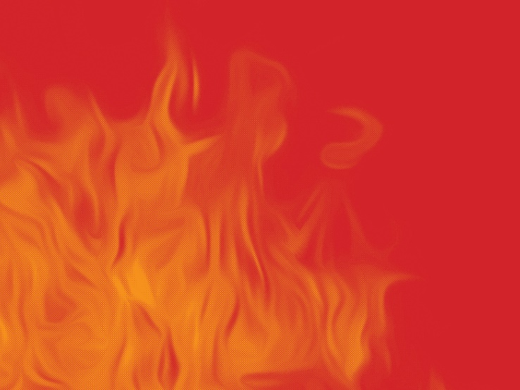
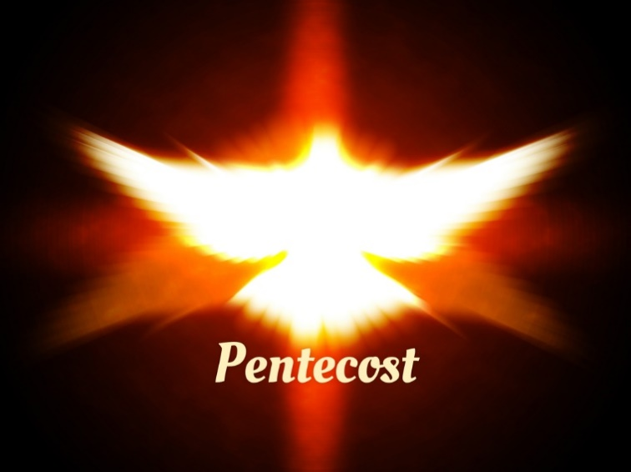
Beautiful Lord,
may we say “yes” to you
so that the Spirit in our hearts
will once again be set ablaze.

Additional learning resources parents may wish to engage with
- The Royal Shakespeare Company have partnered with the BBC to bring audiences six plays between now and September as part of their Culture in Quarantine initiative. All six are available on iPlayer and there are activities and resources to support young children as they watch the plays. https://www.rsc.org.uk/at-home-with-shakespeare

- Get creative! With all this extra free time we all have at home, it’s the perfect time to get creative and maybe learn a new hobby. Creative Bug is offering free craft lessons, from knitting to jewellery-making, drawing and origami.

Teacher Tips
- Remember - in a normal school day, there are several ‘break times’ throughout the day, so make sure as well as ensuring they complete their work, you build in ‘relaxation’ time.

- If the children are really engaged and interested in something, see what cross curricular links you can make. Capitalise on their interests and don’t worry too much if it ‘fits’ into their weekly learning.

Converting Time in Seconds and Minutes
1 minute = ________ seconds

60 seconds = ________ minute
HINT!
2 minutes = 2 x 60 seconds
2 x 6 =
so
2 x 60 =

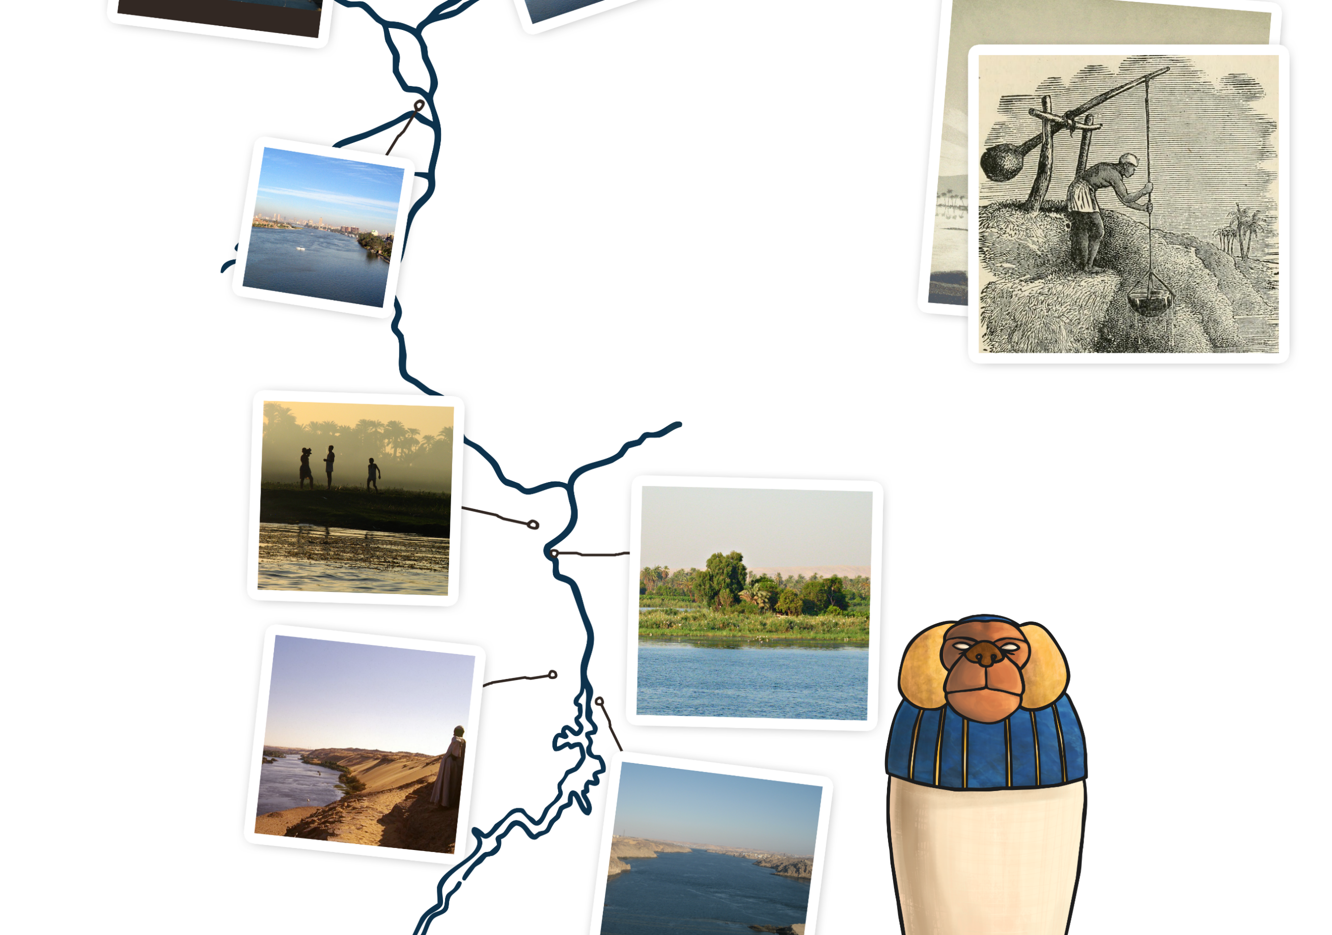
Nile was the reason that the first farmers settled there around 5000BC. The river was used for water, food and transport, as well as making the soil in the area perfect
for growing crops.
The river banks were also filled with a reed called papyrus, which was turned into a kind of paper. The ancient Egyptians also used these reeds to build the boats that they would use to transport people, goods and materials up and down the river.
The ancient Egyptians would also use the river to catch fish with spears and nets as well as catch birds that came to the water.
The God
It was very important to pay thanks to a God for their gifts so people would pay tribute to the God Hapi for bringing the flood to the land to allow them to grow their crops. A lot of farmers would keep an amulet of Hapi or a statue as a sign of respect.
The farmers would lift the water from the canals using a tool called a shaduf (or shadoof) (above). A shaduf is a large pole balanced on a beam. At one end of the pole was a heavy weight and on the other end was a bucket. The ancient Egyptian farmer would pull the bucket down into the water, then the weight would pull the filled bucket back out again. He would then swing the bucket round and empty the bucket onto his crops.
Moving the Water
The Water
Where the river Nile starts is not certain. Some people think that it originates in Burundi. The water in the Nile comes from the White Nile and the Blue Nile.
The White Nile water comes from Lake Victoria whilst the Blue Nile water comes from lake Tana in Ethiopia.
The Water
The melting snow on the Ethiopian mountains and the summer rain is what caused the flood. The water would rush down the Nile and into Egypt where it would burst the banks and flows onto all the nearby flat fields.
The farmers would then build mud-brick reservoirs to keep the water in. They would then build canals to allow the water to flow near their land to make it easy to move to the crops.
The ancient Egyptians would also use the river to catch fish with spears and nets as well as catch birds that came to the water.
Flooding
1. The Nile is approximately 4132 miles long (6650km). That makes it the longest river in the world.
3. Since ancient Egyptian times, Crocodiles have lived in the water, most measuring in at 4 metres long.
Quick Facts!
2. The river starts in the country of Burundi and runs through Ethiopia, Uganda, Sudan and touches a few more before it reaches Egypt, where it flows into the Mediterranean Sea.
The Nile

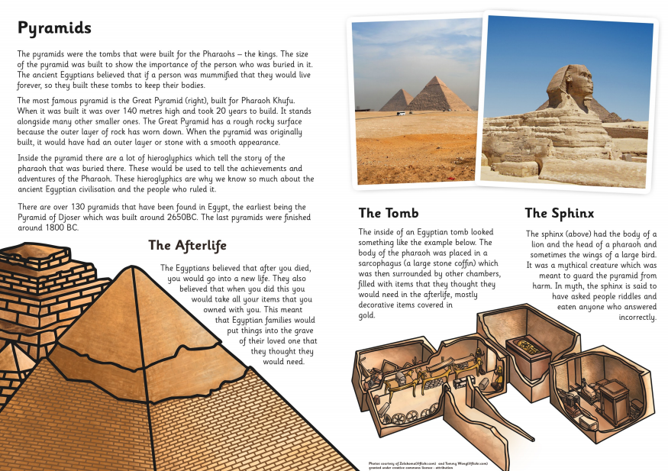

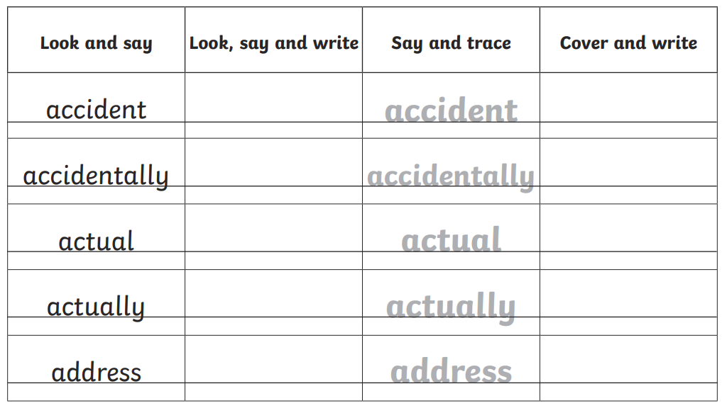

The Journey

After watching the clip of the Journey again, think about the place that the girl goes to.

Imagine you have a pen like the girls and you can draw anything you want. What colour would you use? Where would you go and what would you draw?

Draw and describe the place that your drawing took you to.

How does it make you feel? What is special about your journey?

CHALLENGE- Can you create your own wordless story based on the setting you described above?

History- The Pyramids

Geography- River Mersey

PE- Warm Up

PE- Cricket

Practise your bowling- find something safe to bowl towards.
Maybe you could use a bin or a wall (not near a window!)- we don’t want any broken flower pots of gnomes either please!

