St Joseph’s Catholic Primary School - LEARNING AT HOME PLANNING
YEAR 3
Date- WC 27th April
Weekly Mathematics Tasks  (Aim to do 1 per day) | Weekly Reading Tasks  (Aim to do 1 per day)
- Continue to play on Times Table Rockstars - your child will have an individual login to access this (preferably 5 mins everyday but they have been set a target of 5 games over the week).  - Try Numbots (access through TTRS with same login). Work your way through the levels, they start off easy but get harder!  - Complete the 5-a day for 27th April at https://corbettmathsprimary.com/wp-content/uploads/2018/06/bronze-april-27.pdf  - Complete pages 15-18 in “Addition & Subtraction” booklet in your pack.  Then play the following game and practise using roman numerals. How many levels can you complete?  www.transum.org/software/SW/Starter_of_the_day/Students/Roman_Numerals.asp | - Encourage your child to read for at least 15 minutes independently. Ask them to  summarise what they have read and make  predictions as to what might happen next.  They could do this orally or write a short  summary.  - Read the poem – ‘A Child’s Thought’ by Robert Louis Stevenson. Learn it off by heart and recite it to someone in your family. https://www.whatdowedoallday.com/poetry-challenge-for-kids/  - Complete the common exception wordsearch attached.  - Listen to the Greek myth of Theseus & Minotaur  https://www.youtube.com/watch?v=xQuAUBX5xBw
Weekly Spelling Tasks  (Aim to do 1 per day) | Weekly Writing Tasks  (Aim to do 1 per day)
quick lucky  nice gentle  late simple  close basic  happy frantic  funny dramatic  Can you add the suffix -ly to each of these words.  Remember the rules for adding suffixes!  - When the root word ends in silent ‘e’ keep the ‘e’ if the suffix begins with a consonant.  - When the root word ends in ‘y’ change to an ‘i’ except when the suffix is -ing.  - If the root word ends in -le the -le is changed to -ly.  - If the root word ends in ‘ic’ add - ally. | - Complete a r eview about a book you have read recently.  - Dictate the sentences attached and check spellings afterwards.  - http://www.pobble365.com/ Follow the link to Pobble 365 website. Look at the picture for the day and choose one of the suggested activities. Pictures are changed daily.  - Continue writing your diary. You could start a ‘Time Capsule’ and keep for your future self to look back on.

Foundation subjects and Learning Project - to be done throughout the week
- RE- Listen to the story of ‘Doubting Thomas’ https://www.youtube.com/watch?time_continue=10&v=vLqX5VQTCbg&feature=emb_logo
Create a poster displaying the words of Jesus to Thomas – ‘You believe because you have seen me. Blessed are those who believe without seeing me.’ Jn 20:29

- History – Find out 5 facts about the Egyptians and 5 things you would like to find
out. Perhaps you could put on Twitter.

- Geography – Weather and Climate – https://www.funkidslive.com/learn/marina-ventura/climate-explorers/major-climate-zones-world/# Look at this website to learn about the different climate zone and the complete the worksheets attached.

- Science – What does a plant need to live? Watch the video and complete the activity.
https://www.bbc.co.uk/bitesize/topics/zy66fg8/articles/zcmtk2p

Let’s get physical!
Start each day by following Joe Wicks/ Just Dance or Cosmic Kids Yoga on You Tube
Try a new skill in your garden - eg: knock the ball up on a tennis racquet a number of times; learn how to do ‘keepy-ups’ with a football; Cricket - see activities attached

Pray Together
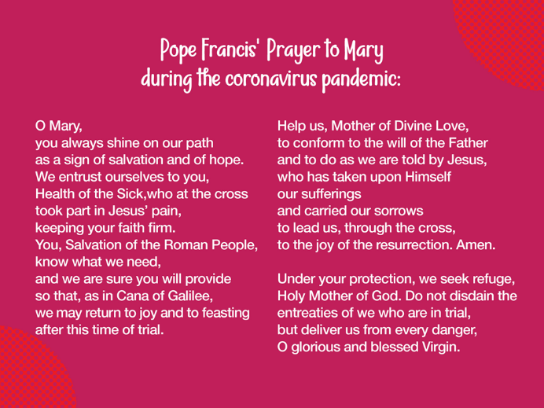
Additional learning resources parents may wish to engage with
BBC Bitesize – Lots of free resources here with videos and quizzes, too.
https://www.chesterzoo.org/ - Chester Zoo website have a range of resources to help with teaching & learning at home.
The Natural History Museum has free virtual tours.
For music lovers, there is a 21-day free trial to learn an instrument with Prodigies Music.
Teacher Tips
- Please don’t worry if you are unable to complete some activities.

- Remember to practice and improve your handwriting - slow it down, sit comfortably with your feet on the floor, don’t tense your hand, hold your pen/ pencil correctly.

- Memrise – Take this opportunity to learn a language through games and video clips on this online app.

Dictation
He hops and skips and smiles on his way to school.
I am hoping that when Jo hopped she didn’t hurt her knee.
We are phoning the school and stopping the sharing of lollies.

Year 3/4 CEWs Wordsearch
circle perhaps
earth pressure
bicycle natural
heart difficult
interest recent

l w d i f f i c u l t t
i n t e r e s t a s t v
u n k y b t c r h n v e
n p b b q z u t e s l k
p s l k z t r c k c k p
f r n a a a e v r v t e
s i e n e r q i k n z r
t o v s h d c x e i h h
u x f m s h y c y s e a
x s d I y u e q j w a p
m f p u l r r f f l r s
z b i c y c l e t h t g

Climate Zone | Description | Photograph
Very dry: less than 250mm of rain in desert regions
Temperatures peak in summer months at 40°C or more! Temperatures can drop 20°C between midday and midnight
 | High temperatures all year round  Wet, wet, wet! Rainfall totals  2000mm a year  Two seasons: wet and dry (or drier!) | 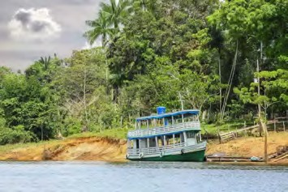
 | Four seasons  No extremes of temperature – it’s tepid  Year-round rainfall: summer may be the wettest season | 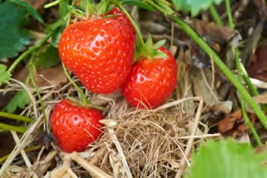
Short winter days, and the midnight sun in summer
Sub-zero temperatures for seven months of the year
No wetter than the temperate zone, maybe drier
 | Intense sunshine ripens citrus fruits here  Take a siesta in summer months to cope with the heat  Plentiful winter rain makes up for very dry summer months | 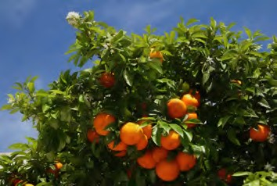

ODDIZZI GRAPHIC ORGANISERS © di 2017

Where?  ……………………………………………………………............  ……………………………………………………………............  ……………………………………………………………............  ……………………………………………………………............  ……………………………………………………………............  ……………………………………………………………............ | What is it like?  ……………………………………………………………........  ……………………………………………………………........  ……………………………………………………………........  ……………………………………………………………........  ……………………………………………………………........  ……………………………………………………………........
Seasons  ……………………………………………………………............  ……………………………………………………………............  ……………………………………………………………............  ……………………………………………………………............  ……………………………………………………………............ | Across the day  ……………………………………………………………........  ……………………………………………………………........  ……………………………………………………………........  ……………………………………………………………........  ……………………………………………………………........
What’s good about the climate?
………………………………………………………………………………………………………………………………………………..
………………………………………………………………………………………………………………………………………………..
………………………………………………………………………………………………………………………………………………
………………………………………………………………………………………………………………………………………………
Any problems?
………………………………………………………………………………………………………………………………………………
………………………………………………………………………………………………………………………………………………
………………………………………………………………………………………………………………………………………………
………………………………………………………………………………………………………………………………………………

Cricket Practice

Lesson 1

This is how to grip a ball when playing cricket.
It doesn’t have to be a cricket ball a tennis ball will be fine.
Outside put 2 cones/markers out and take 15 big steps back .
Under arm try to get the ball between the 2 markers
If the ball goes between the cones after one bounce - score one.
.
About 1 m apart

X
X
Approx 15 steps
To make it more difficult move cones closer together. Can you still get it through?
-------------------------------------------------------------------------------------------------------------------------
To develop close catching .
Skill
- Close catching. Pupils work in pairs and stand opposite each other 3-5m apart. One person throws the ball to the other, aiming for their waist height.
- The catcher must stand with feet shoulder width apart with the little fingers together and hands in front of the body. They must catch with the fleshy part of the hands and wrap the fingers around the ball and draw the ball into the body.
- See how many catches they can make in 30 seconds.
- Move apart and then see if they can make the same number of catches.

