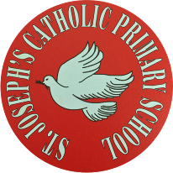
St Joseph’s Catholic Primary School - LEARNING AT HOME PLANNING
YEAR 4
Date- WC 27th April
Weekly Mathematics Tasks  (Aim to do 1 per day) | Weekly Reading Tasks  (Aim to do 1 per day)
- Continue your daily work on Times Tables rockstars. We have been logging on to see how you are doing. Well done to those children who are improving their scores- keep practising!  - Ensure you are completing your daily 4 calculations in your orange book. Want to challenge yourself? Ask for some adding fractions or decimals this week.  - Go to: https://whiterosemaths.com/homelearning/year-4/ This page has links to a whole week’s worth of lessons on rounding decimals and money. Please choose the option Summer Term Week 2.  - If you found decimals tricky last week, try these consolidation activities first before you try this week’s work:  Fractions game These games will help improve your knowledge of fractions- choose your own level.  Decimal demonstrator Parents may find this demonstrator useful for visual representations of tenths and hundredths. Children- test your parents or older siblings!  Decimals Ordering You will need to click the ‘Try Decimals’ option. In this game, you simply order the numbers from smallest to largest. | - Listen to your child read a book of their own choice and let them discuss what they have read.  See PDF above for example question prompts. You might like to focus on a different aspect each day. For example, on Monday you might want to ask simple retrieval questions. On Tuesday you might want to ask the children to pick out some new vocabulary from the text and find the meaning in a dictionary. Wednesday could be looking at some inference questions, Thursday could be making a prediction about what might happen next in the story or in events and Friday could be summarising a chapter or book in a few sentences.  Encourage them to read with expression and intonation.  - Complete the Hedgehogs Reading comprehension  - If you are very confident with your reading comprehension, instead try Challenge reading comprehension  - If you find reading comprehension a bit trickier, you might prefer to try Hedgehogs 2  ● Our driver text for this half term is Where the Forest Meets the Sea by Jeannie Baker.  Book activity: Show photos of jungle animals, birds, frogs and insects such as the  ones shown in the BBC Blue Planet II slideshow below or use examples of Henri Rousseau’s jungle paintings. Pupils write thought and/or speech bubbles to imagine what the animals are thinking or saying.  https://www.bbc.co.uk/programmes/p04gdkhf/p04gdhnh  Refer to Where the forest Meets the Sea- show the story on YouTube without words and collect ideas about what could be happening. Look at the collage style illustration, what do they think is the effect of this? (Using real materials makes it seem like a real place.)  Which parts are real, and which do they think are in the boy’s imagination?
Weekly Spelling Tasks  (Aim to do 1 per day) | Weekly Writing Tasks  (Aim to do 1 per day)
Practise the following words.  vision mansion tension  confusion collision explosion  exclusion discussion mission  Can they improve their score each day?  Can they put these words into sentences?  -sion word practice  NB: If your child has differentiated spellings, their words are:  vision mansion division  explosion confusion tension  Can they put these words into sentences?  https://spellingframe.co.uk/ Lots of useful activities here. | - Look at the different landscapes and scenes in the attached powerpoint. Choose a scene and use your senses to complete the senses chart, choosing words and short phrases to describe what you can see, hear, smell, feel and even taste. (If you don’t have a printer to print the sheet, just write down some lists for each sense)  - Read the description below and discuss the use of carefully chosen words and phrases specific to the environment.  Now write your own ‘Close your eyes and imagine’ description, based on your own chosen landscape from yesterday.  - Reread to the end of Where the Forest Meets the Sea (on YouTube). Discuss the importance and effect of the repeated phrase ‘My father says...’ (for emphasis, makes him seem important and wise...). What do your own parents and  family members say? Write these down, using inverted commas to show direct speech.  - Write a short paragraph for a tourist website about the history of the Daintree forest. Greater depth: Write a paragraph from the point of view of the developers,  persuading the reader that the new complex will be of benefit.  - You can practise your grammar with some of these fun grammar games:  Adjective Detective  Verbs and Adverbs  Apostrophes

Foundation subjects and Learning Project - to be done throughout the week
- Science Our topic for this term is Living things and their habitats. Can you draw a picture of an animal found in the rainforest and find out some facts about this animal? The following may help you:
- Geography – Look at the attached map showing the location of rainforests across the world. Can you name some of the countries where rainforests are found, and the continents they are in?
Revise the names of the continents by learning the continents song: 7 continents
A longer term project could be to start to learn the names of some of the countries in every continent.
- Art- Continue to explore and discuss the works of the artist Henri Rousseau. Watch the following clip and discuss Henri Rousseau 'Surprised'
Let’s get physical!
Down in the Rainforest PE Take part in this lesson about animals in the rainforest.
Can you do 10,000 steps a day? Miss Ward and Mrs Burley are both attempting this every day- see if you can keep up!
Learn a new physical skills over the next few weeks. Miss Ward is learning to touch her toes! You might like to try to learn how to do keepy-ups with a football, do a forward roll or walk on your hands!

Pray Together
The Gospel for the coming Sunday can be found at http://universalis.com/mass.htm
A children’s liturgy for Sunday 26th April and Sunday 3rd May can be found here, with accompanying activities. CAFOD Children's Liturgy
You may like to say a prayer each morning before you begin your school work tasks.
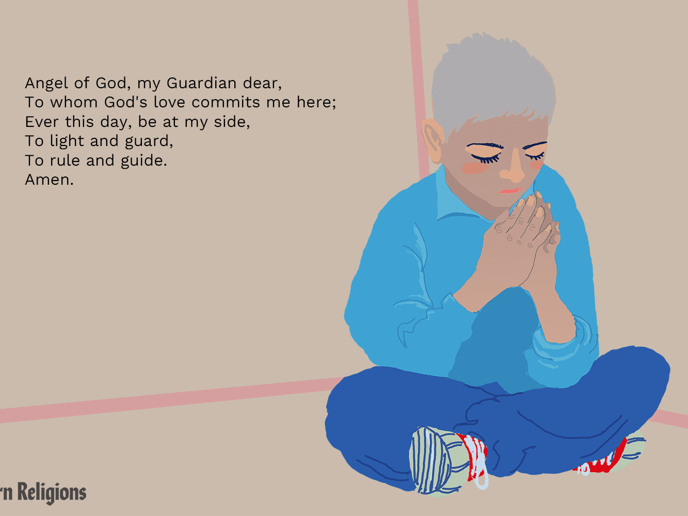

Additional learning resources parents may wish to engage with
Our school Twitter page will keep you up to date with challenges set by the teachers and let you see what other pupils have been up to. Follow us @stjosephsbh

Oxford Owl has some free ebooks, similar to those we use in school. You will need to register initially (for free), but many resources are free.
https://home.oxfordowl.co.uk/books/free-ebooks/
Teacher Tips
- Working for short but focussed chunks of time, punctuated by breaks to play or have snack, may suit your child best. In class, we try to keep ‘teacher-talk’ to a minimum and give the children plenty of opportunities to talk through their learning. Sometimes it might be effective to use an older sibling to help with explanations and discuss your child’s understanding of their work.
- If your child has produced work they are really proud of, we would love to see it on our school Twitter page.
- Have fun with learning and feel free to adapt and tailor any of the activities above to your child’s interests.

