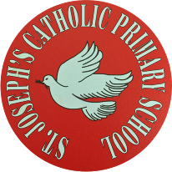
St Joseph’s Catholic Primary School - LEARNING AT HOME PLANNING
YEAR 4
Date- WC 11th May 2020
Weekly Mathematics Tasks  (Aim to do 1 per day) | Weekly Reading Tasks  (Aim to do 1 per day)
- Continue your daily work on Times Tables Rock stars. We have been logging on to see how you are doing. Well done to those children who are improving their scores- keep practising!  - Ensure you are completing your daily 4 calculations in your orange book. Want to challenge yourself? Ask for some subtracting fractions or decimals this week.  - Go to: https://whiterosemaths.com/homelearning/year-4/ This page has links to a whole week’s worth of lessons with resources, worksheets and answers. Please choose the option Summer Term Week 4.  - If you would like some extra work on perimeter, why not have a go at completing this booklet? | ● Listen to your child read a book of their own choice and let them discuss what they have read. Encourage them to read with expression and intonation.  ● Complete the reading comprehension below entitled “Ahoy Me Hearties.”  ● Our driver text for this half term is Where the Forest Meets the Sea by Jeannie Baker.  Watch the first two minutes of the clip below and imagine what you might have seen on the island one hundred million years ago. https://www.youtube.com/watch?v=2ZR1pN8MGAo  ● Read the reading resource below and answer the questions on polar animals.
Weekly Spelling Tasks  (Aim to do 1 per day) | Weekly Writing Tasks  (Aim to do 1 per day)
Practise the following words.  weather whether  team teem  who’s whose  medal meddle  missed mist  Can they improve their score each day?  Can they put these words into sentences?  NB: If your child has differentiated spellings,  their words are:  again both beautiful could everybody  Can they put these words into sentences? | - Write a short description of what the world would have looked like a million years ago on the island from “Where the Forest Meets the Sea” using descriptive vocabulary, adjectives and your imagination.  - Keep a daily diary with your child - we are living through history! What they write could be used by future historians!  - Write an adventure story involving you travelling back in time to meet the ancient aboriginal children mentioned in the You tube clip above on “Where the Forest Meets the Sea”. Think about how you are going to communicate with the children. Would they speak a special ancient language?  - Write a report on Nelson Mandela using the information file below. Use headings and paragraphs to complete your work.

Foundation subjects and Learning Project - to be done throughout the week
- Science – We are looking at ways of classifying living things. Can you research vertebrates? What can you find out? Please complete the following attached activity on vertebrates.
- Geography – This week the focus is how land height is shown on a map. Please complete the following activity, using the resource below.

- Art – Please complete the following art work this week.
Let’s get physical!
Start each day by following Joe Wicks/ Just Dance or Cosmic Kids Yoga on You Tube
Can you do 10 press ups/sit ups a day?
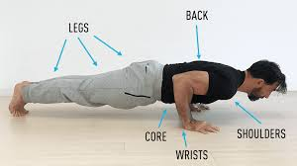

Pray Together
The Gospel for the coming Sunday can be found at http://universalis.com/mass.htm
Can you say a prayer for all of our clergy who are offering us guidance in these times?
May is the month of Mary.Please offer our prayer to Mary for our School and Parish communities.
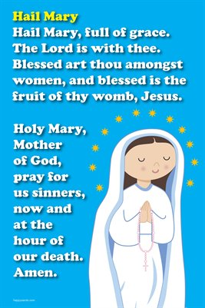
Additional learning resources parents may wish to engage with
Classroom Secrets Learning Packs - These packs are split into different year groups and include activities linked to reading, writing, maths and practical ideas you can do around the home.
Twinkl - to access these resources click on the link and sign up using your own email address and creating your own password. Use the offer code UKTWINKLHELPS.
Headteacher chat - This is a blog that has links to various learning platforms. Lots of these are free to access.
Our school Twitter page will keep you up to date with challenges set by the teachers and let you see what other pupils have been up to. Follow us @stjosephsbh
Oxford Owl has some free e books, similar to those we use in school. You will need to register initially (for free), but many resources are free.
https://home.oxfordowl.co.uk/books/free-ebooks/
Teacher Tips
- Remember - in a normal school day, there are several ‘break times’ throughout the day, so make sure as well as ensuring they complete their work, you build in ‘relaxation’ time. For you as well as the children!
- Please clap in appreciation for our wonderful NHS at 8pm on Thursday evening. We really do appreciate all of the hard work that they are doing to help us at this challenging time.

