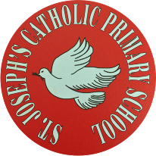
St Joseph’s Catholic Primary School - LEARNING AT HOME PLANNING
YEAR 4
Date- WC 1st June 2020
Weekly Mathematics Tasks  (Aim to do 1 per day) | Weekly Reading Tasks  (Aim to do 1 per day)
- It is very important to continue your daily work on Times Tables Rock stars. We have been logging on to see how you are doing- we would like to see a few more of you online practising.  Well done to those children who are improving their scores- keep practising! Well done to 4BW who are currently beating 4C by nearly 2000 points in the current class v class challenge!  There is a new challenge for this week:Y4 boys versus Y4 girls battle for us on TT rockstars.  - Ensure you are completing your daily 4 calculations in your orange book. Want to challenge yourself? Ask for some subtracting fractions or decimals this week.  - Go to: https://whiterosemaths.com/homelearning/year-4/ This page has links to a whole week’s worth of lessons with resources, worksheets and answers. Please choose the option Summer Term Week 6 for work on fractions.  - If you would like some extra work on fractions, why not have a go at completing the attached revision sheet? | ● Listen to your child read a book of their own choice and let them discuss what they have read. Encourage them to read with expression and intonation.  ● Complete the reading comprehension below entitled “Female Mountaineers”  ● Our driver text for this half term is Blue John by Berlie Doherty.  Watch the first minute of the clip below and imagine what the world that the queen of darkness inhabits is looks like.  https://www.youtube.com/watch?v=WO1JfexygTU  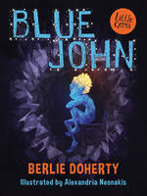  ● Think about the first page of “Blue John” that you heard in the clip. Highlight any words or phrases that stand out for you or that are new to you. If you are able to, look up any of these words in the dictionary. Think about what sort of words they are, i.e. verbs, adjectives.
Weekly Spelling Tasks  (Aim to do 1 per day) | Weekly Writing Tasks  (Aim to do 1 per day)
Practise the following words.  Furious humorous  dangerous envious  courageous glorious  spacious famous  Can they improve their score each day?  Can they put these words into sentences?  NB: If your child has differentiated spellings,  their words are:  because different darkness weakness sadness happiness  Can they put these words into sentences? | - Keep a daily diary with your child - we are living through history! What they write could be used by future historians!  - Write a write of a story opening starting with ‘imagine a world…’ mentioned in the You tube clip above on “Blue John”. Introduce a character who might go to live in a new world like this. You can use illustrations to help.  - Listen to the clip from You tube again (Page 2) Imagine you are the person you thought might live in this new world. Write about which objects you would take with you down into the depths. Try and describe them as best you can. Give reasons for your choices.  - Please complete the attached revision sheet on adverbs.

Foundation subjects and Learning Project - to be done throughout the week
- Science – We are looking at electricity in this half term. Can you think about what you already know about electricity? What can you find out? Please complete the attached sheet on an electricity activity.
- History – Starting from this week we will be studying the ancient hill “Mam tor” in the Peak District. Please look at the attached History sheet and read the features of a hillfort. Cut them out and rank them in order deciding which features were most important to protect the inhabitants. What else can you find out about the history of this sight?
- Geography – This half term the focus is on UK geographical regions and the physical characteristics of mountains and hills. Please research the difference between hills and mountains. Make a list of their differing characteristics. The diagram below will give you some ideas.

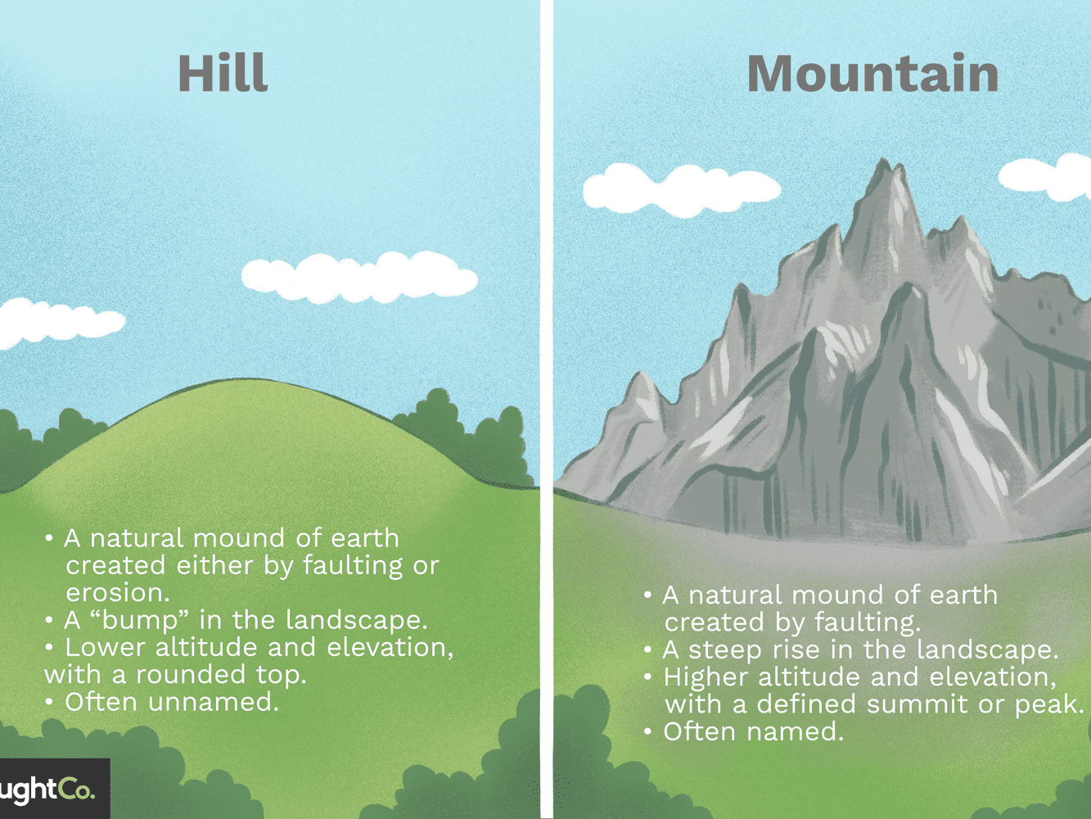
- D.T. – Please research head torches. Make a labelled drawing of a head torch that you might use in a cave.
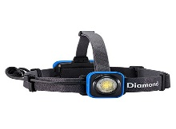

- Music -Please log onto this website for fun music activities https://charanga.com/yumu
Attached to this sheet are individual log-in details for each child- please retain and use your individual log-in and try to do one of the sessions every week.

Let’s get physical!
Start each day by following Joe Wicks/ Just Dance or Cosmic Kids Yoga on You Tube
Can you do 10 press ups/sit ups a day?
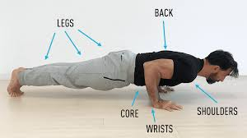

Pray Together
The Gospel for the coming Sunday can be found at http://universalis.com/mass.htm
Please keep the Pope in your prayers.
JUNE’S PRAYER INTENTION
This month, during which the Solemnity of the Sacred Heart occurs, the Pope asks that “We pray that all those who suffer may find their way in life, allowing themselves to be touched by the Heart of Jesus”.
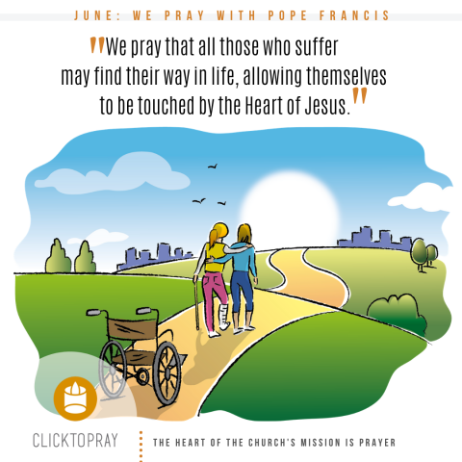
Additional learning resources parents may wish to engage with
Classroom Secrets Learning Packs - These packs are split into different year groups and include activities linked to reading, writing, maths and practical ideas you can do around the home.
Twinkl - to access these resources click on the link and sign up using your own email address and creating your own password. Use the offer code UKTWINKLHELPS.
Headteacher chat - This is a blog that has links to various learning platforms. Lots of these are free to access.
Our school Twitter page will keep you up to date with challenges set by the teachers and let you see what other pupils have been up to. Follow us @stjosephsbh
Oxford Owl has some free e books, similar to those we use in school. You will need to register initially (for free), but many resources are free.
https://home.oxfordowl.co.uk/books/free-ebooks/
Teacher Tips
- Remember - in a normal school day, there are several ‘break times’ throughout the day, so make sure as well as ensuring they complete their work, you build in ‘relaxation’ time. For you as well as the children!
- Please clap in appreciation for our wonderful NHS at 8pm on Thursday evening. We really do appreciate all of the hard work that they are doing to help us at this challenging time.

