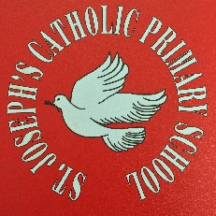

Personal, Social and Health Education

At St Joseph’s Primary School our aim is to promote healthy, independent and responsible members of society.
Our pupils are given opportunities in PSHE, SEAL (Social and Emotional Aspects of Learning) lessons and assemblies to develop confidence, self-motivation and an understanding of their rights and responsibilities within our diverse society.

We encourage our pupils to play a positive role in contributing to school life and the wider community through forming a school council, fundraising events and supporting nominated charities. We teach PSHE in a variety of ways: as a discrete subject, through SEAL lessons, via assemblies and through other subjects such as RE, History, Geography, Literacy, Maths and Science, as well as through outdoor educational visits and activities.

As much as possible we ask children to self-reflect, analysing how their behaviours and actions can affect others. This is particular relevant where their behaviour has been negative and goes against our school rules and code of conduct.

We teach children to understand, appreciate and follow the fundamental British Values of
-Democracy
-The Rule of Law
-Individual Liberty
-Mutual Respect
-Tolerance of those with different faiths and beliefs

