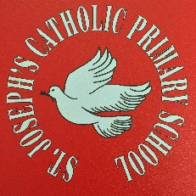

Performing Arts Curriculum

This part of the Curriculum really helps children to not only express themselves as individuals but also helps them to work together to create something memorable.
It not only helps them to appreciate the beauty and power of the performing arts themselves but it also enables them to understand the power of “the team” in creating such a project and that each person has a valuable part to play.
The performing arts are critical, as with the visual arts, in giving children that sense of “awe and wonder” which we hope will be something they develop throughout their lives. It also develops their self-confidence, self worth and appreciation of others.
Throughout their time at St Joseph’s the children will have lots opportunities to participate in the performing arts. These range from regular class assemblies, The Key Stage One Christmas Concerts, Year 6 Productions as well as regularly during lessons, for example role play and ‘hot seating’.
Running alongside this will be teaching of Speaking and Listening – two vital skills to allow children to communicate. They will be taught to speak clearly and in the appropriate style for a variety of purposes.
During the English curriculum, the children will also learn about play scripts and study the works of Shakespeare. It is also our wish for children to learn a variety of poems ‘by heart’ to further develop their appreciation of the beauty of this art.

