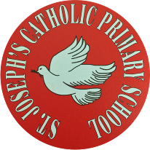
St Joseph’s Catholic Primary School - LEARNING AT HOME PLANNING
YEAR 4
Date: WC 22nd June 2020
Weekly Mathematics Tasks  (Aim to do 1 per day) | Weekly Reading Tasks  (Aim to do 1 per day)
Daily 5-A-Day starters:  https://corbettmathsprimary.com/5-a-day/  Bronze or silver level: 22nd – 28th June  In Maths this week we are studying symmetry and coordinates. First, we will look at how to complete a simple symmetric figure with respect to a specific line of symmetry.  - Please begin by watching this clip from the BBC bitesize website :  https://www.bbc.co.uk/bitesize/topics/zrhp34j/articles/z8t72p3  and then this clip:  https://www.youtube.com/watch?time_continue=382&v=vEro2-qcFqU&feature=emb_logo  Please complete the 3 attached worksheets dated 22 6 20 on symmetry.  Next is coordinates. Please view these clips on coordinates:  https://www.bbc.co.uk/bitesize/topics/zgthvcw/articles/z96k9qt  Now attempt the 3 attached worksheets on coordinates.  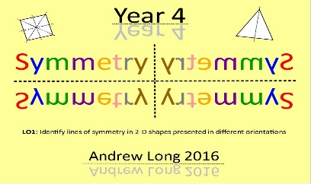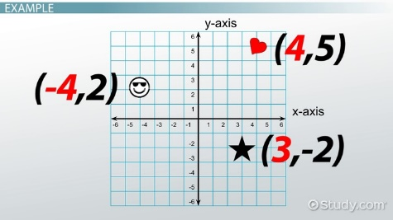 | Complete this reading comprehension about Sherpas (see below). Would you like to be a Sherpa? Explain your answer giving reasons from the text.  Listen to Barak and Michelle Obama read The Word Collector by Peter H Reynold. We love words just as much as Jerome in the story! We would like YOU to become word collectors this week! Write down words that impress you that you have read or heard on the TV. Have your family used any words that have made you say WOW?  Choose some words and complete the RESCUE sheet below (Read – Explore – Spell – Check – Understand – Explain)  Read Chapter 3 of Blue John and answer the VIPERS questions (see below).  This week on Epic! Mrs Burley has been reading about the basketball player LeBron James and The Unofficial Guide to Building Skyscrapers in Minecraft.
Weekly Spelling Tasks  (Aim to do 1 per day) | Weekly Writing Tasks  (Aim to do 1 per day)
Practise the following words:  happily prettily greedily clumsily gently simply humbly basically frantically dramatically  Can you write a spelling story including all of these words?  NB: If you normally get given 8 spellings each week, choose 4 of these words and really focus on them over the course of the week.  ______________________________  Further practice can be found at - and also try the activities at https://spellingframe.co.uk/spelling-rule/13/8-The-suffix-ly  _____________________________  Proofreading  Read through examples of your own writing from this week and identify any words they think are misspelt. Use a range of strategies to correct the spelling.  ________________________________  Use some of the strategies that you have been taught this year to help you with your spellings this week:  - Look, Say, Cover, Write and Check  - Segmenting – split the word into chunks  - Quick write – see how many times you can write the same word in 1 minute  - Draw an image to match the word – This makes the word memorable.  - Pyramid words – start with the 1st letter, then write the 1st and 2nd underneath, then the 1st, 2nd and 3rd under that and so on. | Now read Chapter 3 – Song. Look at the last sentence, “They saw that the darkness was full of magic.” Write this sentence in the middle of a piece of paper. Around it, add your ideas about what you think the children saw. Write sentences to describe this.  _______________________  Write down the rules for the possessive and plural apostrophe. Check your answers on this website https://www.youtube.com/watch?v=zNFPnVz7JB4 When you think you have got it, try this online quiz on spag.com. Let us know if you can’t remember your login details.  _________________________  June 21st is not only Father’s Day, it is also officially the first day of summer!!! This is also known as The Summer Solstice or Midsummer’s Day. Look at the picture and complete the activities on https://www.onceuponapicture.co.uk/portfolio_page/summer-night/  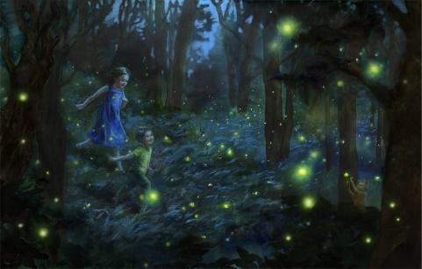  __________________________  Read about Stonehenge at https://www.bbc.co.uk/bitesize/topics/z82hsbk/articles/zg8q2hv. Create an information fact file about Stonehenge. You may wish to include illustrations and diagrams.  __________________________  A Midsummer Night’s Dream is one of Shakespeare’s great comedies. Watch it here:  https://www.bbc.co.uk/iplayer/episode/b078jltg/cbeebies-presents-a-midsummer-nights-dream  Choose a character from the play who interests you and write about what happens to them in the play. Most of all, we would like you to sit back and enjoy watching this fabulous Shakespeare play. Can you guess why we chose this play for you to watch?

Foundation subjects and Learning Project - to be done throughout the week
- Science – Electricity is our topic this half term. This week we are focusing on conductors and insulators. Copy and paste this link to these clips from the BBC bitesize website.
https://www.bbc.co.uk/bitesize/topics/zj44jxs
Now complete the attached worksheet on conductors and insulators.
- History – We are studying the ancient hill “Mam tor” in the Peak District. Last week we asked you to think about what life may have been like in a hillfort. This week we want you to explore the image on the worksheet and work out what is going on. Then record your ideas on the attached History Sheet of what you are sure of, what you think and what you don’t understand. Use the website below to find out what life may have been like at this hill fort.
https://www.bbc.co.uk/bitesize/topics/z82hsbk/articles/z8bkwmn#:~:text=By%20the%20end%20of%20the,their%20people%20from%20enemy%20attacks.&text=Iron%20Age%20farmers%20grew%20crops,cows%20and%20flocks%20of%20sheep.
- Geography – This half term the focus is on UK geographical regions and the physical characteristics of mountains and hills. Last week the focus was on gradients. This week we are studying how different types of mountains are formed.

Please copy and paste this link to a very useful help page to find out more about the different types of mountains that exist:

http://www.primaryhomeworkhelp.co.uk/mountains/types.htm#:~:text=Mountains%20are%20formed%20by%20slow,be%20pushed%20upwards%2C%20forming%20mountains.

Now complete Geography Year 4 worksheet 22 6 20.

- Music Please look at this website where Fran Scott and Greg Foot explore the science of sound, music and musical instruments. These clips are taken from the original BBC series, House of Sound:
https://www.bbc.co.uk/teach/class-clips-video/music--science-ks2-house-of-sound/zncr7nb

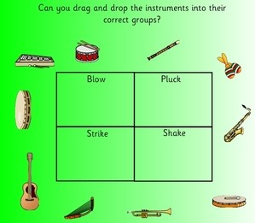

- Please log onto this website for fun music activities https://charanga.com/yumu

Let’s get physical!
It’s very important to keep our bodies healthy.
There are many videos online to help us do this.
You could make a chart to record your daily exercise! We should all aim to do about 30 minutes a day to stay healthy.
Each week you could challenge yourself to try and do slightly more than the week before!

Can you do this every day for a week? Once at 9am? Once at 12pm? Once at 3pm?
- 10 Star Jumps
- 10 squats
- 10 Frog jumps
- 10 second plank
- 1 minute - running on the spot

Pray Together
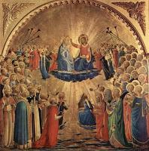

The Communion of Saints is made up of all people who
place their hope in Jesus and belong to Him through
Baptism. It includes those who have died and those who
are still alive.

Look at the picture and think about how it illustrates the
Communion of Saints?

Now make your own illustration for the Communion of
Saints and write an explanation for it.

Additional learning resources parents may wish to engage with
School Twitter page - this will keep you up to date with challenges set by the teachers and let you see what other pupils have been up to. Follow us @stjosephsbh
Top Marks – This site contains lots of fun English and Maths games. Click on ‘Learning Games’ at the top of the page and select the 7-11 age group tab. www.topmarks.co.uk
Twinkl – to access these resources click on the link and sign up using your own email address and creating your own password. Use the offer code UKTWINKLHELPS.
Classroom Secrets: - Free Learning Packs - These packs are split into different year groups and include activities linked to reading, writing, maths and practical ideas you can do around the home. https://kids.classroomsecrets.co.uk/
Headteacherchat - This is a blog that has links to various learning platforms. Lots of these are free to access https://www.headteacherchat.com/post/corona-virus-free-resources-for-teachers-and-schools

Teacher Tips
Working for short but focussed chunks of time, punctuated by breaks to play or have snack, may suit your child best. Remember that this week is half term so try to enjoy the week.
If the children are really engaged and interested in something, see what cross curricular links you can make. Could it be turned into a project? Please share any work that you are proud of with us on our school Twitter account as we would LOVE to see it.

Blue John: Chapter 3 – Song
One day as Blue John clambered up from the caves’ deepest chambers, he heard sounds from outside.
He could hear, faint and far away, the call of the curlew on the moors, and the watery ripple of the skylark. He could hear the wind shimmying down the gorge of Winnats Pass and, far away, he could hear the bird-cries of children playing.
There was a tiny eye of light high up at the end of the passage. Blue John wanted to touch it. He felt drawn towards it as the sea is drawn by the moon. Yet he could hear the voice of his mother, pulling him back down to the safe darkness. “Blue John! Blue John! Stay with me!”
(p25-26)
But the sounds from the outside were growing nearer. He could hear voices and footsteps, and the tiny high sound of someone singing. The sounds were coming towards the cavern. Dark shapes were blocking out the pinhole light of the sky.
Blue John ran to the deepest chamber and hid there, afraid. “Who are they?” he cried. “Who are they?”
The Queen of Darkness laughed. “They’re children!” she told him. “People come here to look at my caves, to wonder at my marvels and my mystery. Be still, and you can watch them. See how the creatures of the light stumble and fall in my world. But never, never follow them into their world. Promise me, Blue John.”
“I promise,” he said.
(p28-29)
Blue John clambered up onto his shelf and lay there, as still as stone. He watched and waited as the sounds of the outside grew nearer, and as he was a little bit excited, and he was a little bit afraid.
“And here they come.” The Queen of Darkness said. “Here come the children!”
In they came, giggling and shouting and pushing each other.
Slipping and sliding and laughing out loud. Tripping and ducking and eating their sandwiches. Fumbling and falling and full of jokes and courage and sunshine.
But as they came further and deeper into the caverns, a hush grew over them.
Their voices sank down into whispers. They crept forward inch by inch, feeling with their soundless feet, blind as moles, hands clasping, and their breath was as quiet as ghosts around their lips.
They saw that the darkness was full of magic.
(p30-33)

V | What does the word clambered mean? Put it into a sentence of your own. (p25)
I | Why do you think Blue John is afraid of the children? (p28)
P | What do you think will happen now that the children are in the cave?
E | Explain why you think Berlie Doherty gave the tile of Song to this chapter. What title would you give it?
R | What did the children do when they first entered the cavern? (p30)
S | Summarise what has happened in this chapter in no more than 50 words.

Word R E S C U E
The word I have chosen is: _________________
Read the word
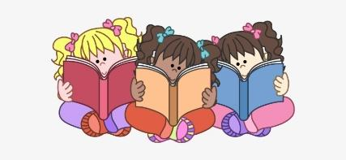
Explore it

Spell it
(use spelling strategies – sound buttons, pictures etc)
Check it
(write it 3 times from memory)
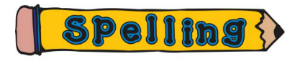
Understand it
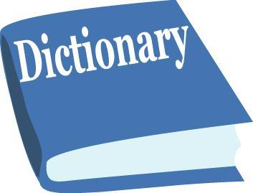
Explain it
(explain it in context)

