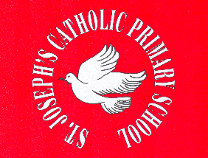

St. Joseph’s Catholic Primary School
Roll of Honour: Darts

2015/16 | Keira Brady-Jones
2014/15 | Leighton McDonnell
2013/14 | Shea Edge
2012/13 | Ethan Mort
2011/12 | Dylan Doran
2010/11 | Liam Padmore
2009/10 | James Irving
2008/09 | Joseph Wingfield

