St Joseph’s RC Primary
SEN School Information Report 2023-2024
Due for review September 2024.
SENCO: Clare Dyas-Ward
SEND Governor: Dawn Crawford

Introduction

At St Joseph’s Catholic Primary School, we aim to offer excellence and choice to all our children, whatever their ability or needs. We have high expectations of all our children. We aim to achieve this through the removal of barriers to learning and participation. We want all our children to feel that they are a valued part of our school community. Through appropriate curricular provision, we respect the fact that children:

- have different educational and behavioural needs and aspirations;
- require different strategies for learning;
- acquire, assimilate and communicate information at different rates;
- need a range of different teaching approaches and experiences.

Objectives of our SEND Provision

We aim :-
(a) to enable every pupil to experience success
(b) to keep an ongoing register (SEND Register) of all children whom we consider to have special educational needs.
(c) to identify those children as early as possible, assess, record and regularly review their progress and needs.
(d) to provide learning programmes geared to their needs.
(e) to work collaboratively with parents, other professionals and support services.
(f) to ensure that parents or carers are able to play their part in supporting their child’s education.
(g) to involve the child, so as to encourage a move from dependent to independent learning.

St Joseph’s firmly believes in developing a strong partnership with parents/carers and that this will enable children and young people with SEND to achieve their potential. The school recognises that parents/carers have a unique overview of their child's needs and how best to support them, and that this gives them a key role in the partnership. Parents/carers hold key information and have a critical role to play in their children's education.

As of September 2014, all schools have been required to publish details of its school offer, detailing support for pupils with special educational needs and/or a disability to complement the Wirral LA Local Offer. Below are details of the current school offer at St Joseph’s and the Local Offer for Wirral.

https://www.sendlowirral.co.uk/

As parents or carers you may have some concerns to raise about your child’s learning and the first port of call should be your child’s class teacher. Listed below are some of the questions you might want to ask.

They are interactive so please click on the question to follow the link to an answer.

What is 'Special Educational Needs and Disability'? PAGE 5

What should I do if I think my child has Special Educational Needs? PAGE 5

How will the school respond to my concern? PAGE 6

How will the school decide if my child needs extra support? PAGE 7

What will the school do to support my child? PAGE 8

Who will support my child in school? PAGE 11

What training and expertise do staff have for the additional support my child needs? PAGE 12

What support will there be for my child’s emotional and social well-being? PAGE 12

How will my child be able to contribute their views and be involved in the process? PAGE 14

How will the curriculum be matched to my child’s needs? PAGE 15

What opportunities will there be for me to discuss my child’s achievement? How will I know how well my child is progressing? PAGE 17

How does the school know how well my child is doing? PAGE 18

How will my child be included in activities outside the classroom including school trips? PAGE 19

How accessible is the school environment? PAGE 20

How will the school prepare and support my child to join the school/ transfer to a new school? PAGE 21

How can I be involved in supporting my child? PAGE 22

How can I access support for myself and my family? PAGE 23

Who can I contact for further information? PAGE 23

What is 'Special Educational Needs and Disability'?

Definition of Special Educational Needs (SEND) as taken from section 20 of the Children and Families Act 2014.
A child or young person has special educational needs if he or she has a learning difficulty or disability which calls for special educational provision to be made for him or her.
A child of compulsory school age or a young person has a learning difficulty or disability if they; (a) have a significantly greater difficulty in learning than the majority of others of the same age, or (b) have a disability which prevents or hinders them from making use of facilities of a kind generally provided for others of the same age in mainstream schools or mainstream post-16 institutions.
A child under compulsory school age has special educational needs if they fall within the definition at (a) or (b) above or would do so if no special educational provision were made. Children must not be regarded as having a learning difficulty solely because the language or form of language of their home is different from the language in which they will be taught.

What should I do if I think my child has Special Educational Needs?

If you are concerned that your child has a special educational need (SEN), in the first instance we ask that you speak to your child’s class teacher who will then follow up your concerns. Concerns can be discussed at parents’ evenings which are held twice a year, or by making an appointment to meet with your child’s class teacher at any point throughout the school year.

The Special Educational Needs Coordinator (SENCO) is also available to speak by appointment on Fridays. Mrs Dyas-Ward, the SENCO is responsible for:

- Coordinating all the support for children with SEND and developing the school’s SEND Policy to make sure all children get a consistent, high quality response to meeting their needs in school.
- Ensuring that you are:
  - involved in supporting your child’s learning
  - kept informed about the support your child is getting
  - involved in reviewing how they are doing
- Liaising with all the other people who may be coming into school to help support your child’s learning.
- Updating the school’s SEND register (a system for ensuring all the SEND needs of pupils in this school are known) and making sure that there are excellent records of your child’s progress and needs.
- Providing specialist support for teachers and support staff in the school so they can help children with SEND in the school achieve the best progress possible.

How will the school respond to my concern?

The class teacher will listen to any concerns you may have at a pre-arranged meeting. If your concern cannot be met at that meeting then the class teacher will take some time to look into the concern and liaise with the SENCO and/or the Headteacher. A follow up meeting may be arranged to ensure your concern is addressed and to plan any additional support your child may receive. If relevant at this stage, possible referrals to outside professionals to support your child’s learning will be discussed.

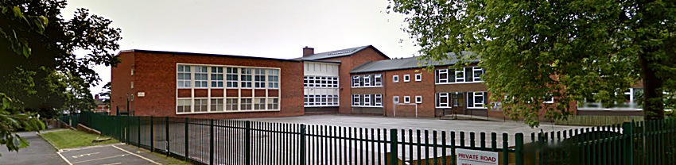
Make an appointment to talk to the class teacher or SENCO.

How will the school decide if my child needs extra support?

If your child is identified as making limited progress within any of the four broad areas of need as identified in the ‘Special Educational Needs and Disability Code of Practice, the school may set up a meeting to discuss this with you in more detail. It may be agreed after discussion that your child will be added to the Special Educational Needs Register. Children’s progress is tracked and monitored internally through numerous means including informal and formal assessments, observation in class, looking at work in books, Pupil Progress meetings and discussions between parents and teachers.

We will:
- listen to any concerns you may have
- plan any additional support your child may receive
- discuss with you any referrals to outside professionals to support your child’s learning

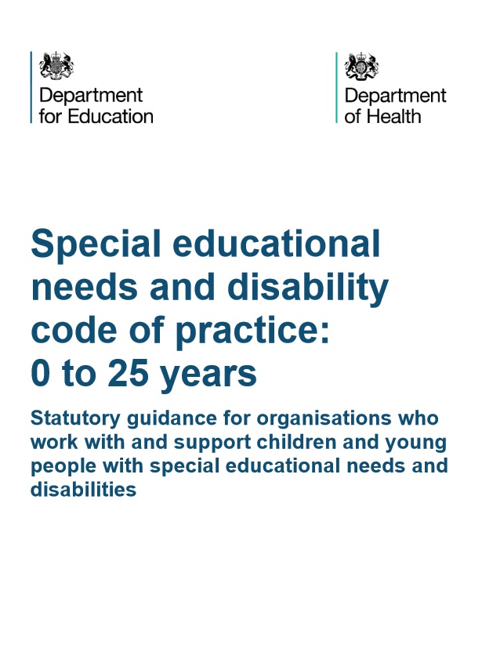
SEND Code of Practice

What will the school do to support my child?

All teachers at St Joseph’s Catholic Primary School are expected to deliver consistently good teaching that meets the needs of all pupils. This is known as Quality First Teaching.

This means:
- That the teacher has the highest possible expectations for your child and for all pupils in their class.
- That all teaching is based on building on what your child already knows, can do and can understand.
- Different ways of teaching are in place so that your child is fully involved in learning in class within well differentiated ability groups. This may involve things like using more practical learning/ apparatus/ different methods of recording work.
- Your child’s teacher will have carefully checked on your child’s progress and will have decided that your child has gaps in their understanding/learning and needs some extra support to help them make the best possible progress.

However, we recognise that each child's needs are unique and so each child will receive different support, depending upon their specific needs. The Special Educational Needs Co-ordinator (SENCO) and class teacher will decide which strategies and resources are appropriate to support your child's needs. Where outside agencies are involved, they will provide advice about how best to support your child's needs.

Any pupil identified as having a special educational need and/or disability is on the SEND register. Targeted support will be given to these pupils to help them to make progress. All children on the SEND register will have a Personal Support Plan (PSP), detailing their targets and strategies for achieving these targets. Reviews will be held at least termly. If your child has more complex needs, an Additional Support Plan may be put in place. External agencies eg paediatricians/ Educational Psychologists/ Speech and Language Therapists all contribute to this plan, which is usually reviewed termly.

Some examples of ways we may support your child further may include:

Specific group work within a smaller group of children
This group or one to one support may be:
- Run in the classroom or outside.
- Run by a teacher or most often a Teaching Assistant who has had training to run these groups.

SEN Support
- Your child may engage in group sessions with specific targets to help him/her to make more progress.
- A Teaching Assistant/teacher or outside professional may run these small group/individual sessions
- You will be asked to come to a meeting to discuss your child’s progress and help plan possible ways forward.
- You may be asked to give your permission for the school to refer your child to a specialist professional e.g. a Speech and Language Therapist (SALT) or Educational Psychologist (EP). This will help the school and yourself understand your child’s particular needs better and be able to support them better in school.
- The specialist professional will work with you, your child, class teacher and SENCO to understand their needs and make recommendations, which may include:
- Making changes to the way your child is supported in class e.g. some individual support or changing some aspects of teaching to support them better
  - Support to set specific targets which will include their expertise
  - A group run by school staff under the guidance of the outside professional e.g. a social skills group
This type of support is available for a child who has specific gaps in their understanding of a subject/area of learning and who therefore has been identified as requiring SEN Support.

Interventions currently being run include:
- Orrets Meadow Outreach
  - Phonics Booster groups- RWI small group or one to one tuition.
  - Speech and Language support groups.
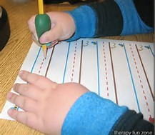
  - Motor skills support groups.
  - Beanstalk reading programme.
  - Maths basic skills groups.
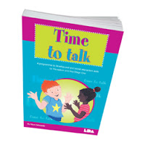
  - IDL Cloud online Literacy support.
  - Self Esteem groups.
  - Individual 1:1 work tailored around a child’s individual plan.

We also have additional specialist support from:
  - Educational Psychologist.
  - SENAAT(Special Educational Needs Advisory and Assessment Team) Teacher
  - Speech and Language Therapist.
  - Paediatricians.
  - Hearing Support Service/ Vision Support service.
  - School Nursing Service.
  - Orrets Meadow Outreach.
  - The 0-19 School Nurse team.
  - The Wirral Mental Health Support Team
  - A TA has been trained as an ELSA (Emotional Literacy Support Assistant).

Education, Health Care Plans
Since September 2014, 'Statements' have been replaced by 'Education, Health and Care Plans'. This document continues to outline a pupil's special educational need and the support that the school needs to put in place to help them, but it is a much more child friendly document, based around the pupil and their family.

Only children with the most complex and significant special educational needs will be considered for an Education, Health Care Plan (EHCP). If you think your child needs a EHCP you will need to discuss your concerns with the school Special Educational Needs Co-ordinator (SENCO), who will advise you about whether your child needs an Education, Health and Care Plan and only once the school has exhausted its provision and outside agency support will this be considered. These discussions are normally held at a review meeting with outside agencies.

Who will support my child in school?

- Qualified and experienced teachers
- Experienced and skilled teaching assistants (All of our TAs are Level 2 or Level 3)
- Volunteers eg the Beanstalk charity reading volunteers.
- Peer support
- Outside professionals eg the Educational Psychologist.
- SENCO with the National Senco Award qualification.
- Mental Health professionals
- The Speech and Language Therapis

What training and expertise do staff have for the additional support my child needs?
Class teachers/Headteacher/Assistant Headteacher/SENCO:
- A high proportion of our teachers are experienced teachers
- All teachers have had First Quality training in areas of English and Maths.
- Some staff members have had epi-pen and asthma training (2021).
- All members of staff, including Midday Assistants, have had Safeguarding training
- Several members of staff are trained in the use of the defibrillator.
- In the past 18 months, staff including Teaching Assistants have had additional training on:
-Good Autism Practice (June 2022)
-ASD Support in the Classroom (March 2023)
-Orrets Meadow school training on Working Memory strategies (March 2023 and June 2022).
-Hearing Support training on supporting hearing impaired children in the classroom (November 2022)
-The EALIP programme for supporting children with English as an Additional Language (November 2022)
-Adaptive teaching (February 2023)
-Word Aware vocabulary and language development (July 2023)
-We have also been supported by Wirral Maths Hub to develop our maths teaching for children with SEND (May 2022)
- Several members of staff are trained in Team Teach, an accredited, award-winning provider of positive behaviour management training, equipping individuals and teams in a variety of settings to deal with challenging situations and behaviours in ways that lead to desirable outcomes and positive relationships at work or in daily life.

SENCO:
- Experienced class teacher across both Key Stages.
- Qualified teacher status.
- Non-class based for 1 day per week.
- Achieved National SENCO Award Qualification Autumn Term 2017, a Masters-Level qualification in SEN Co-Ordination.
- Team Teach trained
- Has had Bereavement Awareness training from Child Bereavement UK as well as Word Aware training.
- One of the school Designated Safeguarding Leads.

Teaching assistants:
- All teaching assistants trained to deliver specific Literacy and Maths intervention programmes.
- Some teaching assistants have had Team Teach training
- One teaching assistant has trained with Wirral Educational Psychology Team as an ELSA (Emotional Literacy Support Assistant).
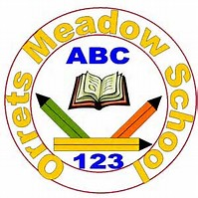
- 2 teaching assistants have been trained in delivering Dyslexia support, by the Orrets Meadow Outreach teacher.

What support will there be for my child’s emotional and social well-being?

Supporting children in their emotional and social well-being is an integral part of our curriculum for all children at St Joseph’s. Two members of staff are embarking on training as Mental Health First Aiders this academic year, 2023-24. One teaching assistant, Mrs Langan, is trained as a Mental Health Lead. Mrs Langan is also the school ELSA (Emotional Literacy Support Assistant).

If your child has a long or short term medical illness then please refer to the Medical Needs policy which outline the level of care and support provided at our school.

Children are encouraged to talk first to their class teacher or Teaching Assistant if they have a concern or a worry regarding friendships and social activities. Children are also encouraged to write their concerns down and put them in the easily accessible ‘Talking Time Tin’. Mrs Langan our ELSA then addresses concerns individually with the children.

Our themed assemblies and lessons support the children’s personal development. Outside agencies support within all areas including social, mental and emotional health, such as the Mental Health Support Team
Our school has a Behaviour policy which outlines a firm but fair approach for all children. Rewards and sanctions can also be personalised to suit a child’s particular needs.

We offer a wide range of clubs and after school activities, which all children have access to, regardless of SEND. If you are interested in your child attending a particular club, but have a concern or question due to a SEND condition, please discuss with class teacher in the first instance to see if any adjustments are required and we will do our best to ensure your child can take part. We aim to ensure at least 10% of all places in clubs are filled by children with SEND, to ensure fair representation in extracurricular activities.

The School Council, which meets at least monthly, gives the children the opportunity to discuss any ideas for improvements to the school and provides a safe forum for discussing any concerns. Council members are elected from every class in Years 2-6 and children are invited to bring concerns to the attention of their elected representatives.
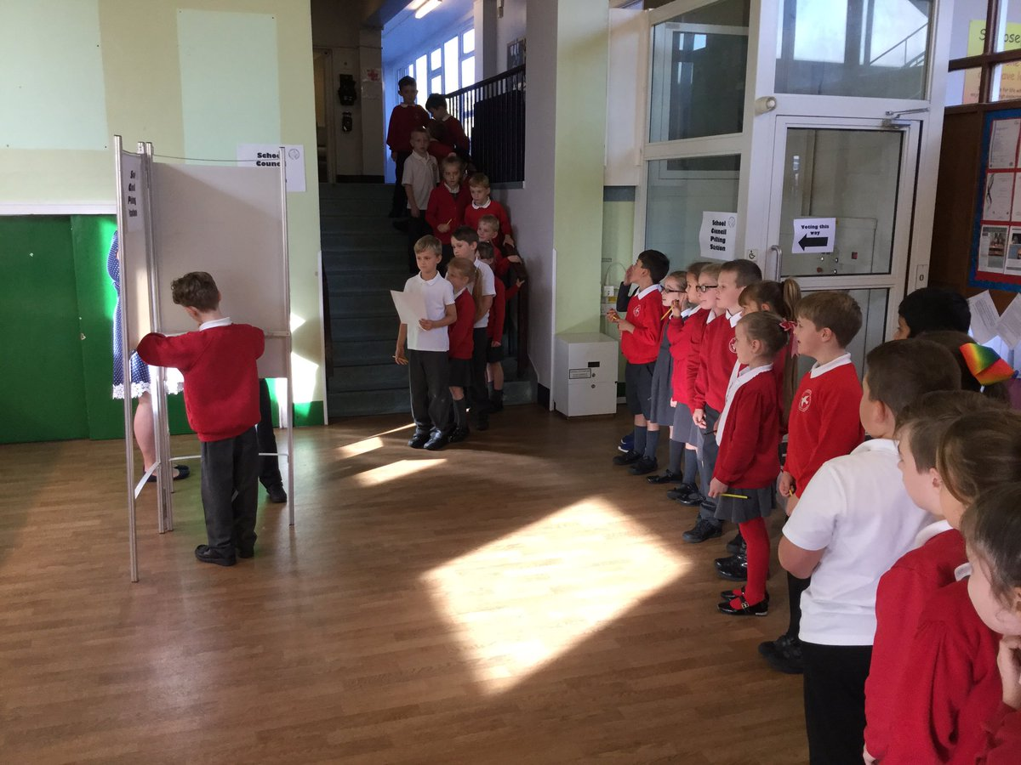

How will my child be able to contribute their views and be involved in the process?

Your child will be able to contribute at all SEND reviews should the child be old enough and/or be able to contribute. They can have their views and needs expressed at the reviews, discussions with the class teacher or their views can be sought through pupil interviews, informal discussions, through The Feelings Art book, Social Stories, etc. All children across the school are invited to share any worries or concerns confidentially via the Talking Time post box. These concerns are then read by the school ELSA and appropriate action taken, whether this be a conversation with the child, the class teacher or a period of extra 1:1 support.
Some children who require greater levels of support are involved in creating their own One-Page Profile, detailing their likes and dislikes and telling the teaching staff how they would best like to be supported in school.
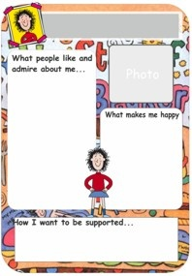

How will the curriculum be matched to my child’s needs?

Class teachers plan lessons according to the specific needs of all groups of children in their class, and will ensure that your child’s needs are met. They have the children’s Personal Support Plan targets alongside their planning to ensure children with SEND individual’s needs are met.

Specially trained support staff can adapt the teachers planning to support the needs of your child where necessary.

Specific resources and strategies will be used to support your child individually and in groups. These may be outlined on your child’s Personal Support Plan or Additional Support Plan. Every subject leader has identified ways in which their subject curriculum can be adapted to meet the needs of children with SEND.

Planning and teaching will be adapted on a daily basis to meet your child’s learning needs.
Where advice has been given from specialists eg Occupational Therapists or Speech and Language Therapists, the teacher should aim to incorporate this advice as much as possible into planning for your child.

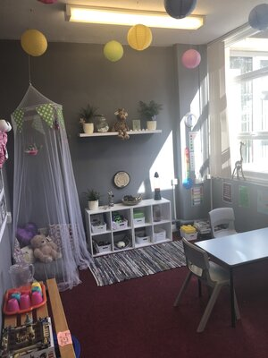
Our peaceful and calm Rainbow Room, where children may go for some 1:1 or small group work.

Waves of Support
The waves of intervention model shows the way we target additional support.

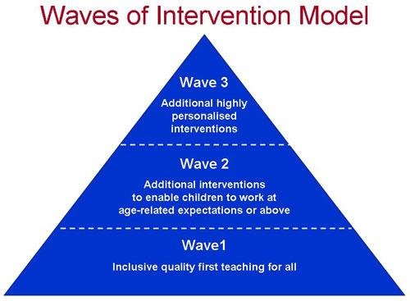
- Wave 1 describes quality inclusive teaching which takes into account the learning needs of all the children in the classroom. This includes providing differentiated work and creating an inclusive learning environment. All children will have their own One-Page Profile.

- Wave 2 describes specific, additional and time-limited interventions provided for some children who need help to accelerate their progress to enable them to work at or above age-related expectations. Wave 2 interventions are often targeted at a group of pupils with similar needs. Children will have their own individualised targets, created with input from themselves, their parents and teaching staff.

- Wave 3 describes targeted provision for a minority of children where it is necessary to provide highly tailored intervention to accelerate progress or enable children to achieve their potential. This may include one to one or specialist interventions.

What opportunities will there be for me to discuss my child’s achievement? How will I know how well my child is progressing?

Your child will have two formal opportunities at Parents’ Evenings to meet with your child’s class teacher to discuss strengths, weaknesses, progress, etc. Further opportunities to meet with the class teacher can be made throughout the year if you or the class teacher has any further concerns. Parents will be actively encouraged to contribute to their child’s Personal Support Plan through discussion with teachers, primarily at Parents’ Evening.

A child identified on the SEND register as having SEN Support will also have these same opportunities with the addition of discussing and reviewing the child’s individual targets. Additional SEN Support meetings may be required throughout the year especially when there is the involvement of outside professionals.

If your child has an Education and Health Care Plan the plan will be reviewed on a minimum of a yearly basis.

For some children with SEND a home-school communication book can be a good link for both parties to learn more about your child on a daily basis ranging from any concerns, updates on positive learning and behaviour, etc.

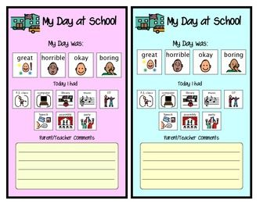

How does the school know how well my child is doing?

Your child’s progress is continually monitored by his/her class teacher. We know how well your child is doing by using the following:

- Assessments based on the Early Learning Goals Ages and Stages in the Reception year.
- Clear baseline assessments are made at the start of the school year, in the key areas of Writing, Reading, Spelling and Mathematics.
- His/her progress is reviewed formally every term and will be assessed as Below, At or Above in each core subject area.
- Children in Year 1 are required to complete the National Phonics Screening that will assess their ability to read real and pseudo words. Children who do not pass in Year 1 are reassessed formally in Year 2 to see if they have met the required national standard. Children learn phonics through the Read Write Inc programme and do not exit this programme until they have reached the required standard in their phonics knowledge. Additional support is given to all children who are yet to meet the required standard in phonics.
- At the end of each key stage (i.e. at the end of year 2 and year 6) all children are required to be formally assessed using Standard Assessment Tests (SATs). This is something the government requires all schools to do and are the results that are published nationally.
- Children in year 4 take part in the national Multiplication Tables Check to assess their times tables knowledge.
- Children with SEND will have individual targets on their Personal Support Plans which will be reviewed with your involvement, every term and the plan for the next term made.
- The progress of children with an EHC Plan is formally reviewed at an Annual Review with all adults involved with the child’s education.
- The SENCO will also check that your child is making good progress within any individual work and in any group that they take part in.
- Outside professionals also provide school with further in depth assessments. These are usually from the Educational Psychologist, Speech and Language Therapist (SALT) or Special Educational Needs Assessment and Advice Team (SENAAT).
- The SENCO meets with your child’s class teacher twice a term to specifically discuss support for children on the SEND register. The class teacher can raise concerns and discuss further support needed at these meetings.

How will my child be included in activities outside the classroom including school trips?

Your child will be allowed to attend any school club allocated to their specific year group. We endeavour to make all activities accessible for all. Where there may be some extra arrangements to be made, you can arrange to meet with the club leader to ensure safety and inclusivity for your child.
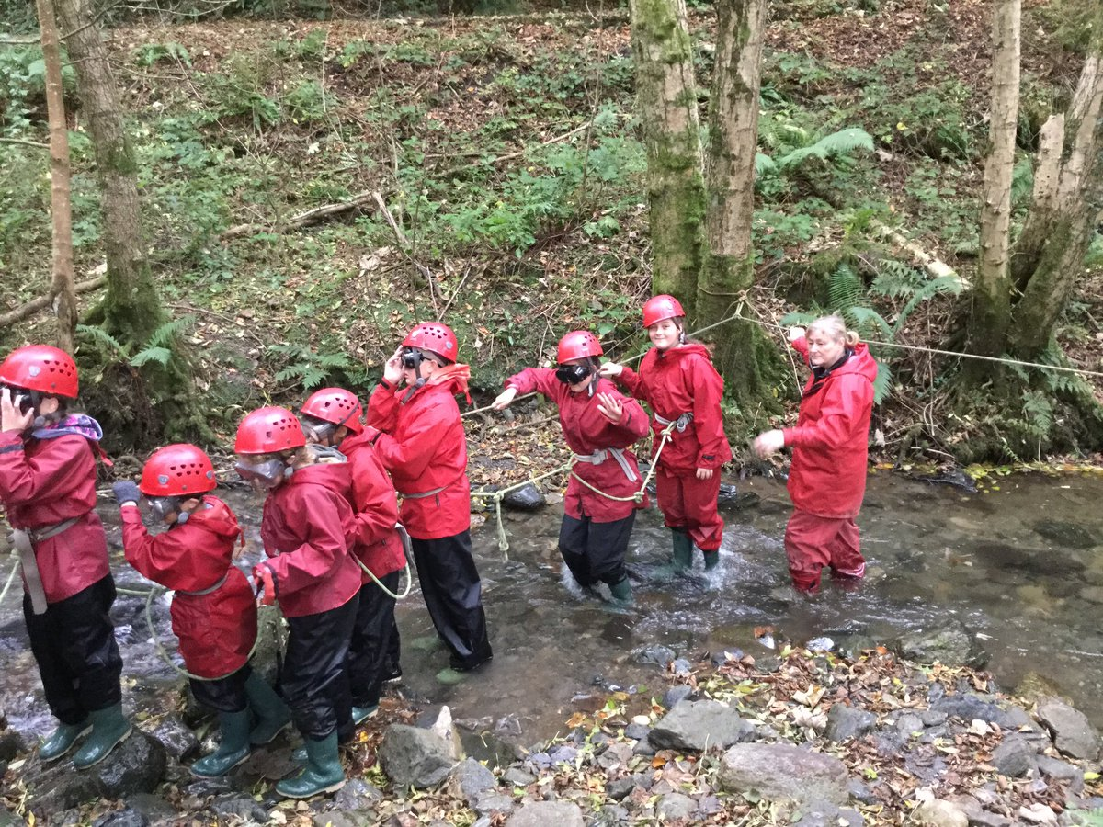

How accessible is the school environment?
ICT
All classrooms have laptops that children can use and we have several ipads. The ICT Suite can be accessed via a lift. Some children may use laptops and ipads to record their work if they find writing difficult.

Facilities
The building is accessible to children with physical disabilities via ramps from some external doorways with lift access to all floor levels. There are also disabled toilet facilities, with a High-Low electronic changing bed, as well as a shower and disabled car parking spaces in the car park. We have a medical evacuation chair, which is a specially designed seat into which mobility-impaired people can be secured and transported from a building, usually via stairways during and emergency.
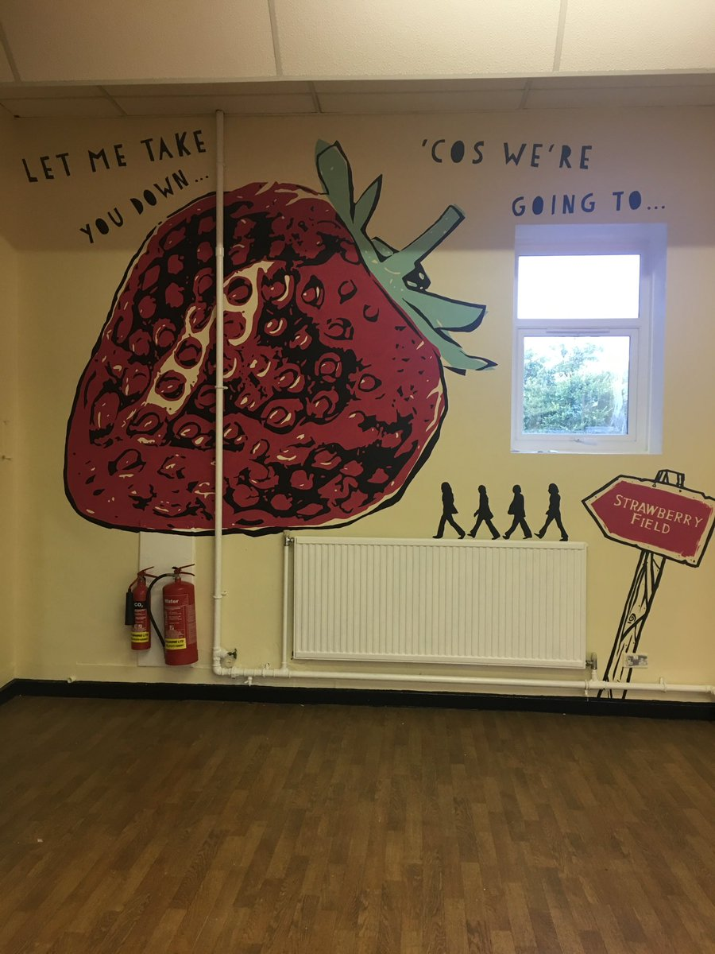

How will the school prepare and support my child to join the school or to transfer to a new setting/school?
We recognise that transitions can be difficult for a child with SEND and take steps to ensure that any transition is a smooth as possible.

If your child is joining our school:

- We will meet with any parents/ carers at their request to discuss the child’s needs. We will liaise with other agencies as required, such as Health Visitors or Speech and Language, to share information about the child.

If your child is moving to another school:
- We will contact the school SENCO and ensure he/she knows about any special arrangements or support that need to be made for your child.
- We will make sure that all records about your child are passed on as soon as possible.

When moving classes in school:
- Information will be passed on to the new class teacher in advance and in most cases, a planning meeting will take place with the new teacher. All Personal Support Plans will be shared with the new teacher. Each class teacher has a SEND file containing information about any additional needs in the class. This file moves through the school with the class so that all relevant paperwork and information can be passed up efficiently as children move through the school.
- Additional support to take account of children’s individual needs can be arranged, e.g. a child friendly book of photos and additional information to support the transition from one setting to another.

In Year 6:
- Your child will complete lessons about aspects of transition to support their understanding of the changes ahead.
- A member of staff from the secondary school settings comes to visit and meet with the children who will be attending their school. Your child will visit their new school on a set Transition Day and staff from the new school will visit your child in this school. Many hold Open Evenings for parents to attend in order to support your decision making process about which school is the right choice for your child.
- If your child has already been identified as having special educational needs, then the SENCO at our school meets with all the secondary school SENCO during the final term of Year 6. Details of the pupil's needs are passed on to the new SENCO, along with details of what support has been in place at our school to help them. Our SENCO passes on information about any outside agencies that have been involved and all SEN paperwork is passed on, including documents such as Personal Support Plans and outside agency reports. The receiving secondary school will then have all the relevant information needed to put support in place as soon as your child joins them in Year 7.
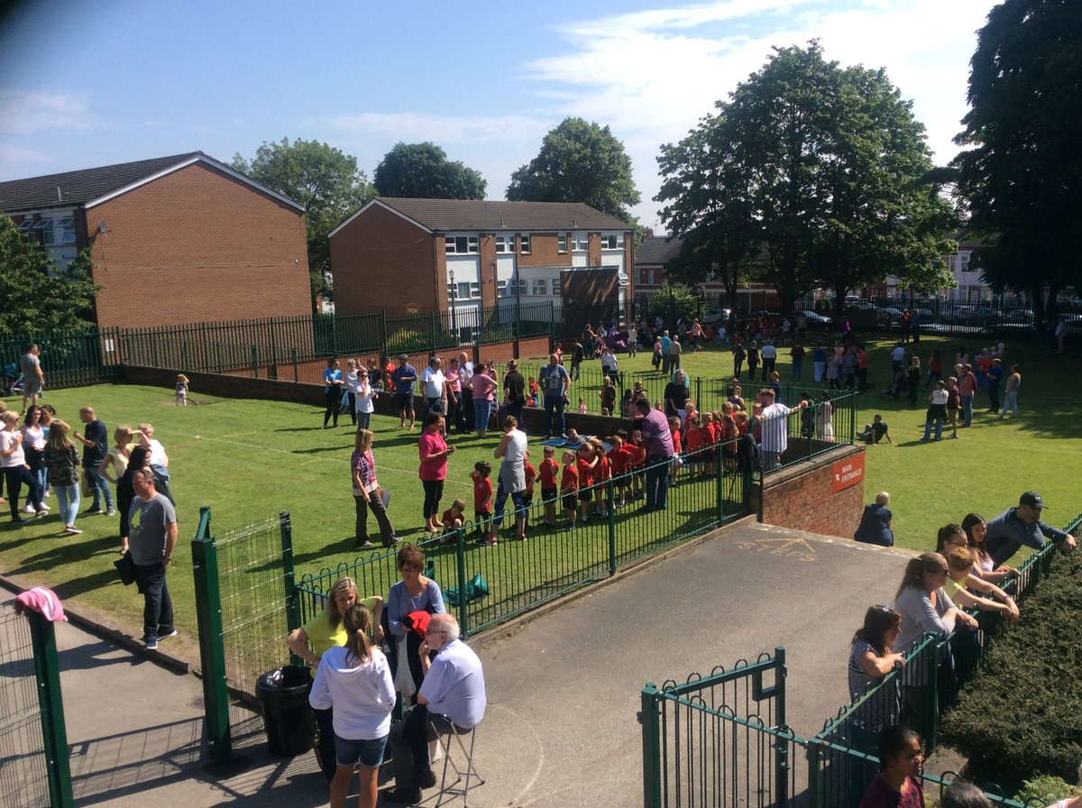

How can I be involved in supporting my child?

You can support your child by:
- Attending parents’ evenings and SEND support meetings.
- Helping them to complete their homework to a good standard and on time.
- Ensuring your child gets to school on time and with all the appropriate equipment.
- Talking to the class teacher if you have any concerns about your child,
- Providing lots of opportunities to speak and have conversations with your child.
- Reading with your child and practising number skills.

Teachers are more than happy to share any ideas they have with you so you can top up the learning at home.

How can I access support for myself and my family?

By looking at the Local Authority Offer https://www.sendlowirral.co.uk/, you will see a list of all the services available to you and your child. You can arrange to meet with our SENCO who might also be able to point you in the right direction.

Wirral SEND Partnership Wirral SEND partnership is an impartial, independent and confidential service which gives free information, advice and support about matters relating to Special Educational Needs or Disabilities (SEND) and is for parents or carers of children aged 0-25, and young people aged 16-25 with special educational needs and/or disabilities.

Who can I contact for further information?

Class teachers – available five days a week by appointment.
Email: schooloffice@stjosephs-birkenhead.wirral.sch.uk

Mrs C Dyas-Ward – SENCO available Fridays (appointment to be made). Email Senco@stjosephs-birkenhead.wirral.sch.uk

Wirral Borough Council Local Offer
Providing information for children and young people (0-25 years) with special educational needs and disabilities.
https://www.sendlowirral.co.uk/

Wirral SEND Partnership
https://localofferwirral.org/listing/wirral-send-partnership/

