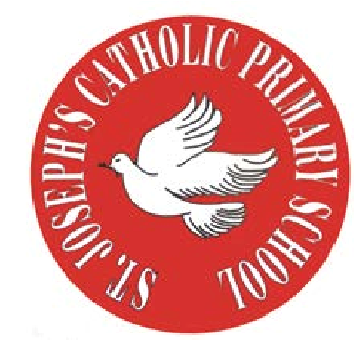
RE Newsletter - Spring 1

St Joseph’s Catholic Primary School
Woodchurch Road, Birkenhead CH43 5UT
Headteacher.
Mr A. Turner

Dear Parents,
We begin this term full of the joy of the Christmas season which ends for us at the celebration of the Baptism of Jesus on 12th January. On the 2nd February we celebrate the feast of the Presentation of the Lord (Candlemas) when Jesus is recognised as ‘The Light of the World’. We must also remember that each one of us is called to be a ‘light’, an inspiration to those around us.

During the winter of Ordinary Time, i.e. up to Lent, we are asked to pray for these intentions: Peace on Earth; Christian Unity; The Sick and Those Who Care for Them; Victims of Trafficking and Those who Work to Combat it; The Unemployed.

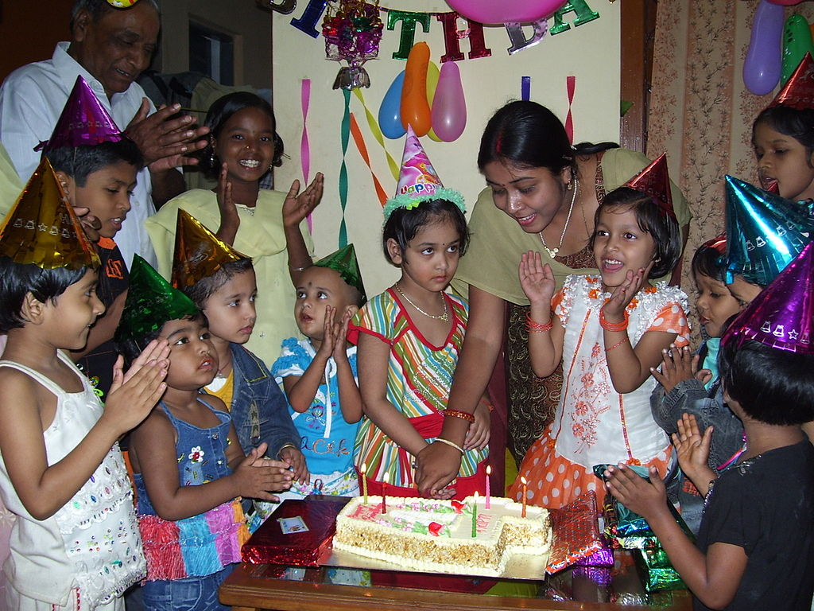
Below you will find what your child is learning about in RE this half term.

Year 1 – Families and Celebrations
The children will learn about what it means to be a member
of a family and to be a member of the school community.
They will learn what it means to belong to the Church family.

They will hear how Jesus’ family took him to the Temple and think about why this was a special occasion. They will learn about some of the celebrations in the Church and why we celebrate these occasions.

At home
You could help your child by:
• discussing the importance of celebrations in our lives
• encourage them to think about Church celebrations e.g. Christmas, Easter etc

RE Newsletter - Spring 2
The Season of Lent

Dear Parents,
The word Lent comes from an old English word that means ‘lengthen’ and refers to the turning of Winter into Spring when the days lengthen and the cycle of life is renewed once more. There is more sunlight, birdsong is more noticeable, spring bulbs are in bloom and trees are beginning to show signs of coming to life. These signs of new life are echoed in the season of Lent through which the Church bids us to reawaken and refocus on tending to the Lord who calls us ‘come back to me, with all your heart’. The journey of Lent is a journey towards the new way of living that Jesus, through the Holy Spirit, promised to us through the power of our most celebrated season – Easter.

We tend to celebrate Christmas as if it’s the most important time in the Church’s year, but the Resurrection of Jesus is the most important event for Christians. When Christians say that their hope is in the risen Jesus, they mean it is their greatest hope. When Jesus rose on the first Easter morning, it was a brand new kind of life. He promises this same life to all who hope in him. No wonder that Easter is the greatest feast!

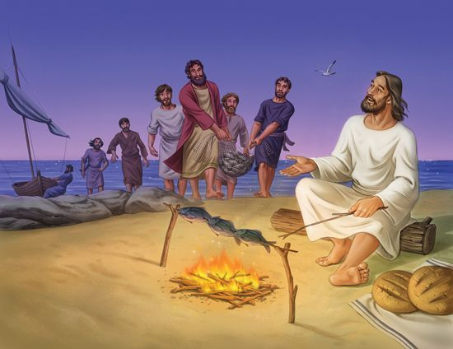
Year 1 – Following Jesus
Year 1 will hear how Jesus chose some of the first disciples
(Luke 3. 5: 1- 11) and reflect on how we choose our friends.
They will hear how Martha and Mary were friends of Jesus
and think about how we can be his friends. They will listen to
the story of Jesus and his followers going into Jerusalem and think
of how we can praise Jesus. They will learn that Jesus died on
Good Friday and know that God raised Jesus

At Home
You could help your children by:
•Encouraging them to invite a friend to play

