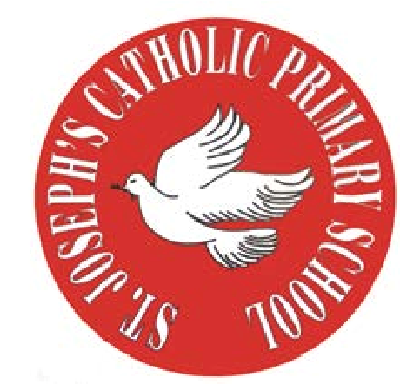

St Joseph’s Catholic Primary School
Woodchurch Road, Birkenhead CH43 5UT
Headteacher.
Mr A. Turner
RE Newsletter - Spring 1

Dear Parents,
We begin this term full of the joy of the Christmas season which ends for us at the celebration of the Baptism of Jesus on 12th January. On the 2nd February we celebrate the feast of the Presentation of the Lord (Candlemas) when Jesus is recognised as ‘The Light of the World’. We must also remember that each one of us is called to be a ‘light’, an inspiration to those around us.

During the winter of Ordinary Time, i.e. up to Lent, we are asked to pray for these intentions: Peace on Earth; Christian Unity; The Sick and Those Who Care for Them; Victims of Trafficking and Those who Work to Combat it; The Unemployed.

Below you will find what your child is learning about in RE this half term.

Year 2 – The Good News
“Jesus is sent to preach good news to the poor. Jesus identifies himself with the poor of every kind and makes active love toward them the condition for entering his kingdom.”
Catechism of the Catholic Church

The children will learn that Jesus brought the good news of God’s
love and that this changed people’s lives. They will learn that Jesus
used his power to help others and reflect on the importance of these
events. They will reflect on how they can bring good news to their
family and friends.

At home
You could help your child by:
• highlighting opportunities when they can give thanks to God
• read stories about Jesus helping people, e.g. The feeding of the 5000

RE Newsletter - Spring 2
The Season of Lent

Dear Parents,
The word Lent comes from an old English word that means ‘lengthen’ and refers to the turning of Winter into Spring when the days lengthen and the cycle of life is renewed once more. There is more sunlight, birdsong is more noticeable, spring bulbs are in bloom and trees are beginning to show signs of coming to life. These signs of new life are echoed in the season of Lent through which the Church bids us to reawaken and refocus on tending to the Lord who calls us ‘come back to me, with all your heart’. The journey of Lent is a journey towards the new way of living that Jesus, through the Holy Spirit, promised to us through the power of our most celebrated season – Easter.

We tend to celebrate Christmas as if it’s the most important time in the Church’s year, but the Resurrection of Jesus is the most important event for Christians. When Christians say that their hope is in the risen Jesus, they mean it is their greatest hope. When Jesus rose on the first Easter morning, it was a brand new kind of life. He promises this same life to all who hope in him. No wonder that Easter is the greatest feast!

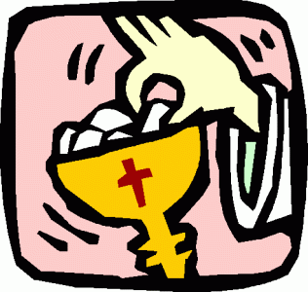
Year 2 – The Mass
Year 2 will learn and reflect on the importance of the
celebration of the Mass. They will learn about the readings
at Mass and why we should listen to them, and learn that at
the Offertory we offer gifts to God. They will also appreciate
that at the Consecration the bread and wine are changed into
Jesus’ Body and Blood.

At Home
You could help your children by:
• reading some bible stories with them
• encouraging them to attend ‘Children’s liturgy’ during Sunday Mass

