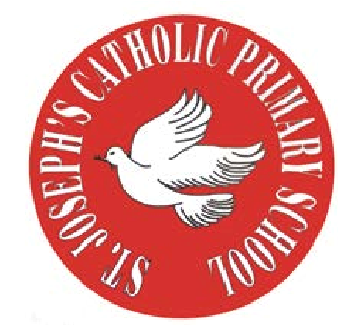
RE Newsletter - Spring 1

St Joseph’s Catholic Primary School
Woodchurch Road, Birkenhead CH43 5UT
Headteacher.
Mr A. Turner

Dear Parents,
We begin this term full of the joy of the Christmas season which ends for us at the celebration of the Baptism of Jesus on 12th January. On the 2nd February we celebrate the feast of the Presentation of the Lord (Candlemas) when Jesus is recognised as ‘The Light of the World’. We must also remember that each one of us is called to be a ‘light’, an inspiration to those around us.

During the winter of Ordinary Time, i.e. up to Lent, we are asked to pray for these intentions: Peace on Earth; Christian Unity; The Sick and Those Who Care for Them; Victims of Trafficking and Those who Work to Combat it; The Unemployed.

Below you will find what your child is learning about in RE this half term.

Year 3 – The Sacrament of Reconciliation
The children will develop their understanding that Jesus called people to change, to turn away from sin and receive the love of God. They will learn that it is not always easy to change and find out about some individuals who changed through the help of Jesus. They will learn that the Sacrament of Reconciliation is a celebration of God’s love and forgiveness and begin to learn an Act of Sorrow. They will learn that Lent is a time to change in order to prepare for Easter.
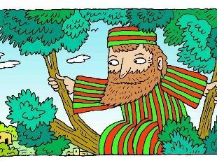
At home
You could help your child by:
• thinking about how Jesus changes our lives
• reading the story of Zacchaeus

RE Newsletter - Spring 2
The Season of Lent
Dear Parents,
The word Lent comes from an old English word that means ‘lengthen’ and refers to the turning of Winter into Spring when the days lengthen and the cycle of life is renewed once more. There is more sunlight, birdsong is more noticeable, spring bulbs are in bloom and trees are beginning to show signs of coming to life. These signs of new life are echoed in the season of Lent through which the Church bids us to reawaken and refocus on tending to the Lord who calls us ‘come back to me, with all your heart’. The journey of Lent is a journey towards the new way of living that Jesus, through the Holy Spirit, promised to us through the power of our most celebrated season – Easter.

We tend to celebrate Christmas as if it’s the most important time in the Church’s year, but the Resurrection of Jesus is the most important event for Christians. When Christians say that their hope is in the risen Jesus, they mean it is their greatest hope. When Jesus rose on the first Easter morning, it was a brand new kind of life. He promises this same life to all who hope in him. No wonder that Easter is the greatest feast!

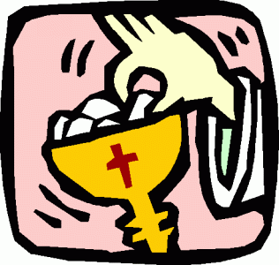
Year 3 – Celebrating the Mass
Year 3 will know why Sunday is special for Christians and will know
that we come to Mass to hear the teaching of Jesus and pray to him.
They will learn that in the Mass we offer thanks to God the Father for
the gift of his Son and learn that during Mass the bread and wine
become the body and blood of Jesus. They will learn that when we
receive Holy Communion we receive Jesus and learn that Jesus is
present in the Blessed Sacrament in the tabernacle. They will also learn
some of the responses in the Mass and understand that Jesus died on
the cross and rose from the dead.
At Home
You could help your children by:
• talking to them about all the things we have to be thankful for
• talking to them about how Sunday is a special day for Christians

