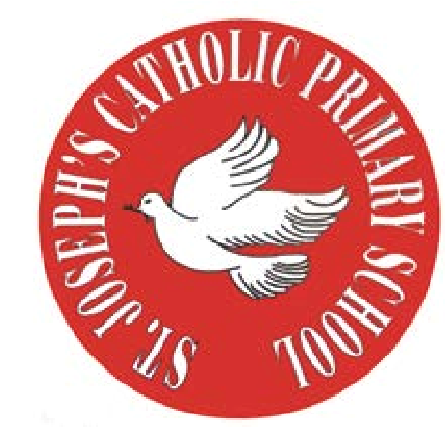
RE Newsletter - Spring 1

St Joseph’s Catholic Primary School
Woodchurch Road, Birkenhead CH43 5UT
Headteacher.
Mr A. Turner

Dear Parents,
We begin this term full of the joy of the Christmas season which ends for us at the celebration of the Baptism of Jesus on 12th January. On the 2nd February we celebrate the feast of the Presentation of the Lord (Candlemas) when Jesus is recognised as ‘The Light of the World’. We must also remember that each one of us is called to be a ‘light’, an inspiration to those around us.

During the winter of Ordinary Time, i.e. up to Lent, we are asked to pray for these intentions: Peace on Earth; Christian Unity; The Sick and Those Who Care for Them; Victims of Trafficking and Those who Work to Combat it; The Unemployed.

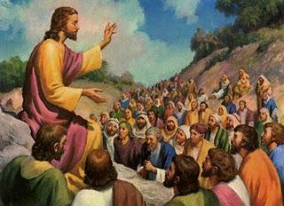
Below you will find what your child is learning about in RE this half term.

Year 4 – Jesus the Teacher
The children will learn that Jesus was born into a Jewish family
and find out about the story of the presentation in the Temple.
They will learn that Jesus attended synagogue as a child and
as an adult read the Torah. They will learn that Jesus travelled
about teaching people.

The children will learn that Jesus came to show us the way to live, understand why
Jesus used parables to teach people and know and understand some of the parables
Jesus told. The children will have a chance to appreciate the relevance of the parables
for us today and recognise that Lent gives us an opportunity to live as Jesus wants us to.

At home
You could help your child by:
• reading some well known parables, e.g. ‘The Sower’ and talk about what they mean for us

St Joseph’s Catholic Primary School
Woodchurch Road, Birkenhead CH43 5UT
Headteacher.
Mr A. Turner

RE Newsletter - Spring 2
The Season of Lent
Dear Parents,
The word Lent comes from an old English word that means ‘lengthen’ and refers to the turning of Winter into Spring when the days lengthen and the cycle of life is renewed once more. There is more sunlight, birdsong is more noticeable, spring bulbs are in bloom and trees are beginning to show signs of coming to life. These signs of new life are echoed in the season of Lent through which the Church bids us to reawaken and refocus on tending to the Lord who calls us ‘come back to me, with all your heart’. The journey of Lent is a journey towards the new way of living that Jesus, through the Holy Spirit, promised to us through the power of our most celebrated season – Easter.

We tend to celebrate Christmas as if it’s the most important time in the Church’s year, but the Resurrection of Jesus is the most important event for Christians. When Christians say that their hope is in the risen Jesus, they mean it is their greatest hope. When Jesus rose on the first Easter morning, it was a brand new kind of life. He promises this same life to all who hope in him. No wonder that Easter is the greatest feast!

Year 4 – Jesus the Saviour
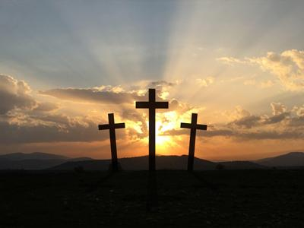
Year 4 will learn that Jesus is truly God and, as man truly human and
learn that Jesus came to share our life so that we can share his life.
They will learn that when Jesus died on the cross he took away our sins,
learn what happened in Holy week and learn what happened on
Easter Sunday.

At Home
You could help your children by:
• reading the stories of Jesus’ last week with them
• visiting church during Holy Week

