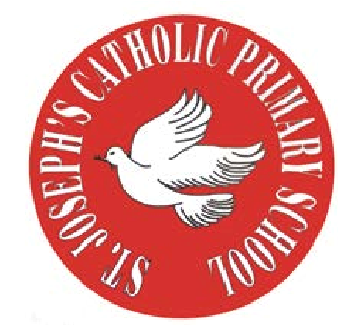
RE Newsletter - Spring 1

St Joseph’s Catholic Primary School
Woodchurch Road, Birkenhead CH43 5UT
Headteacher.
Mr A. Turner

Dear Parents,
We begin this term full of the joy of the Christmas season which ends for us at the celebration of the Baptism of Jesus on 12th January. On the 2nd February we celebrate the feast of the Presentation of the Lord (Candlemas) when Jesus is recognised as ‘The Light of the World’. We must also remember that each one of us is called to be a ‘light’, an inspiration to those around us.

During the winter of Ordinary Time, i.e. up to Lent, we are asked to pray for these intentions: Peace on Earth; Christian Unity; The Sick and Those Who Care for Them; Victims of Trafficking and Those who Work to Combat it; The Unemployed.

Below you will find what your child is learning about in RE this half term.

Year 5 – Inspirational People
The children will learn about the conditions for following Jesus and learn how Jesus described a true disciple. They will have a chance to reflect on their commitment to following Jesus. They will learn the story of a person who had a special love for those rejected by society and about someone who was an inspiration for young people. They will identify people today who are an inspiration in their service of others.

At home
You could help your child by:
• encouraging them to research some information about inspirational people and saints

St Joseph’s Catholic Primary School
Woodchurch Road, Birkenhead CH43 5UT
Headteacher.
Mr A. Turner

RE Newsletter - Spring 2

St Joseph’s Catholic Primary School
Woodchurch Road, Birkenhead CH43 5UT
Headteacher.
Mr A. Turner
The Season of Lent

Dear Parents,
The word Lent comes from an old English word that means ‘lengthen’ and refers to the turning of Winter into Spring when the days lengthen and the cycle of life is renewed once more. There is more sunlight, birdsong is more noticeable, spring bulbs are in bloom and trees are beginning to show signs of coming to life. These signs of new life are echoed in the season of Lent through which the Church bids us to reawaken and refocus on tending to the Lord who calls us ‘come back to me, with all your heart’. The journey of Lent is a journey towards the new way of living that Jesus, through the Holy Spirit, promised to us through the power of our most celebrated season – Easter.

We tend to celebrate Christmas as if it’s the most important time in the Church’s year, but the Resurrection of Jesus is the most important event for Christians. When Christians say that their hope is in the risen Jesus, they mean it is their greatest hope. When Jesus rose on the first Easter morning, it was a brand new kind of life. He promises this same life to all who hope in him. No wonder that Easter is the greatest feast!

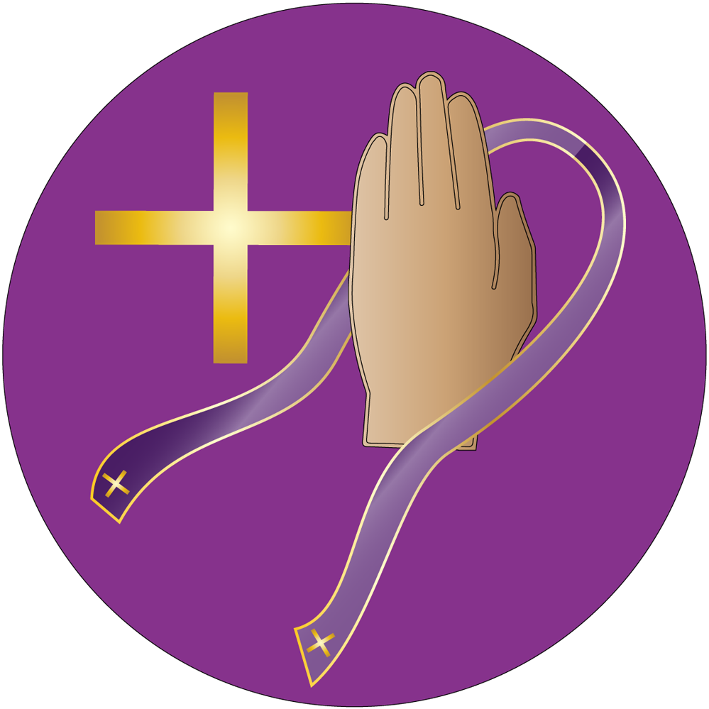
Year 5 – Reconciliation
Year 5 will learn that sin is a failure of love and learn that when we sin
we hurt ourselves and others and damage our relationship with God.
They will begin to understand that God loves and forgives us if we are
truly sorry and learn that God heals our friendship with him and others
through the Sacrament of Reconciliation. They learn how we can prepare
ourselves to receive this Sacrament and learn what happens during the
Sacrament of Reconciliation.

At Home
You could help your children by:
• talking to them about what strengthens their friendships
• reading the stories of Jesus’ last week with them

