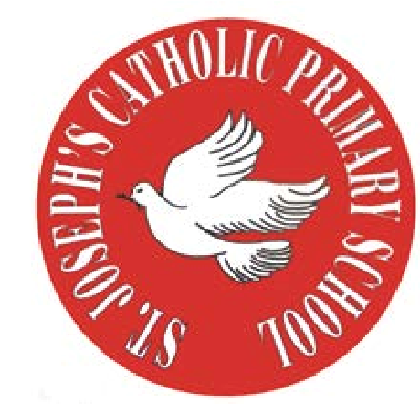
RE Newsletter - Spring 1

St Joseph’s Catholic Primary School
Woodchurch Road, Birkenhead CH43 5UT
Headteacher.
Mr A. Turner

Dear Parents,
We begin this term full of the joy of the Christmas season which ends for us at the celebration of the Baptism of Jesus on 12th January. On the 2nd February we celebrate the feast of the Presentation of the Lord (Candlemas) when Jesus is recognised as ‘The Light of the World’. We must also remember that each one of us is called to be a ‘light’, an inspiration to those around us.

During the winter of Ordinary Time, i.e. up to Lent, we are asked to pray for these intentions: Peace on Earth; Christian Unity; The Sick and Those Who Care for Them; Victims of Trafficking and Those who Work to Combat it; The Unemployed.

Below you will find what your child is learning about in RE this half term.
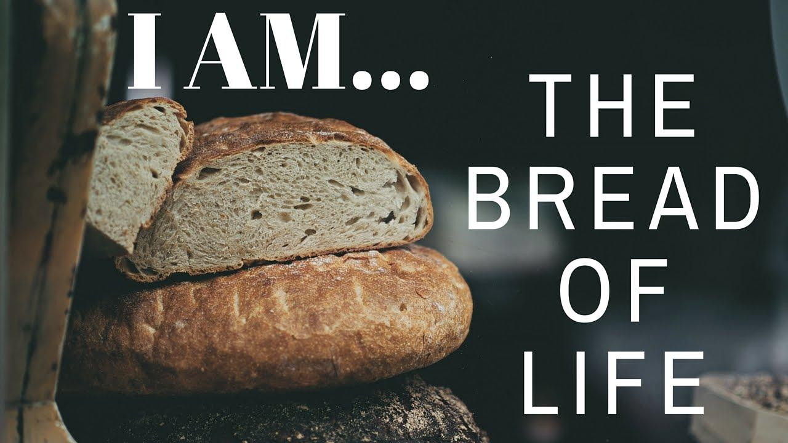
Year 6 - Jesus, the bread of life

The children will learn that the Sacrament of the Eucharist
is a thanksgiving for the life, death and resurrection of Jesus.
They will begin to understand that in the Mass we participate
in Jesus’ sacrifice to God the Father and learn what happened
at the Last Supper.

They will learn the different parts of the Mass and become familiar with most of the responses. The children will learn that the bread and wine are consecrated during Mass and become the body and blood of Jesus. The children will have a chance to reflect on the sacrifice of Jesus and reflect on the sacrifices they can make during Lent.

At home
You could help your child by:
• bringing their attention to the Eucharistic prayer during Mass
• ask them during the week to explain what they have been learning during their RE lessons

RE Newsletter - Spring 2

St Joseph’s Catholic Primary School
Woodchurch Road, Birkenhead CH43 5UT
Headteacher.
Mr A. Turner

St Joseph’s Catholic Primary School
Woodchurch Road, Birkenhead CH43 5UT
Headteacher.
Mr A. Turner
The Season of Lent
Dear Parents,
The word Lent comes from an old English word that means ‘lengthen’ and refers to the turning of Winter into Spring when the days lengthen and the cycle of life is renewed once more. There is more sunlight, birdsong is more noticeable, spring bulbs are in bloom and trees are beginning to show signs of coming to life. These signs of new life are echoed in the season of Lent through which the Church bids us to reawaken and refocus on tending to the Lord who calls us ‘come back to me, with all your heart’. The journey of Lent is a journey towards the new way of living that Jesus, through the Holy Spirit, promised to us through the power of our most celebrated season – Easter.

We tend to celebrate Christmas as if it’s the most important time in the Church’s year, but the Resurrection of Jesus is the most important event for Christians. When Christians say that their hope is in the risen Jesus, they mean it is their greatest hope. When Jesus rose on the first Easter morning, it was a brand new kind of life. He promises this same life to all who hope in him. No wonder that Easter is the greatest feast!

Year 6 - Jesus, Son of God
Year 6 will learn that Jesus healed many people, brought others back to life
and that His miracles led many to believe that he was the Son of God. They will
learn that Jesus’ enemies plotted to have him arrested, and learn about the arrest
and the trial before the high priest. They will learn about Jesus’ trial before Pilate
and learn that Jesus was condemned to death and crucified. They will also learn what Jesus said before he died and about His glorious resurrection. The children will have the chance to reflect on the miracles of Jesus. They will have the opportunity to make the Stations of the Cross and participate in a dramatisation of the passion, death & resurrection of Jesus. They will also reflect on the meaning of the passion, death and resurrection of Jesus for us today.
At Home
You could help your children by:
• discuss what they have found out in class and how it will affect their life.
• look at the Stations of the Cross and talk about their relevance for us today.

