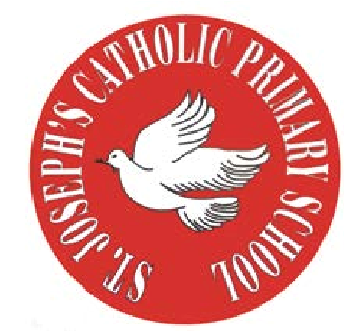
RE Newsletter – Summer 1

St Joseph’s Catholic Primary School
Woodchurch Road, Birkenhead CH43 5UT
Headteacher.
Mr A. Turner

Dear Parents,
The Church is celebrating the great feast of Easter – Jesus risen from the dead. This celebration goes on until the solemnity of Pentecost (Sunday 5th June), the birthday of the Church. At Pentecost we celebrate the outpouring of the Holy Spirit who empowers and enables us to follow in the footsteps of Jesus. During this term the Church dedicates the month of May to Mary, Jesus’ mother.

We hope you find this newsletter of interest and as always, please keep us in your prayers as we continue to support your child in their religious education.

FS1 and FS2– New Life
“Jesus’ life, death and resurrection are the central event of all human history and at the heart of faith”
Religious Education Curriculum Directory
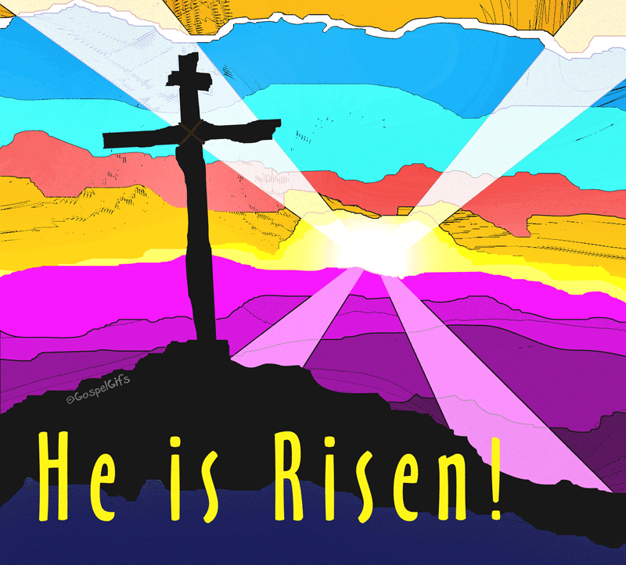
This half term, the children in the Nursery and the Reception classes
will be learning about new life. They will learn about the story of the
empty tomb, and learn that Jesus appeared to his disciples.
The children will begin to understand the special gift of joy and
peace that Jesus gave to his friends (John 20: 19-21) and can give
to us as well. They will hear the story of Jesus going back to his Father
and learn that one day we shall hopefully go there too.

At home
You could help your child by:
• planting an Easter garden
• looking for signs of new life
• practise the Sign of the Cross, ‘Hail Mary’ & ‘Our Father’

RE Newsletter – Summer 2

St Joseph’s Catholic Primary School
Woodchurch Road, Birkenhead CH43 5UT
Headteacher.
Mr A. Turner

Dear Parents,
We welcome you and your children back to school after the half term. We begin in the month of June which is dedicated to the Sacred Heart of Jesus. The devotion to the Sacred Heart of Jesus reminds us of the never ending and merciful love that Jesus has for us.

We hope, as always, you find this newsletter interesting and informative. Please keep us in your prayers as we support your children in their Religious Education.

Below you will find what your child is learning about in RE this half term.

FS1 and FS2– Church

This half term, the children in the Nursery and the Reception classes will be learning about the Church. The children will begin to understand that we call the Church the family of God. They will learn that a church building is a holy place where we can all pray and are welcome. The children will learn that Jesus is present in a special way in the Blessed Sacrament and he invites us to be with him. They will learn to be thankful that lots of people help to look after the church and know why Sunday is a special day.

At home
You could help your child by:
• visiting church, either for Mass or another time, to talk about the church reminding them what a special place a Church is and reasons why
• talking to your child about their Baptism, explaining how this was the day that they became part of God’s family.
