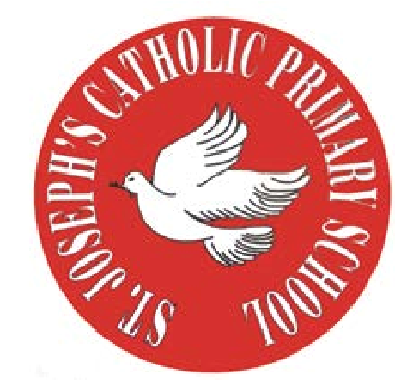
RE Newsletter – Summer 1

St Joseph’s Catholic Primary School
Woodchurch Road, Birkenhead CH43 5UT
Headteacher.
Mr A. Turner

Dear Parents,
The Church is celebrating the great feast of Easter – Jesus risen from the dead. This celebration goes on until the solemnity of Pentecost (Sunday 5th June), the birthday of the Church. At Pentecost we celebrate the outpouring of the Holy Spirit who empowers and enables us to follow in the footsteps of Jesus. During this term the Church dedicates the month of May to Mary, Jesus’ mother.

We hope you find this newsletter of interest and as always, please keep us in your prayers as we continue to support your child in their religious education.

Year 1 - The Resurrection
Year 1 will learn that Jesus appeared to his disciples in the Upper Room and will think about the times when they have experienced great joy and surprise. They will learn that Jesus helped his disciples to understand that he was risen from the dead and was with them (John 21: 9-14) and this made them very happy. They will learn that when Thomas heard that Jesus was alive he did not believe it. They will also become aware that sometimes, like Thomas, we don’t understand what is
happening.

At home
You could help your child by:
• reading stories from the Bible about Easter and Pentecost

RE Newsletter – Summer 2

St Joseph’s Catholic Primary School
Woodchurch Road, Birkenhead CH43 5UT
Headteacher.
Mr A. Turner

Dear Parents,
We welcome you and your children back to school after the half term. We begin in the month of June which is dedicated to the Sacred Heart of Jesus. The devotion to the Sacred Heart of Jesus reminds us of the never ending and merciful love that Jesus has for us.

We hope, as always, you find this newsletter interesting and informative. Please keep us in your prayers as we support your children in their Religious Education.

Below you will find what your child is learning about in RE this half term.

Year 1 - Miracles

The children will hear some stories from the gospels which tell of Jesus using his God-given power to show his love and compassion. They will hear the story of the Calming of the Storm and know that we can ask Jesus to help us when we are afraid. They will learn that Jesus showed his love for sick people when he cured a man who was paralysed and know that Jesus has great love for people who are sick today. They will learn that Jesus responded to the faith of the blind man with compassion
and think of ways that we can trust Jesus in situations of need.

At home
You could help your child by:
•reading the story of the Calming of the Storm or other miracle stories
from the New Testament
▪talking to them about how we can ask Jesus, through our prayers, to
help us

