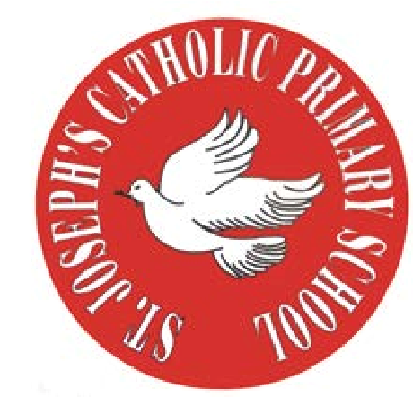
RE Newsletter – Summer 1

St Joseph’s Catholic Primary School
Woodchurch Road, Birkenhead CH43 5UT
Headteacher.
Mr A. Turner

Dear Parents,
The Church is celebrating the great feast of Easter – Jesus risen from the dead. This celebration goes on until the solemnity of Pentecost (Sunday 5th June), the birthday of the Church. At Pentecost we celebrate the outpouring of the Holy Spirit who empowers and enables us to follow in the footsteps of Jesus. During this term the Church dedicates the month of May to Mary, Jesus’ mother.

We hope you find this newsletter of interest and as always, please keep us in your prayers as we continue to support your child in their religious education.

Year 2 - Eastertide
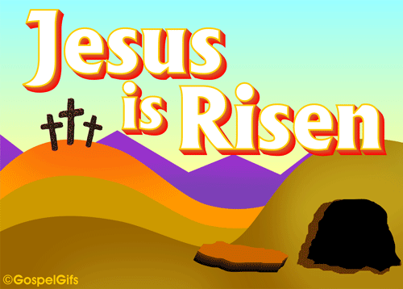
Year 2 will learn that Jesus rose from the dead and still lives with us. They will learn that Jesus told his disciples that he would go back to Heaven but promised that the Holy Spirit would come. They will learn that Jesus ascended into Heaven and promised to return again and that this gives us hope. They will also know the story of the coming of the Holy Spirit on the apostles at Pentecost and know that the Holy Spirit is promised to us.

At home
You could help your child by:
• talking about how the Holy Spirit helps us
• having a close look at the Paschal (Easter) Candle when at Mass

RE Newsletter – Summer 2

St Joseph’s Catholic Primary School
Woodchurch Road, Birkenhead CH43 5UT
Headteacher.
Mr A. Turner

Dear Parents,
We welcome you and your children back to school after the half term. We begin in the month of June which is dedicated to the Sacred Heart of Jesus. The devotion to the Sacred Heart of Jesus reminds us of the never ending and merciful love that Jesus has for us.

We hope, as always, you find this newsletter interesting and informative. Please keep us in your prayers as we support your children in their Religious Education.

Below you will find what your child is learning about in RE this half term.

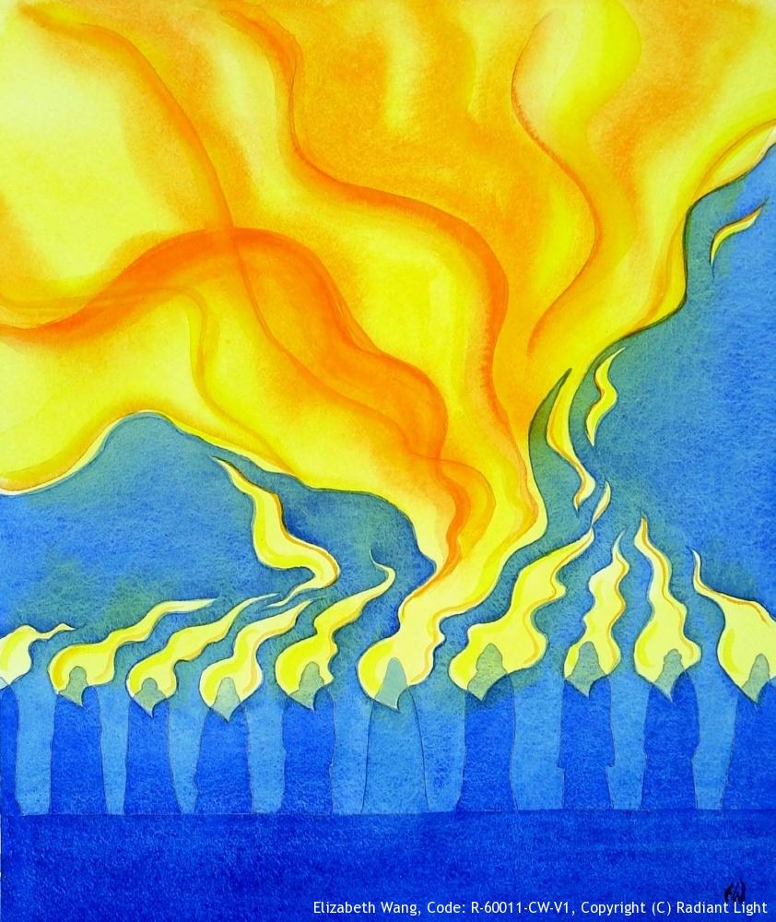
Year 2 - The Church

The children in Year 2 will learn that when the apostles received the
Holy Spirit they spread the Good News. They will reflect on how they
can spread the Good News. They will learn about the early Christian
community and understand that the Christian community continues
today to live by Baptism, the Eucharist and its mission to love God
by loving our neighbour.

At home
You could help your child by:

- talking about the symbols of the Holy Spirit and how the Spirit helps us

