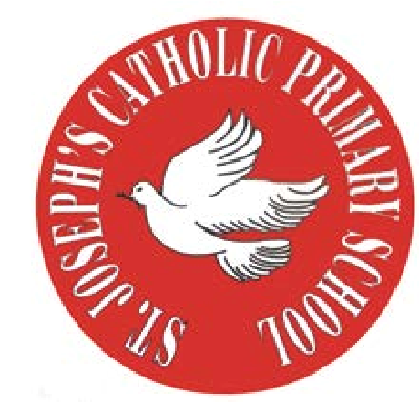
RE Newsletter – Summer 1

St Joseph’s Catholic Primary School
Woodchurch Road, Birkenhead CH43 5UT
Headteacher.
Mr A. Turner

Dear Parents,
The Church is celebrating the great feast of Easter – Jesus risen from the dead. This celebration goes on until the solemnity of Pentecost (Sunday 5th June), the birthday of the Church. At Pentecost we celebrate the outpouring of the Holy Spirit who empowers and enables us to follow in the footsteps of Jesus. During this term the Church dedicates the month of May to Mary, Jesus’ mother.

We hope you find this newsletter of interest and as always, please keep us in your prayers as we continue to support your child in their religious education.

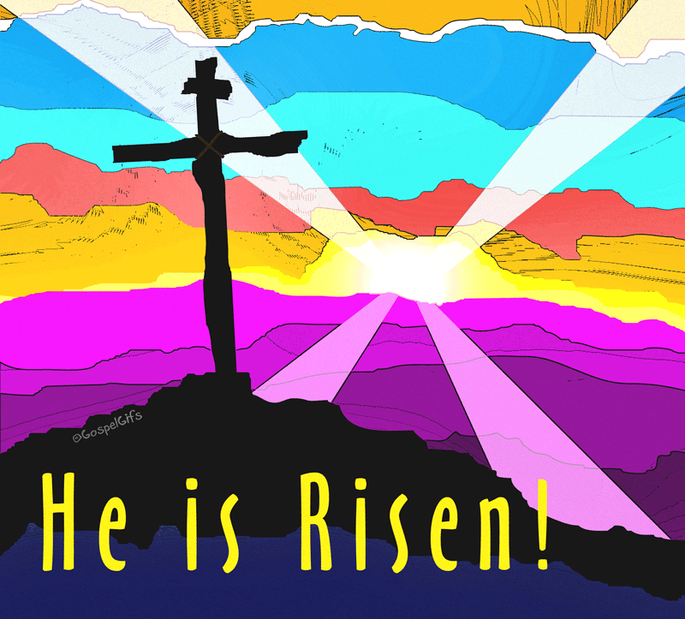
Year 3 - Celebrating Easter & Pentecost

Year 3 will learn that God the Father raised Jesus from the dead on
Easter Sunday. They will learn that because Jesus rose from the dead
we too will rise from the dead. They will hear the story of the
appearance of Jesus on the road to Emmaus and to Thomas. They will
also hear and reflect on the story of the coming of the Holy Spirit at
Pentecost.

At home
You could help your child by:
• talking to them about how the Church celebrates the resurrection
• reading the story of Pentecost with them
• discussing with them what they would have felt if they were one of the
Disciples

RE Newsletter – Summer 2

St Joseph’s Catholic Primary School
Woodchurch Road, Birkenhead CH43 5UT
Headteacher.
Mr A. Turner

Dear Parents,
We welcome you and your children back to school after the half term. We begin in the month of June which is dedicated to the Sacred Heart of Jesus. The devotion to the Sacred Heart of Jesus reminds us of the never ending and merciful love that Jesus has for us.

We hope, as always, you find this newsletter interesting and informative. Please keep us in your prayers as we support your children in their Religious Education.

Below you will find what your child is learning about in RE this half term.

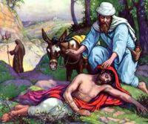
Year 3 - Being a Christian

Year 3 will develop their understanding of what being a Christian
involves. They will reflect on the joy and challenges involved in
following Jesus and learn about these through the lives of Ss. Peter
and Paul. The children will reflect on their gifts and talents and
the gifts the Church calls Sacraments, especially the Eucharist.
They will reflect on how to use the gifts God has given to us to be a
Christian .

At home
You could help your child by:

- encouraging them to recognise their gifts and talents
- talk about how they can use their gifts and talents to help others

