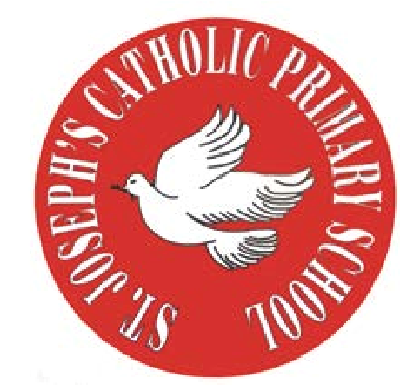
RE Newsletter – Summer 1

St Joseph’s Catholic Primary School
Woodchurch Road, Birkenhead CH43 5UT
Headteacher.
Mr A. Turner

Dear Parents,
The Church is celebrating the great feast of Easter – Jesus risen from the dead. This celebration goes on until the solemnity of Pentecost (Sunday 5th June), the birthday of the Church. At Pentecost we celebrate the outpouring of the Holy Spirit who empowers and enables us to follow in the footsteps of Jesus. During this term the Church dedicates the month of May to Mary, Jesus’ mother.

We hope you find this newsletter of interest and as always, please keep us in your prayers as we continue to support your child in their religious education.

Year 4 - The Early Christians

Year 4 will learn that Peter was chosen by Jesus to play a special
role in the Church and that Jesus gave his followers a mission –
to spread the Good News to others. They will learn that Jesus
promised the Holy Spirit to help his followers and that Pentecost
was the beginning of the Church. They will learn about the
missions of Peter and Paul and about Stephen the first martyr of
the Christian faith.

At home
You could help your child by:
• discussing with them the life of St Peter and that he was the first Pope
• reading the missionary journeys of St Paul in Acts of the Apostles (Ch 16 ff)

RE Newsletter – Summer 2

St Joseph’s Catholic Primary School
Woodchurch Road, Birkenhead CH43 5UT
Headteacher.
Mr A. Turner

Dear Parents,
We welcome you and your children back to school after the half term. We begin in the month of June which is dedicated to the Sacred Heart of Jesus. The devotion to the Sacred Heart of Jesus reminds us of the never ending and merciful love that Jesus has for us.

We hope, as always, you find this newsletter interesting and informative. Please keep us in your prayers as we support your children in their Religious Education.

Below you will find what your child is learning about in RE this half term.

Year 4 - The Church

Year 4 will learn that we all belong to a community. They will learn about different types of community and know what it means to belong to a community. They will develop their understanding of what it means to belong to the community of the Church and know that people become a member of the Church through Baptism. The children will be introduced to the Creed – a statement of the Catholic faith and learn about the structure of the Church’s liturgical year.
At home 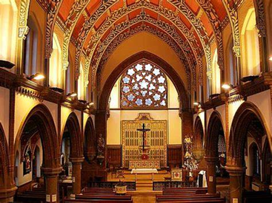
You could help your child by:

- encouraging them to become an active member of the parish community

